1. **Synopsis**
   1. **Introduction of the System**

The Project ***Student Result Processing System*** Software is a complete multi-user Web-Application. The admin accepts and then processes the scores of students and subsequently produces their report cards. The staff adds or updates student’s internal marks. The students can view and analyze their performances in the examination through graphical charts.

This project aimed at providing colleges to add, view and update student results and generate report cards and performance analysis charts, which can be viewed by the students through user friendly GUI based web pages.

* + 1. **Project Title**

"CANARA EXAM MANAGER”

*Student Result Processing System*

* + 1. **Category**

Web Application

* + 1. **Overview**

An individual report card of each student has to be displayed and printed at a keystroke according to standard format. Performance analysis charts are generated which can be viewed by the students through which he/she can analysis their performances in the examination. Student performance in a particular exam or all the exams must be expressed. Only a student of the College or University have the privileges to use this web application and its features, student registration in done only by the admin. The admin will provide username and password to the students which can be changed later by the students. Admin also registers the staff and provides username and password through email. Admin also provides specific role to the staff where a staff with role ‘Internal Auditor’ can add/update the Internal Examination marks of the students and staff with role ‘Faculty’ can only view the results of students. The application reduces the time to a greater extent that is viewing student results and analyzing performance through user friendly interface.

* 1. **Background**
     1. Brief note on Existing System

In the manual student result processing system, all the database commands have to be typed by the users. This procedure is very time consuming, and is limited to a single system. If someone want to get information about a particular subject score, student’s performance or any other content related to college, they have to contact the administrator handling the system.

In the proposed system, there are various controls to provide user friendliness. Details can be accessed over the internet, and huge amount of data, records and information can be stored. It provides high level of security, and there is no risk of data mismanagement. The overall result processing system is easier to use, flexible and with more features.

* 1. Objectives of the System
* The main objective of the system is to provide examination result to the student in a simple and user-friendly way.
* The privileges that are provided to student are to read his/her result and to compare and view his/her performance using graphical charts by providing user id and password for secure login and in case of new student the registration is done by the administrator (office) and the user id and password will be provided by the administrator.
* The privileges that are provided to staff are to read students results and to add or update internal marks to each individual students, by providing user id and password for secure login and in case of new staff the registration is done by the administrator (office) and the user id and password will be provided by the administrator.
* The privileges that are provided to administrator are to view and update the details of students and staff and also add or update student’s results, by providing the admin id and password for secure login.
  1. Scope of the System

In “Student Result Processing System” there are various controls to provide user friendliness. Details can be accessed over the internet, and huge amount of data, records and information can be stored. It provides high level of security and there is no risk of data mismanagement. The overall result processing system is easier to use, flexible and with more features.

* 1. Structure of the System
* Home Page
  + Student Login
  + Staff Login
  + Admin Login
* Login
  + User Name
  + Password
  + Login Button
* Admin Page
  + Home
  + Profile
  + Dashboard
  + Student Details
  + Staff Details
  + Programme and Courses
  + Classes
  + Student Result
  + Log Out
* Staff Page
  + Home
  + Profile
  + Dashboard
  + Classes
  + Student Results
  + Log Out
* Student Page
  + Home
  + Profile
  + Dashboard
  + Results
  + Performance
  + Log Out
    1. Modules
       1. Administrator
* Login: Admin is provided with separate login page where he/she has to enter username and password that is provided to them by the Administrator. This module is for user authentication.
* Dashboard: Administrator has a dashboard where he/she can manage all the functionality at one place.
* Add or Remove User: He/she can add or remove any user or users i: e staff or students.
* View Student Details: He/she can view the details of staff and students.
* Update Student Details: He/she can update the details of students.
* View Staff Details: He/she can view the details of staff.
* Update Staff Details: He/she can update the details of staff.
* View Programme and Courses: He/she can view the courses and subjects offered in the university.
* Update Programme and Courses: He/she can add or remove any courses and subjects and also modify them.
* Add or update student’s Semester marks: He/she can add or update semester marks of each individual students.
* Logout: Admin can log out from his/her dashboard page which can then be accessed only after authorized login.
  + - 1. Staff
* Login: Staff is provided with separate login page where he/she has to enter username and password that is provided to them by the Administrator. This module is for user authentication.
* Dashboard: Staff has a dashboard where he/she can manage all the functionality at one place.
* View Student Details: The staff can view the details of each student.
* Check Examination Result: He/she can check the examination results of the students.
* Add or update student’s internal marks: He/she can add or update internal marks of each individual students.
* Logout: Staff can log out from his/her dashboard page which can then be accessed only after authorized login.
  + - 1. Student
* Login: Students are provided with separate login page where he/she has to enter username and password that is provided to them by the Administrator. This module is for user authentication.
* Dashboard: Student has a dashboard where he/she can manage all the functionality at one place.
* View Personal Details: He/she can view their personal details.
* Check Examination Result: He/she can check their examination results including the remarks provided by the staff.
* Check Performance: He/she can analyze their performance through graphical charts.
* Logout: Student can log out from his/her dashboard page which can then be accessed only after authorized login.
  1. System Architecture



* 1. End Users
* Administrator Role: Manipulates all the records. Provides authorization to the users (students/staff). An admin can add or remove users (students/staff). He/she can view and update the personal details of the students and staff. He/she can view and update the examination results of students.
* Staff Role: Provides remarks to the student’s performance. He/she can view their own personal details and the personal details of student’s. He/she can view the examination results and analyze the performance of students through graphical charts.
* Student Role: Can view their examination results. He/she can analyze their performance through graphical charts.
  1. Software/Hardware used for development
     1. Software

|  |  |
| --- | --- |
| IDE / Text Editor | Brackets, Visual Studio Code, Eclipse. |
| Web Contents | Java Servlets, JSP, HTML, CSS, Java Script. |
| Server-Side Programming | Java |
| Database | My SQL |
| Server | Apache Tomcat |
| Documentation Tool | MS Office |

* + 1. Hardware

|  |  |
| --- | --- |
| Processor | i3 2.30 GHz |
| RAM | 8GB RAM |
| Memory | 70GB of Hard disk space or above |
| Graphics Card | 4GB Intel® UHD Graphics 620 |

* 1. Software/Hardware required for the implementation
     1. Client side

|  |  |
| --- | --- |
| **Operating System** | Any Operating System that supports browser applications like MS Windows, Linux, Mac OS etc. |
| **Browser** | Any browser that supports html5, CSS and JavaScript like Microsoft Edge, Google Chrome, Mozilla Firefox, Brave etc. |

Software

Hardware

|  |  |
| --- | --- |
| Processor | Intel Pentium dual-core or above |
| RAM | 2GB RAM |
| Memory | 50GB of Hard disk space or above |
| Graphics Card | 2GB HD Graphics Card or above |
| Input Devices | Mouse, Keyboard |
| Output Devices | Monitor |

* + 1. Server side

Software:

|  |  |
| --- | --- |
| Operating System | Any Operating System that supports Apace Tomcat server and JRE (Java Runtime Environment) like MS Windows, Linux, Mac OS etc. |
| Server | Apache Tomcat and MySQL server |
| Database | MySQL |

Hardware:

|  |  |
| --- | --- |
| Processor | Intel Pentium dual-core or above |
| RAM | 2GB RAM |
| Memory | 60GB of Hard disk space or above. |

1. **Software Requirements Specification**
   1. **Introduction**

The introduction of the Software Requirements Specification (SRS) provides an overview of the entire SRS with purpose, scope, definitions acronyms, abbreviations and overview of the SRS. The aim of this document is to gather and analyze and give an in-depth insight of the online *Student Result Processing System* by defining the problem statement in detail. The detailed requirements of “CANARA EXAM MANAGER” system is provided in this document.

* + 1. **Purpose**

This document mainly focuses on providing the information about the software requirements of the “CANARA EXAM MANAGER” system, which can be referred by the developers and will be basis for the validation of the final system. The project mainly focuses on exam management, where we can perform activities starting from registration of the students to generation of examination result and analyzing the performance of different examinations and comparing them.

* + 1. **Scope**

The scope of this document is to provide sufficient details on the functional and non-functional requirements are properly implemented. This project has an enormous scope in the upcoming days when the institutions can make their work of generating examination results automatic rather than manually doing all the calculations, which will save a lot of time.

* + 1. **Definition, Acronyms, Abbreviations**

This particular software is defined as automated software for the examination department of Universities/Institutions.

|  |  |
| --- | --- |
| SRS | Software Requirements Specification |
| SRPS | Student Result Processing System |
| CEM | Canara Exam Manager |
| DFD | Data Flow Diagram |
| ERD | Entity Relationship Diagram |
| CFD | Context Flow Diagram |
| DBMS | Database Management System |
| RDBMS | Relational Database Management System |
| GUI | Graphical User Interface |
| ADMIN | The Administrator |
| JSP | Java Server Page |
| SQL | Structured Query Language |
| HTML | Hyper Text Markup Language |
| CSS | Cascading Style Sheets |
| JS | Java Script |

* + 1. **Overview**

This SRS provides the overall description and specific requirements of the project. The general description will describe the requirements of the *“Student Result Processing System”.* The particular requirement section describes the details of the system. The system provides an easy solution to process the results of the students which reduces some of the unnecessary manual calculations. This web application can be used by any user who has basic knowledge of using a computer system without need of any special skills.

* 1. **Overall Description**

This examination software mainly focuses on the automation of the examination process, which starts from the registration of students to generation of examination result and analyzing the performance of different examinations and comparing them. Here Admin registers every detail of staff and students. The admin uploads the marks after getting the results of the examination (which includes all the examinations i: e from semester exams to internal exams) of the students and the result will be publish which can be viewed by the students.

* + 1. **Product Perspective**

The main objective of this **CEM** is to provide examination result to the student in a simple and user-friendly way. It is a web-based application with 3 interfaces Admin, staff and students. All the information is stored in the database, which can be retrieved. The website works with desktops, laptops and mobile with the help of the browser application.

* + 1. **Product Functions**
* Registering staffs and students.
* Ability to modify and upload data.
* Marks of the entire semester can be published.
* Allow admin to take control of the entire application.
* Details of each student’s profile are viewable by admin and staff.
* Staffs can view each student profile and exam results.
* Staffs can give remarks to each student based on their performance.
* Students can view their profile.
* Students can view their marks.
* Students can analyze their performance using enhanced graphs.
  + 1. **User Characteristics**
       1. **Admin:** Admin is the core user. He/she has a complete access to the web-application. The admin manipulates all the records. Provides authorization to the users (students/staff). An admin can add or remove users (students/staff). He/she can view and update the personal details of the students and staff. He/she can view and update the examination results of students.
       2. **Staff:** These are the users who have access to the information regarding the examination results and profile information of each student. He/she can add or update internal marks of each individual students.
       3. **Student:** These are the users who have access to the information regarding the examination results and their profile information. He/she can view their examination results. He/she can analyze their performance through enhanced graphical charts.
    2. **General Constraints**
* The system must be capable of doing parallel operations and must not have scalability issues with regard to number of computers, mobiles, tablets and monitors connected at one time.
* There is a small chance of miscalculations in examination results and performance analysis.
* The developed software should run on any platform (Linux, Mac, Windows etc. which supports Java) that contains a web browser.
* The end user (University) needs a hosting space so that it can be accessed from any remote location.
  + 1. **Assumptions**
* The code should be error-free.
* Roles and tasks are predefined.
* The Administrator is created in the system already.
  1. **Special Requirements**
     1. **User Interface**

The user interface of the web-application should be compatible with any browser such as Google Chrome, Microsoft Edge, Mozilla Firefox, Brave etc.

There are 3 user interfaces for 3 different users they are follows: -

* Admin
* Staff
* Student
  + 1. **Hardware Interface**
* **Processors:** Intel Pentium dual-core or above.
* **RAM:** 2 GB and above.
* **Hard Disk Utilization:** 60 GB and above.
* **Input Devices:** Mouse, Keyboard.
* **Output Devices:** Monitor.
  + 1. **Software Interface:**
* **Browser:** Any browser that supports html5, CSS and JavaScript like Microsoft Edge, Google Chrome, Mozilla Firefox, Brave etc.
* **Server:** Apache Tomcat.
* **IDE’s:** Eclipse Enterprise Edition, Brackets, Visual Studio Code.
* **Web Components:** Java Servlets, JSP, HTML, CSS.
* **Language:** Java.
* **Scripting Language:** Java Script.
* **Database:** MySQL.
  + 1. **Communication Interface:**

This is a web-based system, and communication is done through internet and internet protocols are used (HTTP Protocols).

* 1. **Functional Requirements**

Student Result Processing system is a dynamic web-application that is connected to the database. The students (users) can view their results and analyze their performance. There are 3 modules in this web-application they are: -

* + 1. **Admin Module:** The Administrator is the core user of the system. This module has the following functionalities.
* The Administrator should Login into the system with unique his/her username and password.
* Admin adds or removes users (student/staff).
* Admin views staff Personal details.
* Admin updates staff Personal details.
* Admin views student Personal details.
* Admin updates student Personal details.
* Admin views Programme and courses.
* Admin updates Programme and courses.
* Admin views Results of students.
* Admin updates Results of students.
  + 1. **Staff Module:** Staffs are the observers, although they do not have the privileges to change any data or information of the students except for Internal examination results. This module has the following functionalities.
* The Staff should login into the system with unique his/her username and password.
* Staff views student’s Personal details.
* Staff views his/her own Personal details.
* Staff views Results of students.
* Staff updates Internal marks of the students.
  + 1. **Student Module:** Students are the basic users of this system. He/she don’t have the privileges to modify the data and information regarding his/her own personal details, examination result details, examination schedules any other details. This module has the following functionalities.
* The student should login into the system with unique his/her username and password.
* Student views his/her own Personal details.
* Student views Results.
* Student views Schedules.
* Student views his/her performance in the examination using enhanced graphical charts.
  1. **Design Constraints**

The system is designed to allow web usability. The system is designed in such a way that it will be visible and easy to use on most of the web browsers. The system is secure and does not allow malicious or unauthorized users to access particular resources.

* 1. **System Attributes**
* **Compatibility:** This system will be compatible with almost all the web servers.
* **Flexibility:** The system keeps updating the data according to the changes takes place.
* **Portability:** The system can be run in any operating system and browser.
* **Reliability:** This system is designed to have very simple database just to extract the details of every user. It is tested for all the constraints at development stage.
* **Security:** This system provides with authentication without which no user can pass. So only the legitimate users are allowed to use the application. If the legitimate users share the authentication information, then the system is open to outsiders.
* **Timelines:** The system carries out all operations with consumptions of very less time.
  1. **Other Requirements**
     1. **Safety Requirements:** There are several users in CEM software. Access to the various subsystems will be protected by a user log in screen that requires a username id and password. This gives different views and accessible function of user levels through the system. Maintaining backups ensure the system database security. System can be restored in any case of emergency.
     2. **Security Requirements**
* Depending upon the category of user the access rights are decided.
* Admin has the maximum privileges to all subsystems.
* Only authenticated users can access the systems.
  + 1. **Performance Requirements:** In order to maintain an acceptable speed at maximum numbers of upload allowed from a particular user as any number of users can access to the system anytime. Also, the connections to the server will be based on the attributes of the user like location and server should be working 24X7.

1. **System Design**
   1. **Introduction**

System design is the process of defining the components, modules, interfaces and data for a system to satisfy specified requirements. System design involves designing a new system that will meet the requirements identified during system analysis. The focus of system design is on deciding which modules are needed for system, the specifications of these modules and how the modules should be interconnected.

* 1. **Assumptions and Constrains**

Project assumptions and constraints are identified at the beginning of the project. Throughout the project life cycle, they will be refined and re-analysed. Project assumptions and constraints are key to many processes in the PMBOK Guide. An essential aspect of your project, assumptions, and constraints are not managed like requirements or risks. However, documenting them helps to protect you from future aggravation. You should outline your project’s assumptions and constraints in the project scope statement.

Project constraints are limitations imposed on the project, like the budget, schedule, or resources. **It recognizes six project constraints:** scope, quality, schedule, budget, resources, and risk. Out of these six, scope, schedule, and budget are known as the triple constraints.

* 1. **Functional Decomposition**

Functional decomposition is a method of breaking down a problem into smaller and smaller functions. Each function is subdivided until it is manageable. Functional decomposition refers broadly to the process of resolving a functional relationship into its constituent parts in such a way that the original can be reconstructed from those parts by function components. In general, this process of decomposition is undertaken either for the purpose of gaining insight into the identity of the constituent component or for the purpose of obtaining a compressed representation of the global function, A task which is feasible only when the constituent processes possess a certain level of modularity.

* + 1. **System Software Architecture**

The Project Canara Exam Manager Student Result Processing System uses Java as the backend language where it follows MVC (Model View Controller) Model. In MVC Model the server contains three layer i: e View, Controller and Model. The User side of the web application acts as a client. The information in stored on a remote server database. The user sends request for pages / data to the server through client-side User Interface. The request is received by the Controller (Servlet) on the server where it processes the request and communicates with the Model / Data Model (Java Class) which contains the actual logic for inserting / retrieving the data from database. The Model then connects to the database and executes queries to insert or retrieve the data, the data is then given back to the Controller in the form of object as a response. The Controller processes this data and gives back the data to the user in the form of html page or xml/Json format. This makes the project very secure and helps in maintaining data integrity.

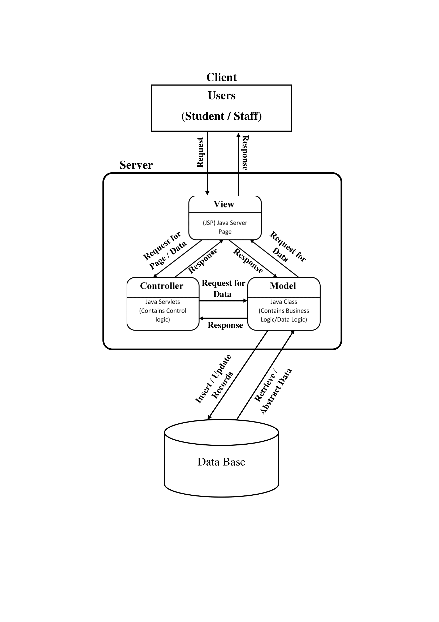

(Apace Tomcat)

* + 1. **System Technical Architecture**

Web Server

(Server Program)

Business Logic

(API Layer, App, Backend)

Data Layer

(Database Services, Third Party Services)

Presentation Layer

(Views / User Interface’s)

HTML, CSS, JavaScript

Apache Tomcat

Java, JSP, Servlet, MySQL Server API

MySQL

**The system is made up of four layers:**

1. **The presentation layer:** Includes user interfaces built using the HTML, CSS and JavaScript tools. The interface is designed using GUI components which are user-friendly.
2. **Web Server layer:** Is to serve websites on the internet. It acts as a middleman between the server and client machines. It pulls content from the server on each user request and delivers it to the App.
3. **Business Logic layer:** Is used for the retrieval of data obtained from user interfaces or acquired form databases. Activities for calculating, managing and making decisions and communicating with the front-end application and back-end database are managed by business logic written using Java language are appearing here.
4. **Data layer:** Is used to store data forwarded by the business layer and retrieve data on demand to the business layer. MySQL database software is used as a back-end database of the system.
   * 1. **System Hardware Architecture**

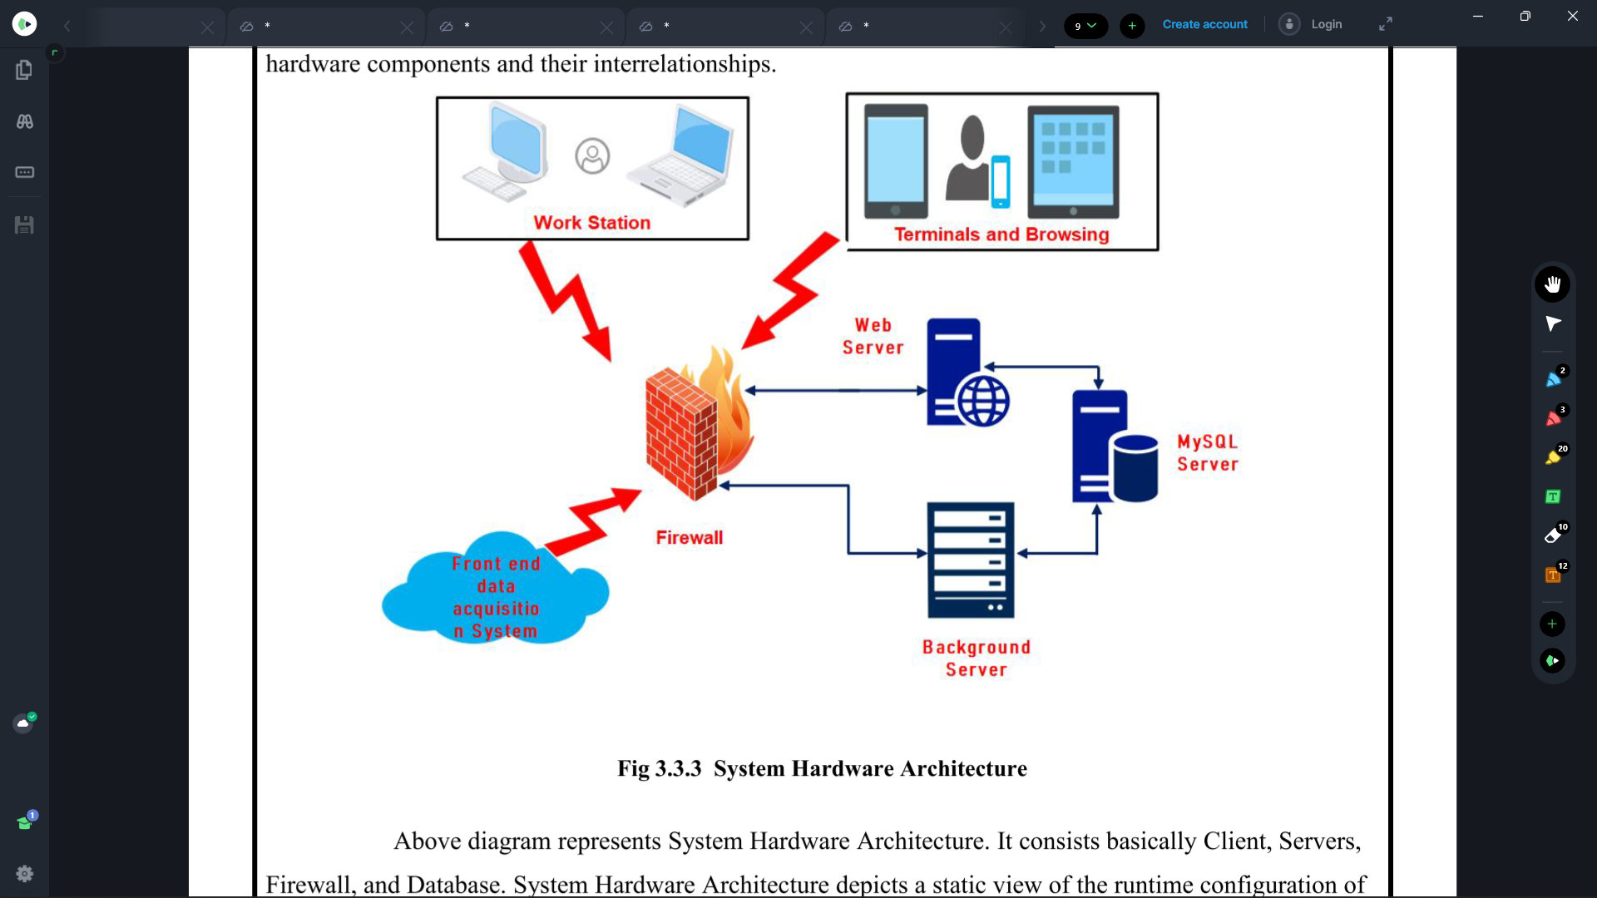

* + 1. **External Interface**
* Name of the Application: Canara Exam Manager.
* Details of Interface: User Interface.
* Type of Interface: Graphical User Interface, Menu driven Interface, Form based Interface.
  1. **Description of Programs**
     1. **Context Flow Diagram**

It defines the flows of information between the system and external entities. The entire software system is shown in single process. It’s designed to be an abstraction view, showing the system as a single process with its relationship to external entities. It represents the entire system as single bubble with input and output data indicated by incoming/outgoing arrows.

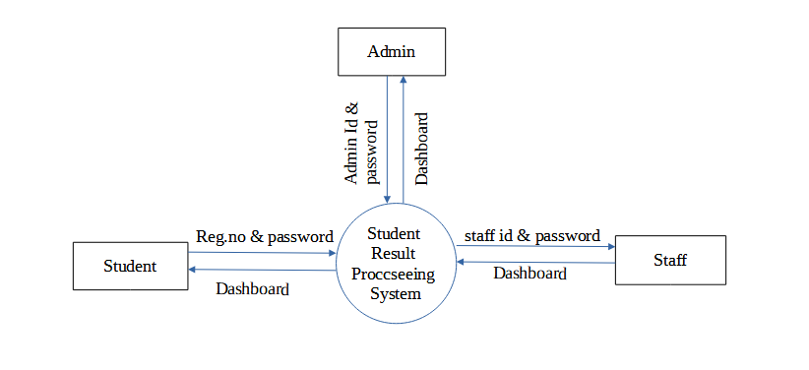

* + 1. **Data Flow Diagram**

Data Flow Diagram are the graphical way of showing the flow of data through an information system. It is the common practice for a designer to draw a context level DFD. A complete set of DFD provide a compact top-down representation of the system. It also expresses the requirement of the system and shows how the current system is implemented. Data Flow Diagram are commonly used during problem analysis. It views a system as a function that perform the input into the desired output. DFD shows the information moves through and how it is modified by a series of transformation. DFD may be used to represent the system at any level of abstraction. DFD can be used to provide the end users with the physical idea of where the data they input ultimately

* + 1. **Data Flow Symbols**

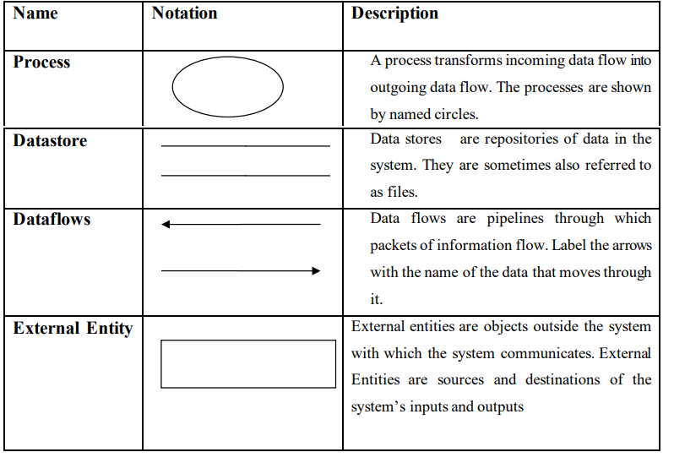

* + 1. **DFD Level 1(Admin)**

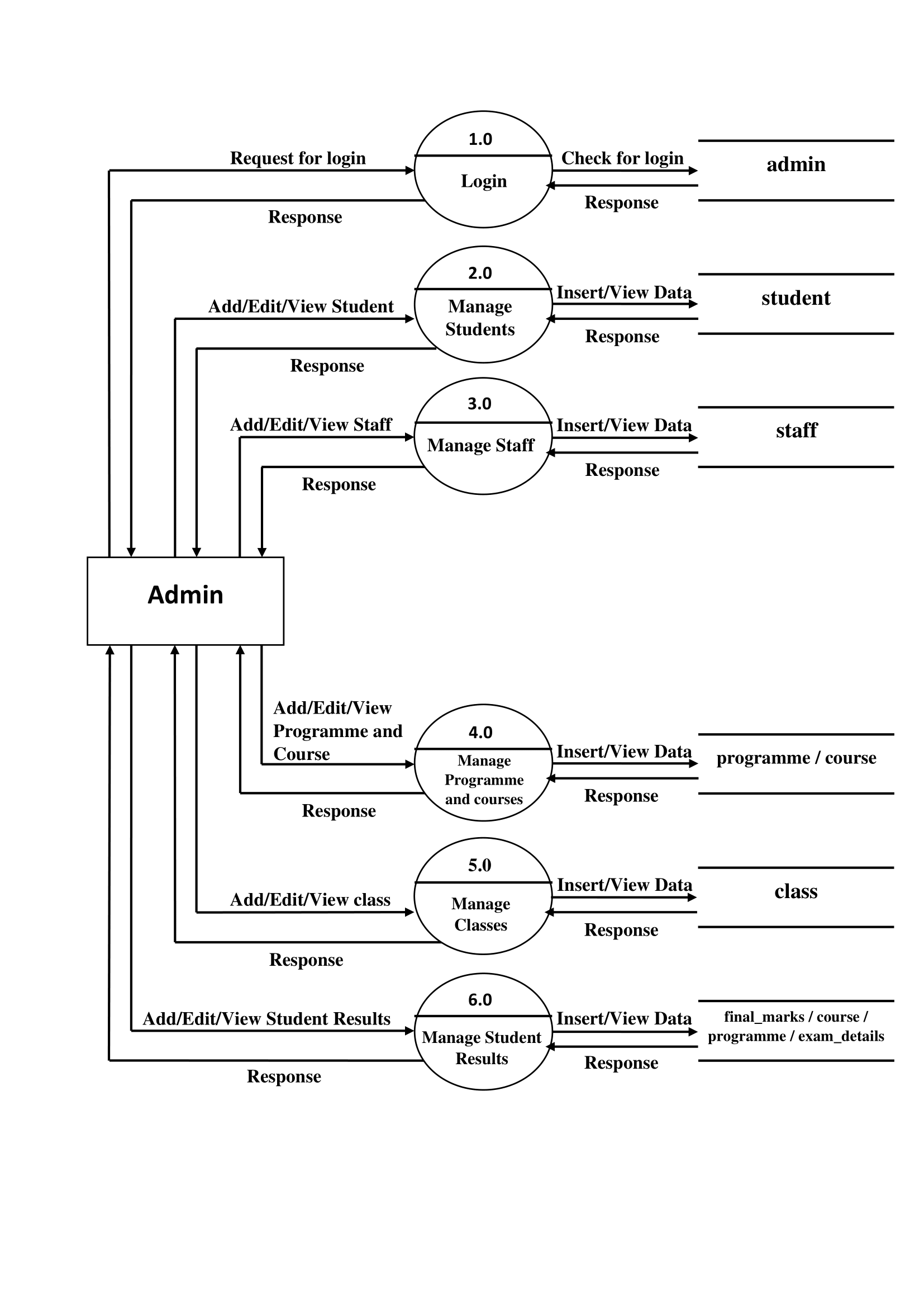

* + 1. **DFD Level 2(Admin)**

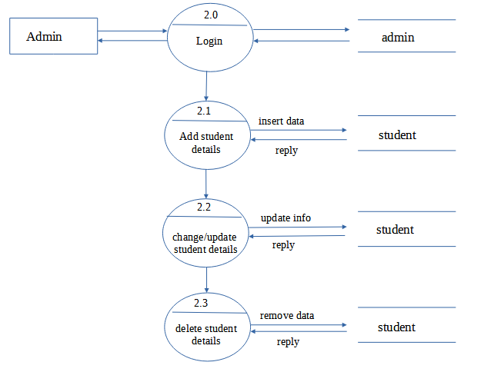

* + 1. **DFD Level 3 (Admin)**

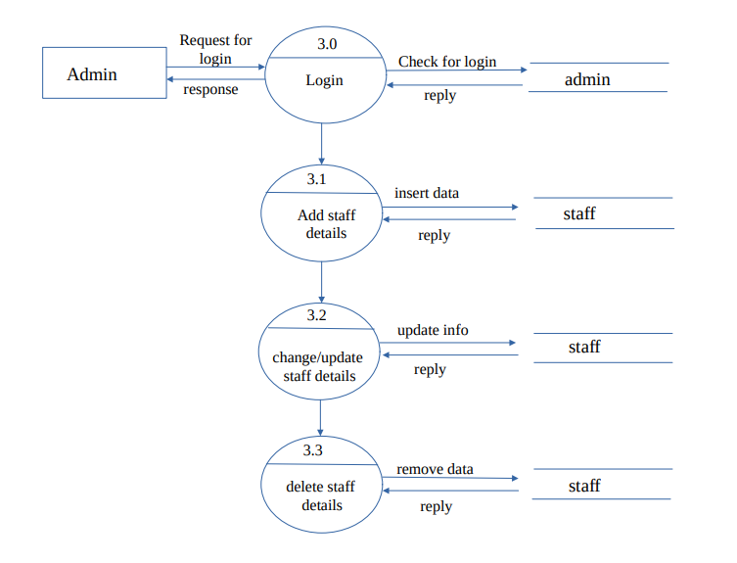

* + 1. **DFD Level 4 (Admin)**

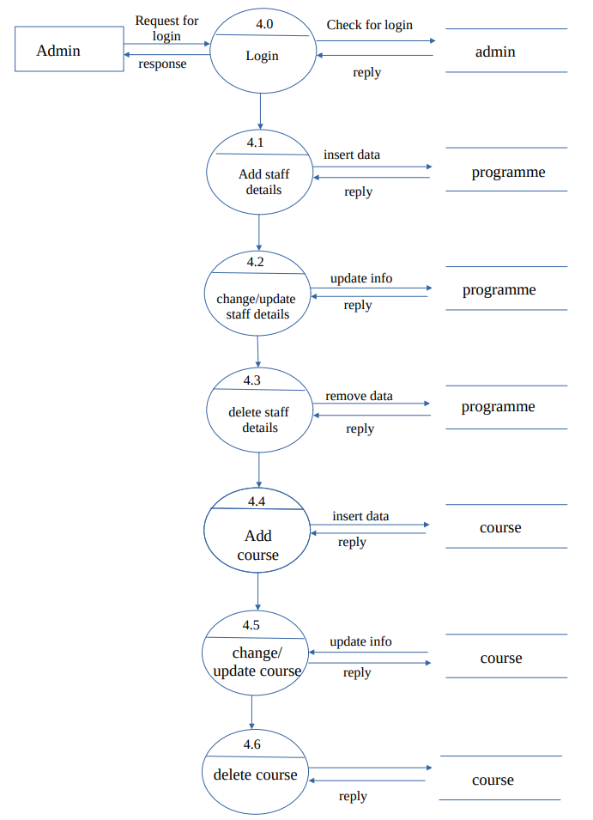

* + 1. **DFD Level 5 (Admin)**

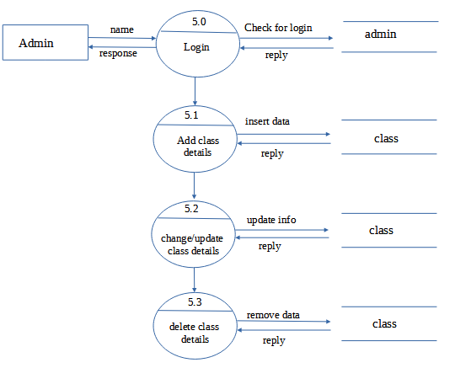

* + 1. **DFD Level 6 (Admin)**

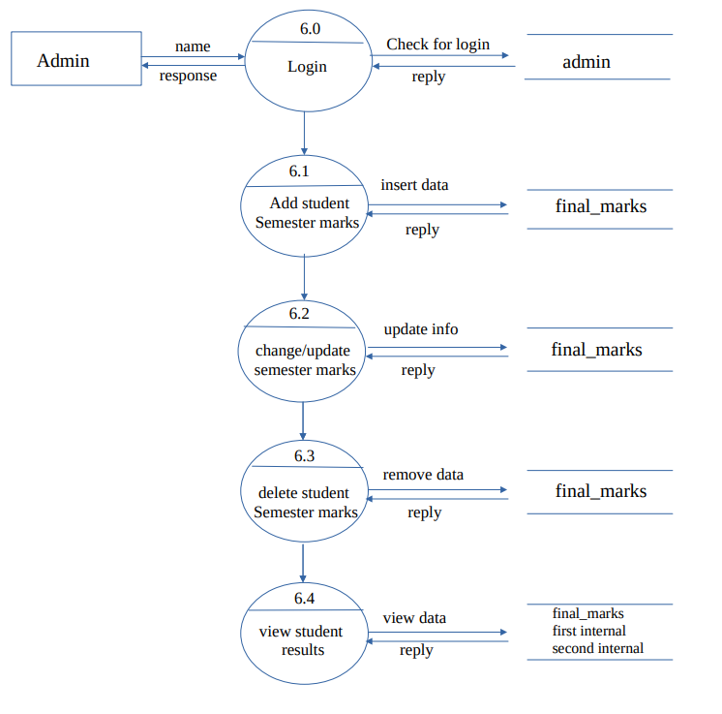

* + 1. **DFD Level 1 (Staff)**

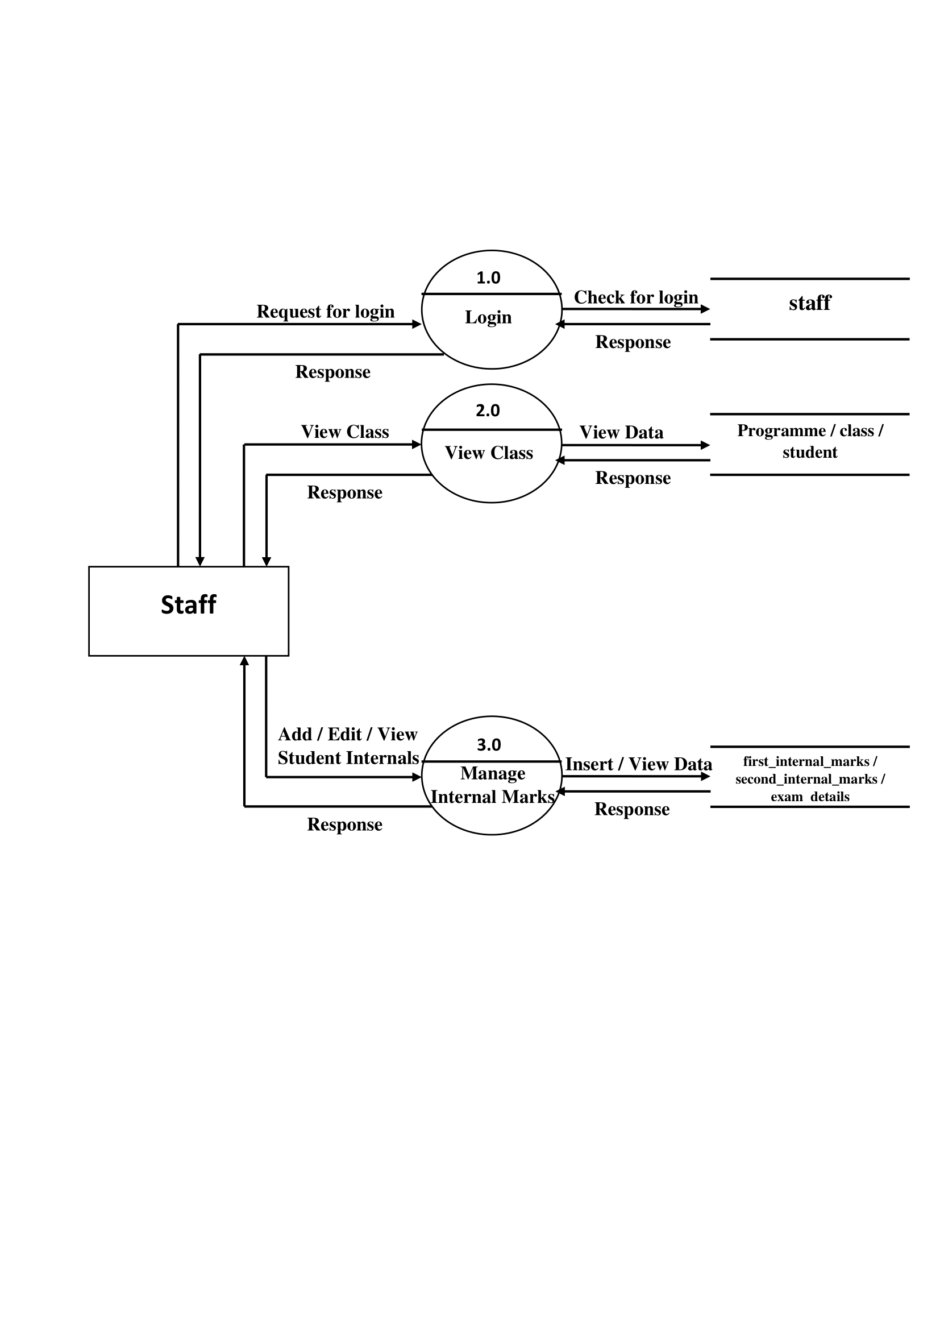

* + 1. **DFD Level 1 (Student)**



* 1. **Description of Components**
     1. **Admin**

**Input:** Login, Reset Password, Change Password, Check Profile, View Dashboard, View Examination Results, Analyse Performance.

**Output:** Profile Page, Dashboard, Marks Sheet, Performance Bar Chart.

* + 1. **Staff**

**Input:** Login, Reset Password, Change Password, Check Profile, View Dashboard, View Student Examination Results, Add / Update Student Internal Marks.

**Output:** Profile Page, Dashboard, Marks Sheet, Add / Update Confirmation Message.

* + 1. **Student**

**Input:** Login, Reset Password, Change Password, Check Profile, View Dashboard, Add / Update Student Details, Add / Update Staff Details, Add / Update Programme and Course Details, Add / Update Class Details, Add / Update Student Semester Results, View Student Examination Results.

**Output:** Profile Page, Dashboard, Marks Sheet, Add / Update confirmation Message.

1. **Database Design**
   1. **Introduction**

Database design is the process of producing a detailed data model of database. The data model contains all the needed logical and physical design choices and physical storage parameters needed to generate a design in a data definition language which can then be used to create a database. A fully attributes data model contains detailed attributes for each entity. The term database design can be used to describe many different parts of the design of an overall database system principally and most correctly. It can be thought of as the logical design of the database structures used to store the dat. In the relational model, these are the tables and views. In an object database, the entities and relationship map directly to object classes and named relationships. However, the term database design could also be used to apply to the overall process of designing, not just the data base structures, but also the forms and quires used as a part of the overall database application within the Data Base Management System (DBMS).

The goals of the database design are as follows:

* A database should provide for efficient data storage, update, and retrieval.
* A database should be reliable, and the stored data should have high integrity to promote user trust in that data.
* A database should be adaptable and scalable to new and unforeseen requirements and applications.
  1. **Purpose And Scope**

The main objectives of database designing are to produce logical and physical designs models of the proposed database system. The logical model; concentrates on the data requirements and data to be stored independent of physical considerations. It does not concern itself with how the data will be stored physically. The physical data design model involves translating the logical design of the database onto physical media using hardware resources and software systems such as DBMS.

This Functional Database Design document provides detailed information of the CanaraExamManager model implemented to support the functional requirements for project target database management system with consideration to the system’s performance requirements. The document describes, how the database that will support the CanaraExamManager Data Model with details of the logical and physical definitions. The document provides the functional and non-functional usage of the tables, considerations and requirements. Further, the document would briefly describe the integration aspects of the Database with the Web Application. The Web Application would provide the users with easy access to project data. (DBMS). If we have a good database then:

* Easy to locate the data or information in no time.
* No redundant data.
* No repetition.
* Secure. Not more than one can access or change the data at the same time.
* Table references (like Primary Key, Foreign keys, etc.) are easier to maintain.
  1. **Database Identification**

**Naming Conventions**

* The identifier should not have quotes.
* Identifier names should not have whitespace.
* Identifiers should be written entirely in lower case.
* Database object names, particularly column names, should be a noun describing the field or object.

**Table Conventions**

* Database table names and column names are defined without leaving space.
* Lowercase used to create database tables and columns.
* Primary key and foreign key defined with the same name.
  1. **Schema Information**

A schema is a structure behind data organization. It is a visual representation of how different table relationships enable the schema’s underlying mission business rules for which the database is created. In a schema diagram, all database tables are designed with unique columns and special features, e.g., primary/foreign keys or not null, etc. Formats and symbols for expression are University understood, eliminating the possibility of confusion. The table relationships also are expressed via the parent table’s primary key lines when joined with the child tables corresponding to foreign keys. Schema diagrams have an important function because they force database developers to transpose ideas to paper. This provides an overview of the entire database while facilitating future database administrator work.

* 1. **Table Definition**
     1. **Database/Schema Name: canaradatabase (MySQL).**

|  |  |  |  |  |  |
| --- | --- | --- | --- | --- | --- |
| Sl.No | Field Name | Data Type | Field Size | Constrain | Description |
| 1 | admin_id | int | 3 | Primary Key | Admin Id |
| 2 | first_name | varchar | 15 | Not Null | First Name |
| 3 | last_name | varchar | 15 | Not Null | Last Name |
| 4 | phone | bigint | 10 | Not Null | Phone Number |
| 5 | email | varchar | 25 | Not Null | Email |
| 6 | password | varchar | 25 | Not Null | Password |
| 7 | profile_image | Mediumblob |  | Null | Profile Image |

* + 1. **Table Name: admin**

* + 1. **Table name: staff**

|  |  |  |  |  |  |
| --- | --- | --- | --- | --- | --- |
| Sl.No | Field Name | Data Type | Field Size | Constrain | Description |
| 1 | staff_id | int | 3 | Primary Key | Staff Id |
| 2 | first_name | varchar | 15 | Not Null | First Name |
| 3 | last_name | varchar | 15 | Not Null | Last Name |
| 4 | gender | varchar | 6 | Not Null | Gender |
| 5 | email | varchar | 25 | Not Null | Email |
| 6 | phone | bigint | 10 | Not Null | Phone |
| 7 | address | varchar | 25 | Not Null | Address |
| 8 | password | varchar | 25 | Not Null | Password |
| 9 | program_id | int | 3 | Foreign Key | Program Id |
| 10 | staff_status | varchar | 5 | Not Null | Status |
| 11 | role | varchar | 16 | Not Null | Role |
| 12 | profile_image | mediumblob |  | Null | Profile Image |

* + 1. **Table name: student**

|  |  |  |  |  |  |
| --- | --- | --- | --- | --- | --- |
| **Sl.No** | **Field Name** | **Data Type** | **Field Size** | **Constrain** | **Description** |
| 1 | reg_no | int | 9 | Primary Key | Register No |
| 2 | first_name | varchar | 15 | Not Null | First Name |
| 3 | last_name | varchar | 15 | Not Null | Last Name |
| 4 | gender | varchar | 6 | Not Null | Gender |
| 5 | dob | date |  | Not Null | Dob |
| 6 | email | varchar | 25 | Not Null | Email |
| 7 | phone | bigint | 10 | Not Null | Phone |
| 8 | address | varchar | 25 | Not Null | Address |
| 9 | birth_place | varchar | 20 | Not Null | Birth Place |
| 10 | birth_district | varchar | 20 | Not Null | Birth District |
| 11 | birth_state | varchar | 20 | Not Null | Birth State |
| 12 | pincode | int | 6 | Not Null | Pincode |
| 13 | password | varchar | 25 | Not Null | Password |
| 14 | programme_id | int | 3 | Foreign Key | Programme Id |
| 15 | class_id | int | 3 | Foreign Key | Class Id |
| 16 | joining_year | int | 4 | Not Null | Joining Year |
| 17 | semester | int | 2 | Not Null | Semester |
| 18 | status | varchar | 5 | Not Null | Status |
| 19 | profile_image | mediumblob |  | Null | Profile Image |

|  |  |  |  |  |  |
| --- | --- | --- | --- | --- | --- |
| **Sl.No** | **Field Name** | **Data Type** | **Field Size** | **Constrain** | **Description** |
| 1 | Programme_id | int | 3 | Primary Key | Programme Id |
| 2 | Programme_name | varchar | 35 | Unique Key / Not Null | Programme Name |
| 3 | Programme_duration | int | 1 | Not Null | Duration |
| 4 | Progrsmme_sem | int | 2 | Not Null | Total Semester |

* + 1. **Table name: programme**

|  |  |  |  |  |  |
| --- | --- | --- | --- | --- | --- |
| **Sl.NO** | **Field Name** | **Data Type** | **Field Size** | **Constrain** | **Description** |
| 1 | class_id | int | 3 | Primary Key | Class Id |
| 2 | class_name | varchar | 10 | Not Null | Class Name |
| 3 | programme_id | int | 3 | Foreign Key | Programme Id |
| 4 | class_year | int | 1 | Not Null | Class Year |

* + 1. **Table name: class**

|  |  |  |  |  |  |
| --- | --- | --- | --- | --- | --- |
| **Sl.NO** | **Field Name** | **Data Type** | **Field Size** | **Constrain** | **Description** |
| 1 | course_code | varchar | 9 | Primary Key | Course Code |
| 2 | course_name | varchar | 64 | Not Null | Course Name |
| 3 | course_type | varchar | 9 | Not Null | Course Type |
| 4 | course_group | varchar | 32 | Not Null | Course Group |
| 5 | course_group_number | float | 2 | Not Null | Course Group Number |
| 6 | course_sem | int | 2 | Not Null | Course Sem |
| 7 | max_marks | int | 3 | Not Null | Max Marks |
| 8 | min_marks | int | 3 | Not Null | Min Marks |
| 9 | max_ia | int | 3 | Not Null | Max IA |
| 10 | programme_id | int | 3 | Foreign Key | Programme Id |

* + 1. **Table name: course**
    2. **Table name: first_internal_marks**

|  |  |  |  |  |  |
| --- | --- | --- | --- | --- | --- |
| **Sl.NO** | **Field Name** | **Data Type** | **Field Size** | **Constrain** | **Description** |
| 1 | reg_no | int | 9 | Foreign Key | Register No |
| 2 | course_code | varchar | 9 | Foreign Key | Course Code |
| 3 | program_id | int | 3 | Foreign Key | Program Id |
| 4 | max_marks | int | 3 | Not Null | Max Marks |
| 5 | min_marks | int | 3 | Not Null | Min Marks |
| 6 | obtained_marks | int | 3 | Not Null | Obtained Marks |
| 7 | grade | varchar | 4 | Not Null | Grade |
| 8 | result | varchar | 10 | Not Null | Result |

* + 1. **Table name: second_internal_marks**

|  |  |  |  |  |  |
| --- | --- | --- | --- | --- | --- |
| **Sl.NO** | **Field Name** | **Data Type** | **Field Size** | **Constrain** | **Description** |
| 1 | reg_no | int | 9 | Foreign Key | Register No |
| 2 | course_code | varchar | 9 | Foreign Key | Course Code |
| 3 | program_id | int | 3 | Foreign Key | Program Id |
| 4 | max_marks | int | 3 | Not Null | Max Marks |
| 5 | min_marks | int | 3 | Not Null | Min Marks |
| 6 | obtained_marks | int | 3 | Not Null | Obtained Marks |
| 7 | grade | varchar | 4 | Not Null | Grade |
| 8 | result | varchar | 10 | Not Null | Result |

* + 1. **Table name: final_marks**

|  |  |  |  |  |  |
| --- | --- | --- | --- | --- | --- |
| **Sl.NO** | **Field Name** | **Data Type** | **Field Size** | **Constrain** | **Description** |
| 1 | reg_no | int | 9 | Foreign Key | Register No |
| 2 | course_code | varchar | 9 | Foreign Key | Course Code |
| 3 | program_id | int | 3 | Foreign Key | Program Id |
| 4 | obtained_marks | int | 3 | Not Null | Obtained Marks |
| 5 | IA_marks | int | 3 | Not Null | IA Marks |
| 6 | total_marks | int | 3 | Not Null | Total Marks |
| 7 | grade | varchar | 4 | Not Null | Grade |
| 8 | credit | int | 2 | Not Null | Credit |
| 9 | grade_point | int | 2 | Not Null | Grade Point |
| 10 | grade_point_weightage | int | 2 | Not Null | Grade Point Weightage |
| 11 | result | varchar | 4 | Not Null | Result |

* + 1. **Table name: exam_details**

|  |  |  |  |  |  |
| --- | --- | --- | --- | --- | --- |
| **Sl.NO** | **Field Name** | **Data Type** | **Field Size** | **Constrain** | **Description** |
| 1 | reg_no | int | 9 | Foreign Key | Register Number |
| 2 | exam_type | varchar | 8 | Not Null | Exam Type |
| 3 | exam_month | Varchar | 9 | Not Null | Exam Month |
| 4 | exam_year | int | 4 | Not Null | Exam Year |
| 5 | result_date | date |  | Not Null | Result Date |

* 1. **Physical Design**

The physical design of your database optimizes performance while ensuring data integrity by avoiding unnecessary data redundancies. During physical design, you transform the entities into tables, the instances into rows, and the attributes into columns. You need to continually monitor the performance and data integrity characteristics of the database as time passes. Many factors necessitate periodic refinements to the physical design

* 1. **Data Dictionary**

A Data Dictionary is a collection of names, definitions, and attributes about data elements that are being used or captured in a database, information system, or part of a research project. It describes the meanings and purposes of data elements within the context of a project, and provides guidance on interpretation, accepted meanings and representation. A Data Dictionary also provides metadata about data elements. The metadata included in a Data Dictionary can assist in defining the scope and characteristics of data elements, as well the rules for their usage and application.

Data Dictionaries are useful for a number of reasons. In short, they:

* Assist in avoiding data inconsistencies across a project.
* Help define conventions that are to be used across a project.
* Make data easier to analyze.
* Enforce the use of Data Standards.
  1. **Entity Relationship Diagram**

An Entity Relation of (ER) Diagram is a specialized graphics that illustrates the interrelationship between entities in a database. Entities are physical items or aggregations of data items that are important to the business that we analysis to the system. It is a framework using specialized symbols to define the relationship between entities. ER diagram is created based on three main components entities, attributes and relationship. ER helps us conceptualize the database and help us know which fields need to be embedded for a particular entity. ER Diagram gives a better understanding of the information to be stored in a database. Reduces completely and saves time which allows you to build database quickly.

* + 1. **ER Diagram symbol’s**

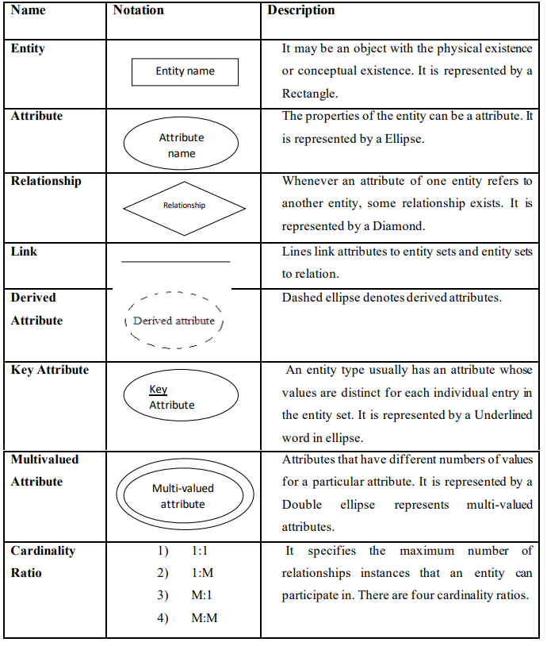

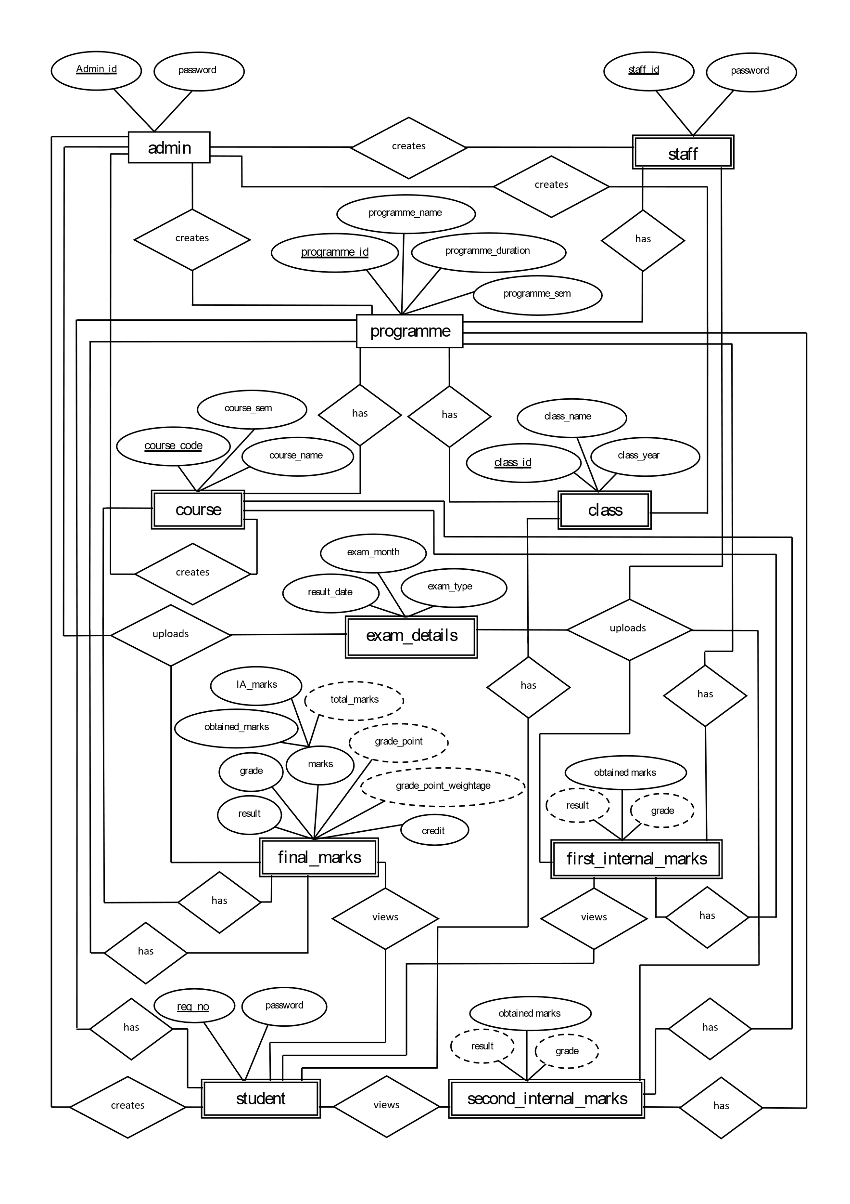

* 1. **Database Administration**
     1. System Information

Server: MySQL

Server type: mysqld

Server Version: 8.0.29.0

Server charset: UTF-8 Unicode(utf8)

* + 1. DBMS Configuration

The exact set of database administration duties of each DBA is dependent on his/her job profile, the IT policies applied by the company he/she works for, and last but not least-the concrete parameters of the database management system in use. A DBA must be able to think logically to solve all problems and to easily work in a team with both DBA colleagues and staff with no computer training.

MySQL Server Configuration:

MySQL 64-bit Installer extracts configuration files to the hard drive of the host during the initial setup. During the initial setup, a predetermined setup type that matches system setup requirements with Full setup are to be installed on the server machine.

To connect Java application with the MySQL database, we need to follow 5 following steps:

1. Driver class: The driver class for the MySQL database is com.mysql.jdbc.Driver.
2. Connection URL: The connection URL for the MySQL database is jdbc:mysql://localhost:3306/canaradatabase where JDBC is the API, MySQL is the database, localhost is the server name on which MySQL is running, we may also use IP address, 3306 is the port number and canaradatabase is the database name. We may use any database, in such case, we need to replace the canaradatabase with our database name.
3. Username: The default username for the MySQL database is root.
4. Password: It is the password given by the user at the time of installing the MySQL database.
   * 1. Support Software Required

**JDBC Driver:** is a software component that enables java application to interact with the database.

* + 1. Storage Requirements

Storage for database continues a set of compatible software and hardware where database files are stored.

* Compatibility must be carefully tested to ensure eliminating bottlenecks and the possibility of data corruption.
* Failure free work in high load conditions and the redundancy of vulnerable components must be provided. Such a set must meet the highest standards in terms of performance and reliability, to ensure.
* continuous and fast access to important data.
  + 1. Backup And Recovery

Database recovery is the process of restoring the databases to a correct state following failure. The failure may be the result of a system crash due to hardware or software errors, a media failure, such as a head crash, or a software error in the application, such as a logical error in the program that is accessing the database. It may also be the result of unintentional or intentional corruption or destruction of data. Whatever the underlying cause of the failure, the DBMS must be able to recover from the failure and restore the database to a consistent state. It is the responsibility of DBMS to ensure that the database is reliable and remains in a consistent state in the presence of failure. In general, backup and recovery refer to the various strategies and procedures involved in protecting the database against data loss and reconstructing the data such as that no data is lost after failure.

1. **Detailed Design**
   1. Introduction

Detailed design can be generally defined as a collection of tasks or processes that enhance the designing, development, implementation, and maintenance of enterprise data management system. Designing a proper database reduces the maintenance cost thereby improving data consistency and the cost-effective measures are greatly influenced in terms of disk storage space. Therefore, there has to be a brilliant concept of designing a database. The designer should follow the constraints and decide how the elements correlate and what kind of data must be stored.

The main objectives behind database designing are to produce physical and logical design models of the proposed database system. To elaborate this, the logical model is primarily concentrated on the requirements of data and the considerations must be made in terms of monolithic considerations and hence the stored physical data must be stored independent of the physical conditions. On the other hand, the physical database design model includes a translation of the logical design model of the database by keep control of physical media using hardware resources and software systems such as Database Management System (DBMS).

* 1. Structure of the software package

The functional components are:

* Admin module
* Staff module
* Student module
  + 1. Admin Module:



* + 1. Staff Module:



* + 1. Student Module:



* 1. Modular decomposition of the system
     1. Admin Module

The Administrator can Manage all the Student and Staff Profile Details along with Programme, Course, Class and Student Semester Result Details. He/she can add/update/delete/view Student, Staff, Programme, Course, Class and Student Semester Result Details. He/she can only view Internal Marks of Students without the privileges to alter the Internal Marks Data.

* + - 1. Login

1. Inputs: Admin ID, Password
2. Procedural Details

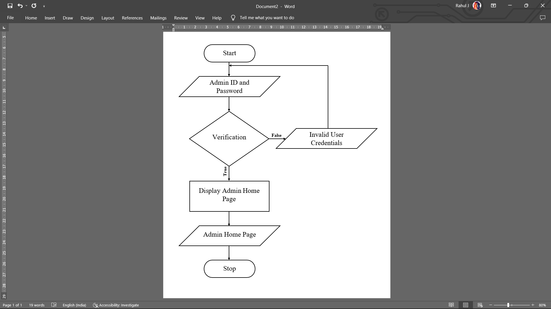

1. File I/O Interface: Graphical user interface for admin to enter Admin ID and Password.
2. Outputs: If Admin ID and Password is correct, admin can gain access to the system.
3. Implementation Aspects: Once admin has gained access to the system, he/she can manage student, staff, programme, course, class details.
   * + 1. Add/Update/Delete Student, Staff, Programme, Course, Class and Student Semester Result Details
4. Inputs

* Student: First-Name, Last-Name, Gender, Date of Birth, Email, Mobile Number, Address, Pincode, Place of Birth, District, State, Year of Joining, Programme, Class, Class Year, Current Semester, Register Number, Password.
* Staff: First-Name, Last-Name, Gender, Email, Mobile Number, Address, Programme, Role, Staff ID, Password.
* Programme: Programme ID, Programme Name, Duration, Total Semester’s.
* Course: Course-Code, Course-Name, Course-Type, Course-Group, Min Marks, Max Marks, Max Internal Marks.
* Class: Programme, Class ID, Class Name, Class Year.
* Student Semester Result: Register Number, Semester, Obtained Marks, Internal Assessment Marks, Credit, Exam Month, Exam Year, Result Publish Date.

1. Procedural Details

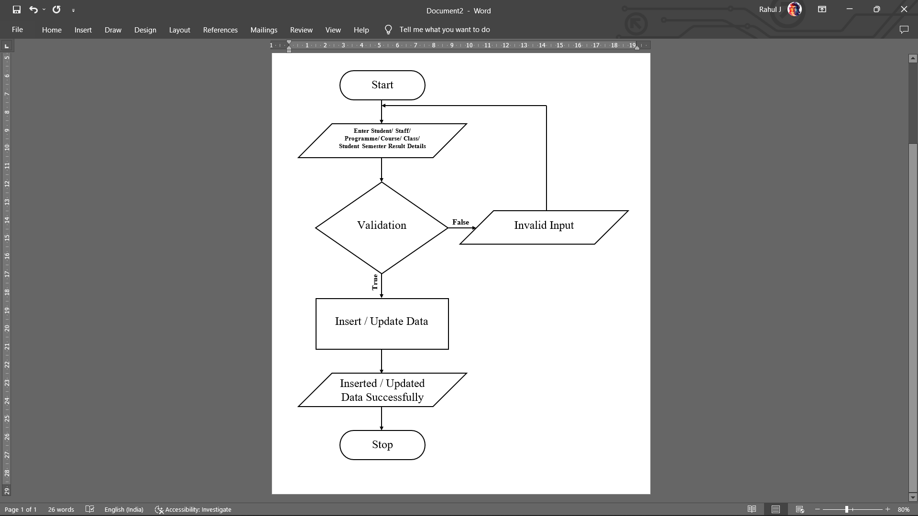

1. File I/O Interface: Graphical user interface for admin to enter Student, Staff, Programme, Course, Class and Student Semester Result details. Custom message based on insertion/updating details will be displayed.
2. Outputs: The Student, Staff, Programme, Course, Class and Student Semester Result Details will be stored in the database.
   * + 1. View Student, Staff, Programme, Course, Class and Student Result Details
   1. Inputs

* Student: Register Number.
* Staff: Staff ID.
* Programme: Programme ID.
* Class: Class ID.
* Student Result: Register Number, Semester.
  1. Procedural Details

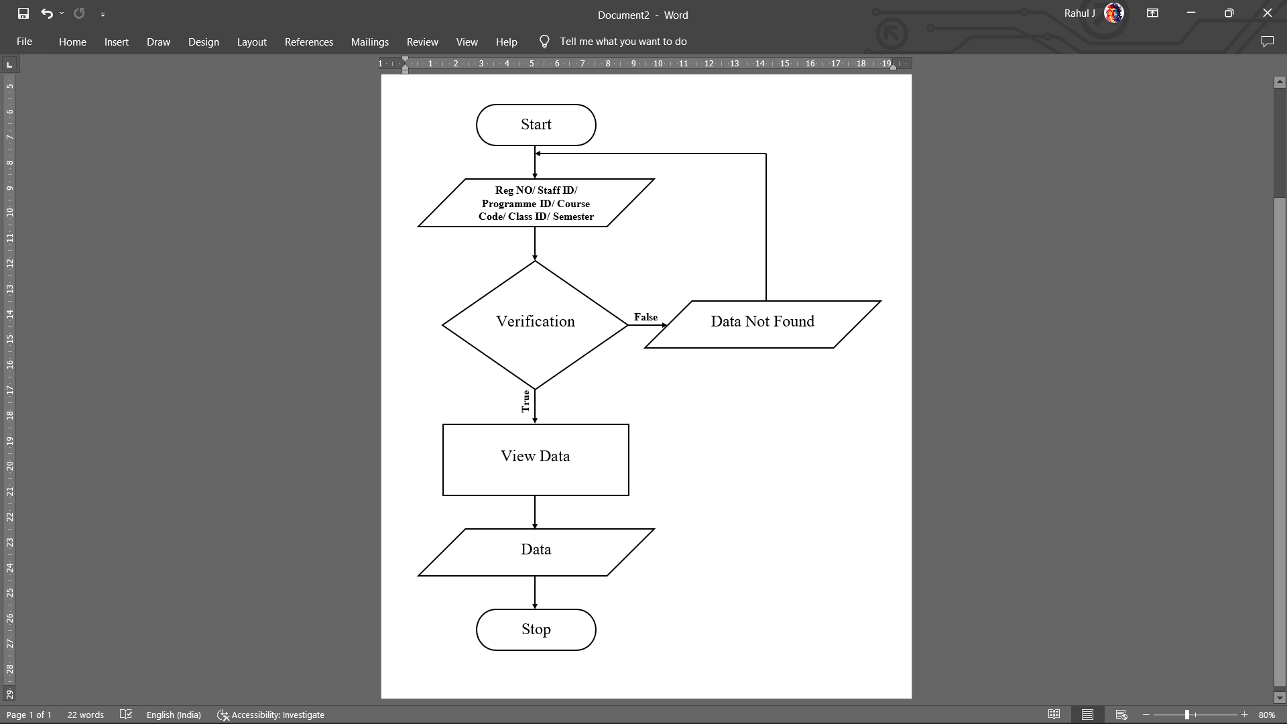

* 1. File I/O Interface: Graphical user interface for admin to view Student, Staff, Programme, Course, Class and Student Semester Result details. Custom message based on existence of data will be displayed.
  2. Outputs: The Student, Staff, Programme, Course, Class and Student Result Details will be displayed.
     1. Staff Module

The Staff is provided with a specific role by admin, these roles define the privileges that the staff have in this web application. Staff with Internal Auditor role can add/update/delete only Internal Marks of students belonging to a particular Programme. He/she can view all student results. Staff with Faculty role can only view student results, he/she does not have the privileges to add/update/delete Internal Marks of students belonging to a particular Programme.

* + - 1. Login
  1. Inputs: Staff ID and Password.
  2. Procedural Details

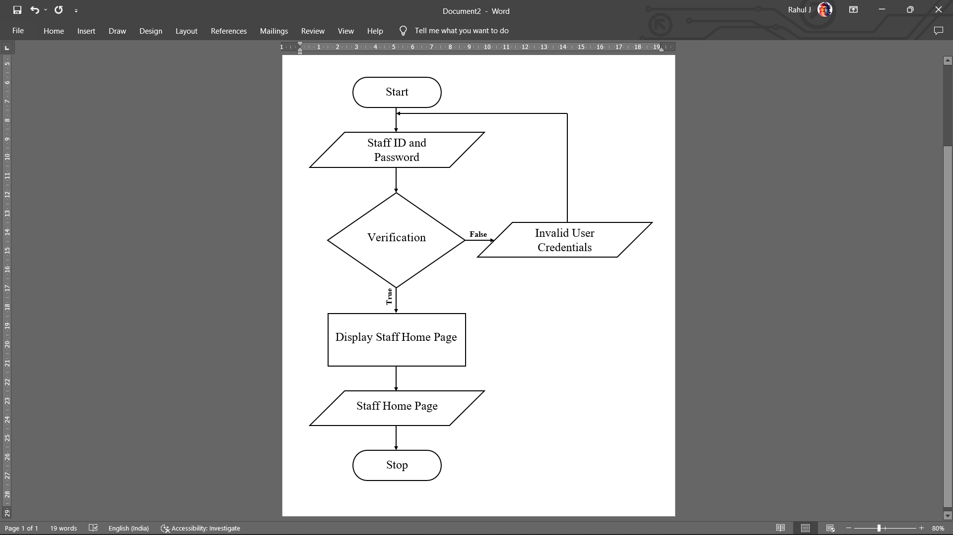

* 1. File I/O Interface: Graphical user interface for admin to enter Admin ID and Password.
  2. Outputs: If Staff ID and Password is correct, staff can gain access to the staff home page.
  3. Implementation Aspects: Once staff has gained access to the staff home page, he/she (only with Internal Auditor role) can manage student internal marks.
     + 1. Add/Update/Delete Student Internal Result Details
       2. Inputs: Register Number, Semester, Max Marks, Min Marks, Obtained Marks, Exam Month, Exam Year, Result Publish Date.
       3. Procedural Details

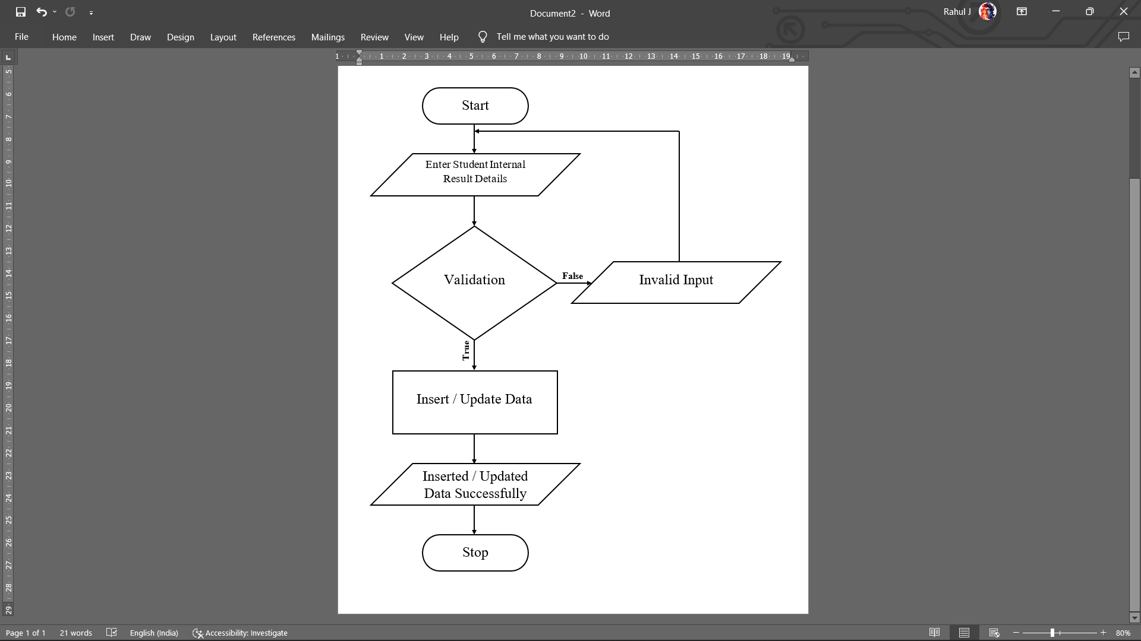

* + - 1. File I/O Interface: Graphical user interface for staff to enter Student Internal Result details. Custom message based on insertion/updating details will be displayed.
      2. Outputs: The Student Internal Result Details will be stored in the database.
      3. View Student Result Details

1. Inputs: Register Number, Semester.
2. Procedural Details

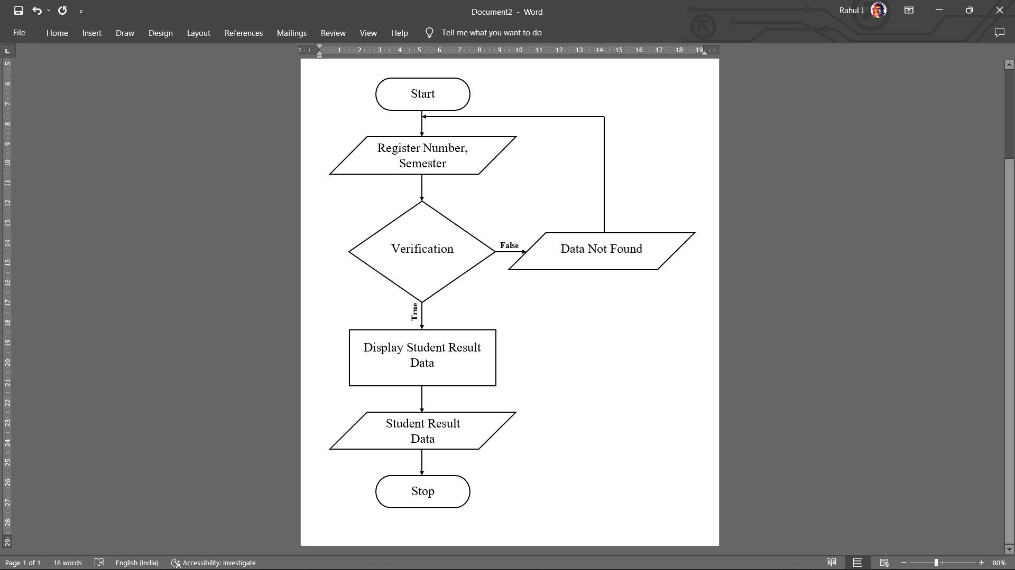

1. File I/O Interface: Graphical user interface for staff to view Student Result details. Custom message based on existence of data will be displayed.
2. Outputs: The Student Result Details will be displayed.
   * 1. Student Module
        1. Login
        2. Inputs: Register Number and Password.
        3. Procedural Details

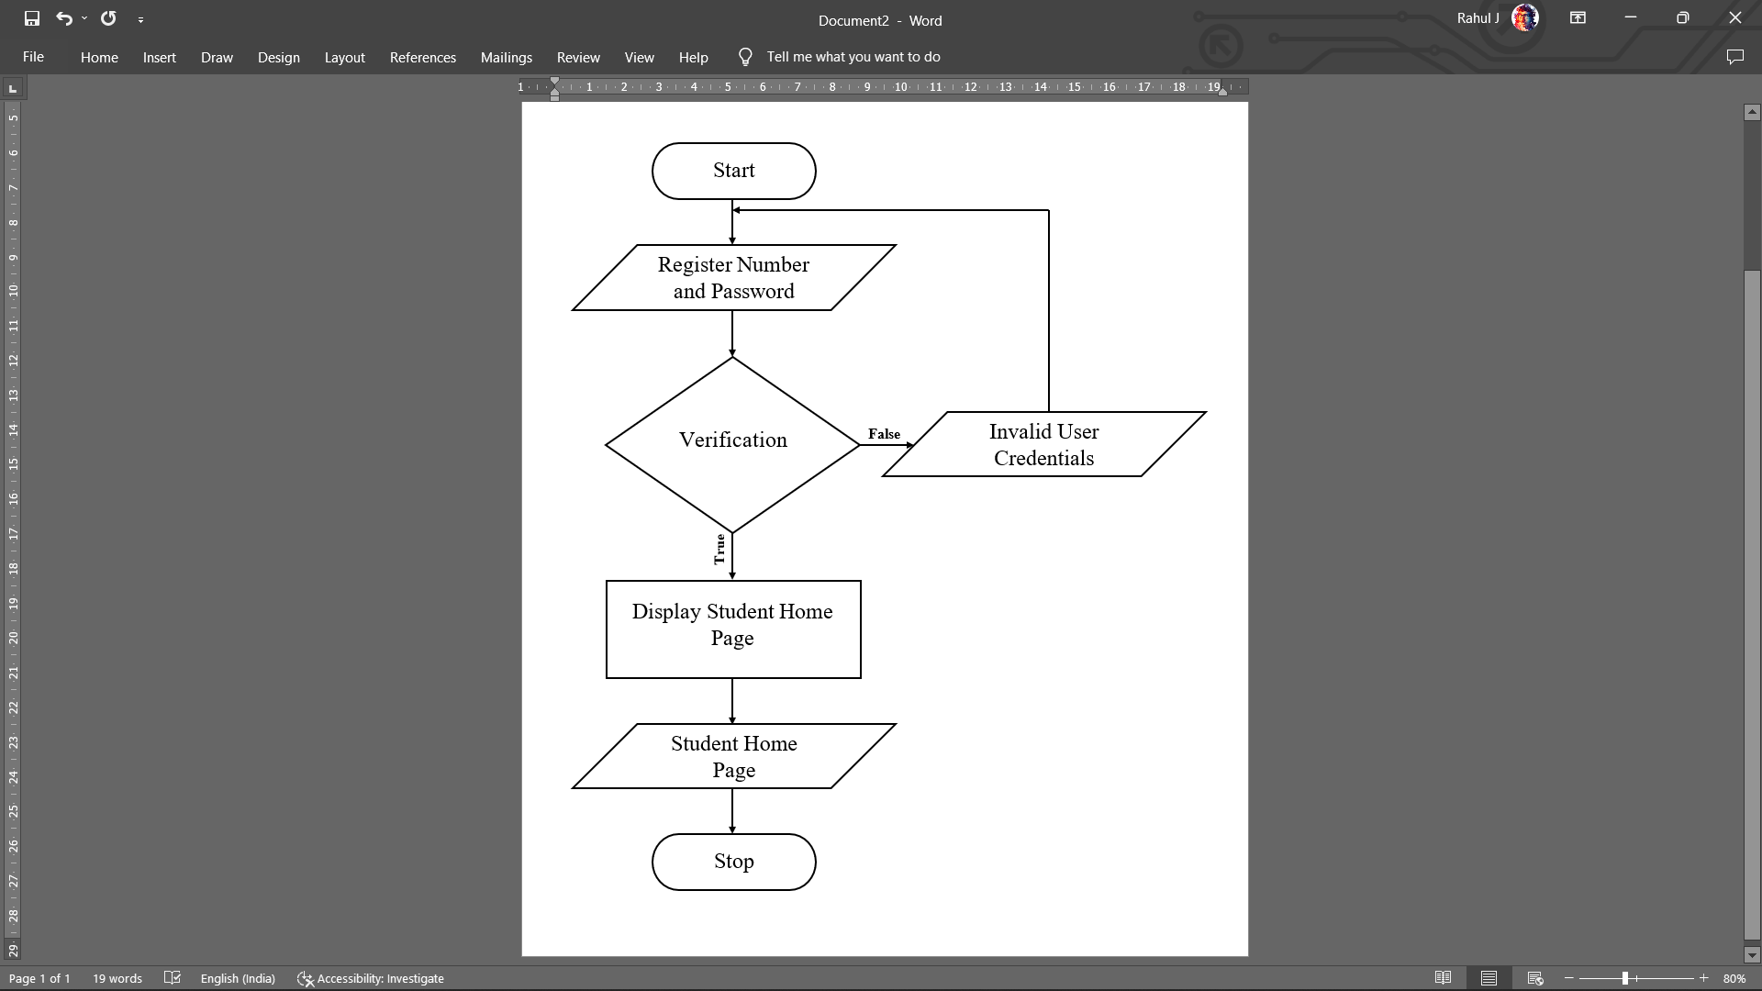

* + - 1. File I/O Interface: Graphical user interface for Student to enter Register Number and Password.
      2. Outputs: If Register Number and Password is correct, student can gain access to student home page.
      3. Implementation Aspects: Once student has gained access to student home page he/she can view examination results and analyze performance.
      4. View Examination Results

1. Inputs: Register Number, Semester.
2. Procedural Details

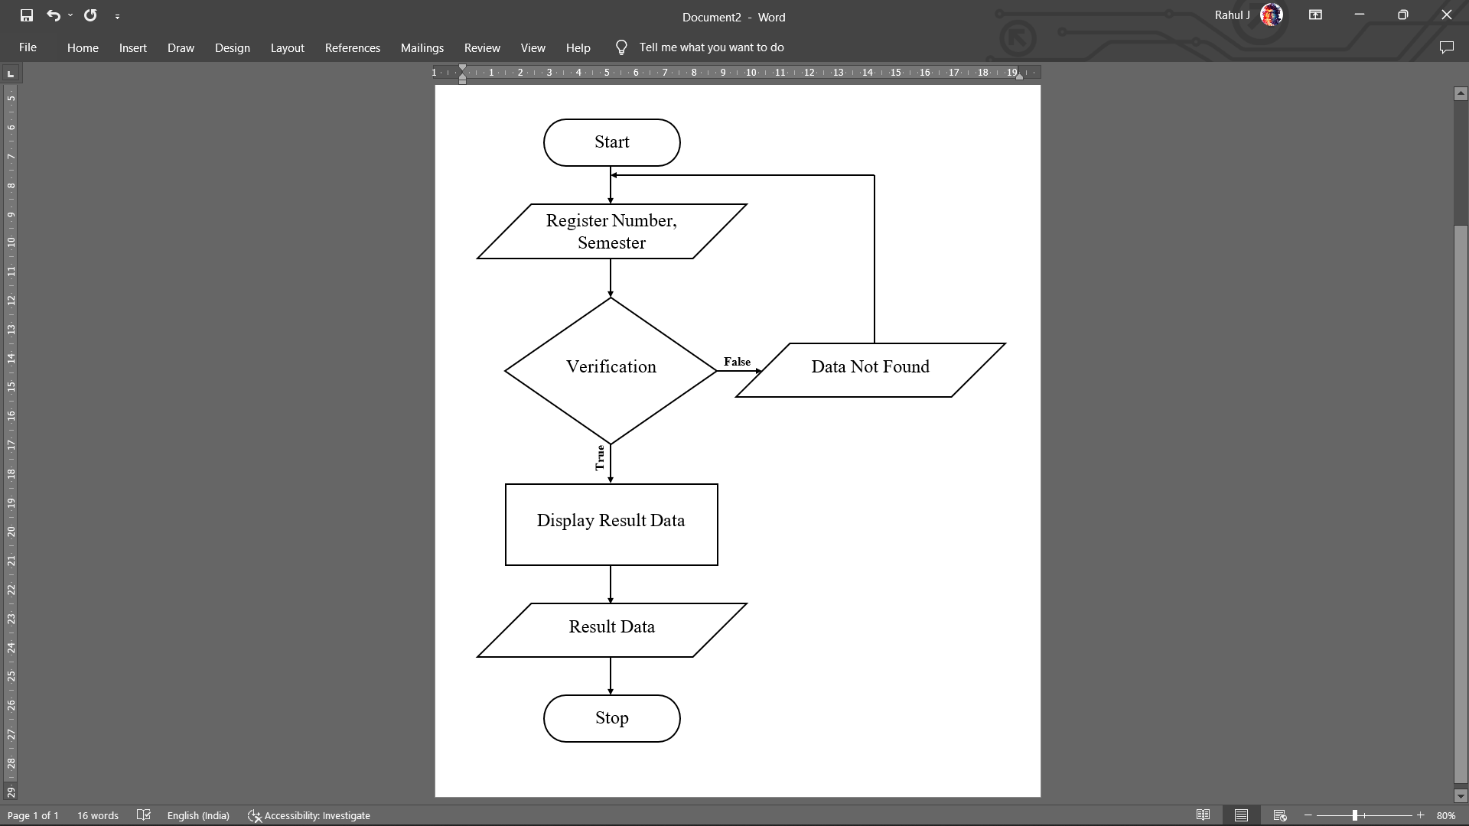

1. File I/O Interface: Graphical user interface for student to view Student Result details. Custom message based on existence of data will be displayed.
2. Outputs: The Student Result Details will be displayed.
   * + 1. Analyze Performance
3. Inputs: Register Number.
4. Procedural Details

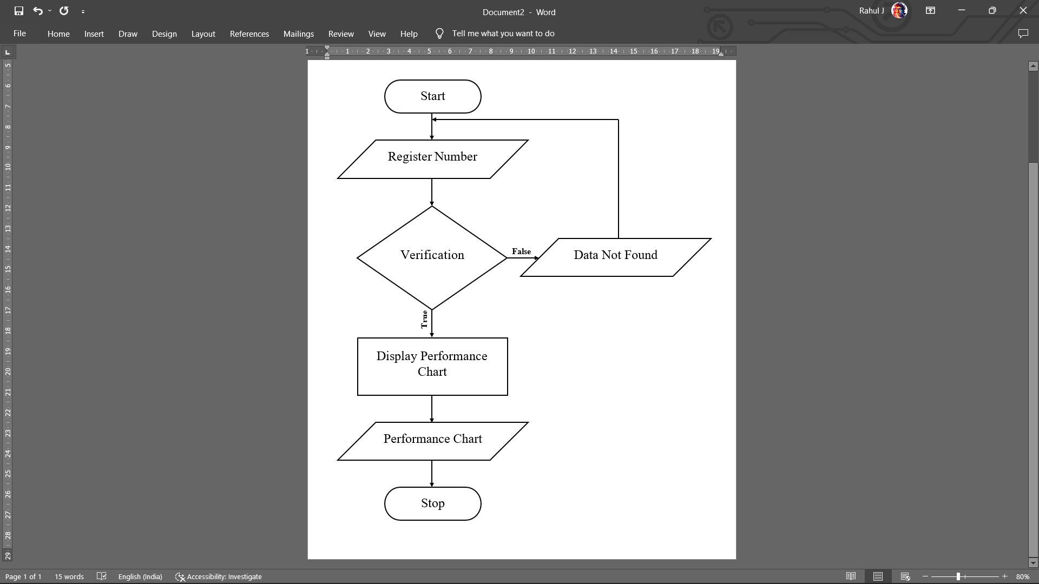

1. File I/O Interface: Graphical user interface for student to view Performance Charts. Custom message based on existence of data will be displayed.
2. Outputs: Performance Charts will be displayed.
3. **Programme Code Listing**
   1. Database Connection

DBConnection.java

package org.CanaraExamManager.util;

import java.sql.Connection;

import java.sql.DriverManager;

import java.sql.SQLException;

public class DBConnection {

public staticConnection createConnection() {

Connection con = null;

String urlString = "jdbc:mysql://localhost:3306/canaradatabase"; //My SQL URL followed by the database name

String userNameString = "root"; //MySQL user name

String passwordString = "Canara@575001"; //MySQL password

try {

try {

Class.forName("com.mysql.cj.jdbc.Driver"); //loadingtheMySQLDriver

} catch (ClassNotFoundException e) {

e.printStackTrace();

}

//Attempting to connect to MySQL database

con=DriverManager.getConnection(urlString,userNameString,passwordString);

} catch (SQLException e) {

e.printStackTrace();

}

return con;

}

}

* 1. Authorization / Authentication

LoginServlet.java

package org.CanaraExamManager.controler;

import jakarta.servlet.ServletException;

import jakarta.servlet.annotation.WebServlet;

import jakarta.servlet.http.HttpServlet;

import jakarta.servlet.http.HttpServletRequest;

import jakarta.servlet.http.HttpServletResponse;

import jakarta.servlet.http.HttpSession;

import java.io.IOException;

import java.sql.Blob;

import org.CanaraExamManager.bean.LoginBean;

import org.CanaraExamManager.dao.LoginDao;

@WebServlet("/LoginServlet")

public class LoginServlet extends HttpServlet {

private static final long serialVersionUID = 1L;

public LoginServlet() // default constructor

{

}

protected void doPost(HttpServletRequest request, HttpServletResponse response) throws ServletException, IOException {

String userNameString = request.getParameter("username");

String passwordString = request.getParameter("password");

String semesterString = "";

String programmeName = "";

String userImageString = "";

Blob userImage = null;

//creating an object for LoginBean class which setter and getter methods

LoginBean loginBean = new LoginBean();

//setting user name and password through the loginBean object which can be used in the future.

loginBean.setUserName(userNameString);

loginBean.setPassword(passwordString);

//creating object for LoginDao which contains the main logic of the application.

LoginDao loginDao = new LoginDao();

HttpSession session = request.getSession();

String loginUser = (String) session.getAttribute("LoginUser");

if(loginUser == "StudentLogin") {

//calling authenticate user method.

String userValidateString = loginDao.authenticateUser(loginBean);

//If the method returns success string then the user will be rooted to his/her page.

if(userValidateString.equals("SUCCESS")) {

session.invalidate();

semesterString = loginBean.getSemester();

programmeName = loginBean.getProgramme();

HttpSession session2 = request.getSession();

session2.setAttribute("student", userNameString);

session2.setAttribute("regNo", userNameString);

session2.setAttribute("studentName", loginBean.getName().trim());

session2.setAttribute("studentPhone", loginBean.getPhone());

session2.setAttribute("studentEmail", loginBean.getEmail());

session2.setAttribute("studentPassword",loginBean.getPassword());

session2.setAttribute("semester", semesterString);

session2.setAttribute("programme", programmeName);

session2.setAttribute("user", "student");

session2.setAttribute("averageFinalMarks", loginDao.averageFinalMarks());

session2.setAttribute("averageFirstInternal", loginDao.averageFirstInternal());

session2.setAttribute("averageSecondInternal", loginDao.averageSecondInternal());

// session2.setAttribute("userImage", userImageString);

response.sendRedirect("studdashboard.jsp");

}else {

request.setAttribute("errMessage",userValidateString);

request.getRequestDispatcher("/studentlogin.jsp").forward(request, response);

}

}

else if(loginUser == "StaffLogin") {

String staffValidateString = loginDao.authenticateStaff(loginBean);

if(staffValidateString.equals("SUCCESS")) {

session.invalidate();

HttpSession session2 = request.getSession();

session2.setAttribute("staff",userNameString);

// session2.setAttribute("StaffName", nameString);

session2.setAttribute("user", "staff");

session2.setAttribute("staffName", loginBean.getName());

session2.setAttribute("staffPhone", loginBean.getPhone());

session2.setAttribute("staffEmail", loginBean.getEmail());

session2.setAttribute("staffPassword",loginBean.getPassword());

response.sendRedirect("staffdashboard.jsp");

}else {

request.setAttribute("errMessage", staffValidateString);

request.getRequestDispatcher("/stafflogin.jsp").forward(request, response);

}

}

else if(loginUser == "AdminLogin") {

String adminValidateString = loginDao.authenticateAdmin(loginBean);

if(adminValidateString.equals("SUCCESS")) {

session.invalidate();

HttpSession session2 = request.getSession();

session2.setAttribute("admin",userNameString );

session2.setAttribute("adminName", loginBean.getName());

session2.setAttribute("adminPhone", loginBean.getPhone());

session2.setAttribute("adminEmail", loginBean.getEmail());

session2.setAttribute("adminPassword",loginBean.getPassword());

session2.setAttribute("user", "admin");

response.sendRedirect("admindashboard.jsp");

}else {

request.setAttribute("errMessage", adminValidateString);

request.getRequestDispatcher("/adminlogin.jsp").forward(request, response);

}

}

}

}

LoginDao.java

package org.CanaraExamManager.dao;

import java.sql.Blob;

import java.sql.Connection;

import org.CanaraExamManager.bean.LoginBean;

import org.CanaraExamManager.bean.StudentStaffDataBean;

import org.CanaraExamManager.util.DBConnection;

import java.sql.Statement;

import java.sql.ResultSet;

import java.sql.SQLException;

public class LoginDao {

float[] marksArray ;

float[] firstInternal;

float[] secondInternal;

public String authenticateUser(LoginBean loginBean) {

//Assign user entered values to temporary variables.

String userNameString = loginBean.getUserName();

String passwordString = loginBean.getPassword();

Connection con = null;

Statement statement = null;

ResultSet resultset = null;

String userNameDBString = "";

String passwordDBString = "";

String statusString = "";

try {

//Fetch database connection object

con = DBConnection.createConnection();

//Statement is used to write queries.

statement = con.createStatement();

resultset = statement.executeQuery(""

+ "select A.reg_no,A.class_id,A.email,A.phone,A.password,A.status,A.semester,A.first_name,A.last_name,A.programme_id,B.programme_id,B.programme_name,C.class_id,C.class_name FROM ((student A "

+ "INNER JOIN programme B ON A.programme_id = B.programme_id) "

+ "INNER JOIN class C ON A.class_id = C.class_id) "

+ "WHERE A.reg_no = "+userNameString+"");

while(resultset.next()) {

userNameDBString = resultset.getString("reg_no");

passwordDBString = resultset.getString("password");

statusString = resultset.getString("status");

statusString.toLowerCase();

String programmeIdString = resultset.getString("programme_id");

String semesterString = resultset.getString("semester");

if(userNameString.equals(userNameDBString) && passwordString.equals(passwordDBString) && statusString.equals("true") ) {

loginBean.setName(resultset.getString("first_name")+" "+resultset.getString("last_name"));

loginBean.setEmail(resultset.getString("email"));

loginBean.setPhone(resultset.getString("phone"));

loginBean.setPassword(resultset.getString("password"));

loginBean.setProgramme(resultset.getString("programme_name"));

loginBean.setSemester(semesterString);

this.marksArray = new float[Integer.parseInt(semesterString)];

this.firstInternal = new float[Integer.parseInt(semesterString)];

this.secondInternal = new float[Integer.parseInt(semesterString)];

for(int i = 1; i <= Integer.parseInt(semesterString) ; i++){

float grandTotalMaxMarks = 0;

float grandTotalMarks = 0;

float grandTotalMaxMarks2 = 0;

float grandTotalMarks2 = 0;

float grandTotalMaxMarks3 = 0;

float grandTotalMarks3 = 0;

ResultSet marksResultSet = null;

marksResultSet = statement.executeQuery("SELECT * FROM (course "

+ "INNER JOIN final_marks ON course.course_code = final_marks.course_code) "

+ "WHERE course.programme_id = "+programmeIdString+" "

+ "AND course.course_sem = "+i+" "

+ "AND final_marks.reg_no = "+userNameDBString+"");

while (marksResultSet.next()) {

grandTotalMaxMarks = grandTotalMaxMarks + (marksResultSet.getFloat("max_marks") + marksResultSet.getFloat("max_IA"));

grandTotalMarks = grandTotalMarks + (marksResultSet.getFloat("total_marks"));

}

float averageMarks = (grandTotalMarks*100)/grandTotalMaxMarks;

if(Float.isNaN(averageMarks)) {

this.marksArray[i-1] = 0;

}else {

this.marksArray[i-1] = averageMarks;

}

ResultSet firstInternalResultSet = null;

firstInternalResultSet = statement.executeQuery("SELECT A.course_code,A.course_sem,A.programme_id,B.course_code,"

+ "B.obtained_marks,B.max_marks,B.reg_no FROM (course A "

+ "INNER JOIN first_internal_marks B ON A.course_code = B.course_code) "

+ "WHERE A.programme_id = "+programmeIdString+" "

+ "AND A.course_sem = "+i+" "

+ "AND B.reg_no = "+userNameDBString+"");

while (firstInternalResultSet.next()) {

grandTotalMaxMarks2 = grandTotalMaxMarks2 + (firstInternalResultSet.getFloat("max_marks"));

grandTotalMarks2 = grandTotalMarks2 + (firstInternalResultSet.getFloat("obtained_marks"));

}

float averageMarks2 = (grandTotalMarks2*100)/grandTotalMaxMarks2;

if(Float.isNaN(averageMarks2)) {

this.firstInternal[i-1] = 0;

}else {

this.firstInternal[i-1] = averageMarks2;

}

ResultSet secondInternalResultSet = null;

secondInternalResultSet = statement.executeQuery("SELECT A.course_code,A.course_sem,A.programme_id,B.course_code,"

+ "B.obtained_marks,B.max_marks,B.reg_no FROM (course A "

+ "INNER JOIN second_internal_marks B ON A.course_code = B.course_code) "

+ "WHERE A.programme_id = "+programmeIdString+" "

+ "AND A.course_sem = "+i+" "

+ "AND B.reg_no = "+userNameDBString+"");

while (secondInternalResultSet.next()) {

grandTotalMaxMarks3 = grandTotalMaxMarks3 + (secondInternalResultSet.getFloat("max_marks"));

grandTotalMarks3 = grandTotalMarks3 + (secondInternalResultSet.getFloat("obtained_marks"));

}

float averageMarks3 = (grandTotalMarks3*100)/grandTotalMaxMarks3;

if(Float.isNaN(averageMarks3)) {

this.secondInternal[i-1] = 0;

}else {

this.secondInternal[i-1] = averageMarks3;

}

}

return "SUCCESS";//Return SUCCESS if the user credentials match the user credentials in the database

}else if(statusString.equals("false")) {

return "Permission Denied!";

}

}

}catch (SQLException e) {

e.printStackTrace();

}

return "Invalid User Credentials";

}

// Method to return averageFinalMarks array

public float[] averageFinalMarks() {

return this.marksArray;

}

public float[] averageFirstInternal() {

return this.firstInternal;

}

public float[] averageSecondInternal() {

return this.secondInternal;

}

public String authenticateStaff(LoginBean loginBean) {

//Assign user entered values to temporary variables.

String userNameString = loginBean.getUserName();

String passwordString = loginBean.getPassword();

Connection con = null;

Statement statement = null;

ResultSet resultset = null;

String userNameDBString = "";

String passwordDBString = "";

String staffStatusString = "";

try {

//Fetch database connection object

con = DBConnection.createConnection();

//Statement is used to write queries.

statement = con.createStatement();

resultset = statement.executeQuery("select staff_id,password,staff_status,first_name,last_name,phone,email from staff");

while(resultset.next()) {

userNameDBString = resultset.getString("staff_id");

passwordDBString = resultset.getString("password");

staffStatusString = resultset.getString("staff_status");

staffStatusString.toLowerCase();

if(userNameString.equals(userNameDBString) && passwordString.equals(passwordDBString) && staffStatusString.equals("true")) {

loginBean.setName(resultset.getString("first_name")+" "+resultset.getString("last_name"));

loginBean.setPhone(resultset.getString("phone"));

loginBean.setEmail(resultset.getString("email"));

loginBean.setPassword(resultset.getString("password"));

return "SUCCESS";//Return SUCCESS if the user credentials match the user credentials in the database

}else if(staffStatusString.equals("false")) {

return "Permission Denied!";

}

}

}catch (SQLException e) {

e.printStackTrace();

}

return "Invalid User Credentials";

}

public String authenticateAdmin(LoginBean loginBean) {

//Assign user entered values to temporary variables.

String userNameString = loginBean.getUserName();

String passwordString = loginBean.getPassword();

Connection con = null;

Statement statement = null;

ResultSet resultset = null;

String userNameDBString = "";

String passwordDBString = "";

try {

//Fetch database connection object

con = DBConnection.createConnection();

//Statement is used to write queries.

statement = con.createStatement();

resultset = statement.executeQuery("select admin_id,first_name,last_name,phone,email,password from admin");

while(resultset.next()) {

userNameDBString = resultset.getString("admin_id");

passwordDBString = resultset.getString("password");

if(userNameString.equals(userNameDBString) && passwordString.equals(passwordDBString) ) {

loginBean.setName(resultset.getString("first_name")+" "+resultset.getString("last_name"));

loginBean.setPhone(resultset.getString("phone"));

loginBean.setEmail(resultset.getString("email"));

loginBean.setPassword(resultset.getString("password"));

return "SUCCESS";//Return SUCCESS if the user credentials match the user credentials in the database

}

}

}catch (SQLException e) {

e.printStackTrace();

}

return "Invalid User Credentials";

}

}

* 1. Data Store / Retrieval / Update

InsertDataServlet.java

package org.CanaraExamManager.controler;

import org.CanaraExamManager.bean.*;

import org.CanaraExamManager.dao.InsertDataDao;

import org.CanaraExamManager.util.EmaiUtility;

import jakarta.servlet.ServletException;

import jakarta.servlet.annotation.WebServlet;

import jakarta.servlet.http.HttpServlet;

import jakarta.servlet.http.HttpServletRequest;

import jakarta.servlet.http.HttpServletResponse;

import java.io.IOException;

import javax.mail.MessagingException;

import javax.mail.internet.AddressException;

@WebServlet("/InsertDataServlet")

public class InsertDataServlet extends HttpServlet {

private static final long serialVersionUID = 1L;

protected void doPost(HttpServletRequest request, HttpServletResponse response) throws ServletException, IOException {

String dataString = request.getParameter("Data");

InsertDataDao insertDataDao = new InsertDataDao();

if(dataString!=null || dataString!="") {

switch (dataString) {

case "student": {

StudentStaffDataBean studentDataBean = new StudentStaffDataBean();

studentDataBean.setfirstName(request.getParameter("sFirstName"));//1

studentDataBean.setLastName(request.getParameter("sLastName"));//2

studentDataBean.setGender(request.getParameter("sGender"));//3

studentDataBean.setDOB(request.getParameter("sdob"));//4

studentDataBean.setEmail(request.getParameter("sEmail"));//5

studentDataBean.setPhone(request.getParameter("sPhone"));//6

studentDataBean.setAddress(request.getParameter("sAddress"));//7

studentDataBean.setPinCode(request.getParameter("sPincode"));//8

studentDataBean.setCity(request.getParameter("sCity"));//9

studentDataBean.setDistrict(request.getParameter("sDistrict"));//10

studentDataBean.setState(request.getParameter("sState"));//11

studentDataBean.setYear(request.getParameter("sYearOfJoining"));//12

studentDataBean.setProgramme(request.getParameter("sProgramme"));//13

studentDataBean.setClass(request.getParameter("sClass"));//14

studentDataBean.setCurrentSemester(request.getParameter("sSemester"));//15

studentDataBean.setRegNo(request.getParameter("sRegNo"));//16

studentDataBean.setPassword(request.getParameter("sPassword"));//17

studentDataBean.setClassYear(request.getParameter("sClassYear"));//18

String dataValidateString = insertDataDao.insertStudentData(studentDataBean) ;

String mailValidateString = "";

if(dataValidateString == "SUCCESS") {

String toAddressString = studentDataBean.getEmail();

String subjectString = "Invitation to join CanaraExamPortal";

String messageString = "<div style=\"background-color:black;color:white;padding:4rem;margin:1rem;\">\r\n"

+ "<div style=\"background-color: black;width: 100%;height: 100%;\"><img src=\"https://lh3.googleusercontent.com/C7R0Hy-Nq-5qll7kg-PO5evyTybIddUipmiHK2QGqsa2eJgpnweY3FXOJBgLrLOTmjibHchSnTHmk9OPL4ql3ajoRPIlPE8rFklPuJsxVNcGBm75haBGc75jH7GXvs3Mmsq_gZXOew=w2400\" style=\"width:100%;height:100%;\"></div>\r\n"

+ "<h3 style=\"color:#e591c3;font-size: 25px;\">Dear "+studentDataBean.getfirstName().trim()+" "+studentDataBean.getLastName().trim()+"</h3><br/>\r\n"

+ "<p style=\"font-size: 20px;font-family:sans-serif\">Welcome to <span style=\"color:skyblue\">CanaraExamPortal</span>, a website created by WEB-CENTRIC for CANARACOLLEGE</p><br/>\r\n"

+ "<p style=\"font-size: 18px;font-family:sans-serif\">The key intent for this initiative is to support students of CANARACOLLEGE to improve their academic performance, \"\r\n"

+ "providing students with a user friendly interface to view semester and internal results. Students can also analyse their\"\r\n"

+ "academic performance through intensive graphical charts and metrics, which will help you to with your academic performance.</p><br/>\r\n"

+ "<p style=\"color:#e591c3;font-size: 27px;text-align: center;font-weight: 800\">2 Easy Steps To Get Started</p>\r\n"

+ "<p style=\"text-align: center;font-size: 16px\">1. Click on the button below to sign in using the following credentials</p>\r\n"

+ "<p style=\"text-align: center;font-size: 20px;\">Username:<span>"+studentDataBean.getRegNo().trim()+"</span></p>\r\n"

+ "<p style=\"text-align: center;font-size: 20px;\">Password:<span>"+studentDataBean.getPassword()+"</span></p><br>\r\n"

+ "<p style=\"text-align: center;font-size: 16px;\">2. Once you're on the platform, you can change your password</p><br>\r\n"

+ "<div style=\"display: flex;justify-content: center;align-items: center;\"><button style=\"color:white;background-color:orangered;font-size:3vh;padding:1rem;font-weight:700;border-radius:8px;\">Get Started</button></div>\r\n"

+ "</div>";

try {

mailValidateString = EmaiUtility.sendEmail(toAddressString,subjectString,messageString);

} catch (AddressException e) {

e.printStackTrace();

} catch (MessagingException e) {

e.printStackTrace();

}

if(mailValidateString == "SUCCESS") {

request.setAttribute("insertionMessage", "SUCCESS" );

request.getRequestDispatcher("messageConfirmer.jsp").forward(request, response);

}else {

request.setAttribute("insertionMessage","Inserted Data successfully" + " but Mail not sent! Please check the Email Id");

request.getRequestDispatcher("messageConfirmer.jsp").forward(request, response);

}

}else {

request.setAttribute("insertionMessage",dataValidateString);

request.getRequestDispatcher("messageConfirmer.jsp").forward(request, response);

}

}case "staff": {

StudentStaffDataBean staffDataBean = new StudentStaffDataBean();

staffDataBean.setfirstName(request.getParameter("firstName"));//1

staffDataBean.setLastName(request.getParameter("lastName"));//2

staffDataBean.setGender(request.getParameter("gender"));//3/

staffDataBean.setEmail(request.getParameter("email"));//4

staffDataBean.setPhone(request.getParameter("phone"));//5

staffDataBean.setAddress(request.getParameter("address"));//6

staffDataBean.setStaffId(request.getParameter("staffId"));//7

staffDataBean.setPassword(request.getParameter("password"));//8

staffDataBean.setProgramme(request.getParameter("programmeId"));//9

staffDataBean.setRole(request.getParameter("staffRole"));

String dataValidateString = insertDataDao.insertStaffData(staffDataBean) ;

request.setAttribute("insertionMessage",dataValidateString);

request.getRequestDispatcher("messageConfirmer.jsp").forward(request, response);

}case "programme": {

ProgrammeCourseClassBean programmeBean = new ProgrammeCourseClassBean();

programmeBean.setProgrammeId(request.getParameter("programmeId").trim());//1

programmeBean.setProgrammeName(request.getParameter("programmeName").trim());//2

programmeBean.setProgrammeDuration(request.getParameter("duration").trim());//3;

programmeBean.setSemester(request.getParameter("totalSemester").trim());//4

String dataValidateString = insertDataDao.insertProgrammeData(programmeBean);

request.setAttribute("insertionMessage",dataValidateString);

request.getRequestDispatcher("messageConfirmer.jsp").forward(request, response);

}case "course": {

ProgrammeCourseClassBean courseDataBean = new ProgrammeCourseClassBean();

courseDataBean.setProgrammeId(request.getParameter("programmeIdInCourse").trim());

courseDataBean.setCourseCode(request.getParameter("courseCode").trim());//2

courseDataBean.setCourseName(request.getParameter("courseName").trim());//3

courseDataBean.setCourseType(request.getParameter("courseType").trim());//4

courseDataBean.setCourseGroup(request.getParameter("courseGroup").trim());//5

courseDataBean.setSemester(request.getParameter("courseSemester").trim());//6

courseDataBean.setMaxMarks(request.getParameter("maxMarks").trim());//7

courseDataBean.setMinMarks(request.getParameter("minMarks").trim());//8

courseDataBean.setMaxIA(request.getParameter("maxIA").trim());//9

String dataValidateString = insertDataDao.insertCourseData(courseDataBean);

request.setAttribute("insertionMessage",dataValidateString);

request.getRequestDispatcher("messageConfirmer.jsp").forward(request, response);

}case "class": {

ProgrammeCourseClassBean classDataBean = new ProgrammeCourseClassBean();

classDataBean.setClassId(request.getParameter("classId").trim());

classDataBean.setClassName(request.getParameter("className").trim());

classDataBean.setProgrammeName(request.getParameter("programmeNameInClass").trim());

classDataBean.setClassYear(request.getParameter("classYear").trim());

String dataValidateString = insertDataDao.insertClassData(classDataBean);

request.setAttribute("insertionMessage",dataValidateString);

request.getRequestDispatcher("messageConfirmer.jsp").forward(request, response);

}case "finalResult": {

int courseCount = Integer.parseInt(request.getParameter("numberOfCourse"));

if(courseCount > 1) {

ResultBean resultBean = new ResultBean();

resultBean.setArraySize(courseCount);

resultBean.setUserName((String)request.getParameter("regNo"));

resultBean.setProgrammeId((String)request.getParameter("programmeId"));

resultBean.setSemester((String)request.getParameter("semester"));

resultBean.setExamMonth((String)request.getParameter("examMonth"));

resultBean.setExamYear(request.getParameter("examYear"));

resultBean.setResultDate(request.getParameter("resultDate"));

for(int i = 1;i<=courseCount;i++) {

resultBean.setObtainedMarks(Integer.parseInt(request.getParameter("obtained"+i)), i-1);

resultBean.setIAMarks(Integer.parseInt(request.getParameter("ia"+i)), i-1);

resultBean.setCredit(Integer.parseInt(request.getParameter("credit"+i)), i-1);

resultBean.setMaxMarks(Integer.parseInt(request.getParameter("maxMarks"+i)), i-1);

resultBean.setMinMarks(Integer.parseInt(request.getParameter("minMarks"+i)), i-1);

resultBean.setCourseCode(request.getParameter("courseCode"+i), i-1);

resultBean.setMaxIA(Integer.parseInt(request.getParameter("maxIA"+i)), i-1);

}

String dataValidateString = insertDataDao.insertFinalMarks(resultBean);

request.setAttribute("insertionMessage",dataValidateString);

request.getRequestDispatcher("messageConfirmer.jsp").forward(request, response);

}

}default:{

response.sendRedirect("home.jsp");

}

}

}

}

}

InsertDataDao.java

package org.CanaraExamManager.dao;

import java.sql.Connection;

import java.sql.PreparedStatement;

import java.sql.ResultSet;

import java.sql.Statement;

import org.CanaraExamManager.bean.ProgrammeCourseClassBean;

import org.CanaraExamManager.bean.ResultBean;

import org.CanaraExamManager.bean.StudentStaffDataBean;

import org.CanaraExamManager.util.DBConnection;

public class InsertDataDao {

// Method for inserting Student Data

public String insertStudentData(StudentStaffDataBean studentDataBean) {

Connection con = null;

String query = "";

PreparedStatement preparedStatement = null;

Statement statement = null;

ResultSet resultSet = null;

String programmeId = "";

String classId = "";

try {

con = DBConnection.createConnection();

statement = con.createStatement();

resultSet = statement.executeQuery("SELECT A.programme_id,B.class_name,B.class_id,B.class_year FROM (programme A "

+ "INNER JOIN class B ON A.programme_id = B.programme_id) "

+ "WHERE A.programme_id = "+studentDataBean.getProgramme().trim()+" "

+ "AND B.class_name = '"+studentDataBean.getclass().trim()+"' "

+ "AND B.class_year = "+studentDataBean.getClassYear().trim()+" ");

while(resultSet.next()) {

programmeId = resultSet.getString("programme_id");

classId = resultSet.getString("class_id");

}

if(programmeId!="" && classId!="") {

resultSet = null;

resultSet = statement.executeQuery("SELECT * FROM student WHERE reg_no = "+studentDataBean.getRegNo()+"");

if(resultSet.next() == false) { //check whether student with that register number already exists

query = "INSERT INTO student(reg_no,first_name,last_name,gender,dob,email,phone,address,"

+ "birth_place,birth_district,birth_state,pincode,password,programme_id,class_id,"

+ "joining_year,semester,status)"

+ "VALUES(?,?,?,?,?,?,?,?,?,?,?,?,?,?,?,?,?,?)";

preparedStatement = con.prepareStatement(query);

preparedStatement.setString(1,studentDataBean.getRegNo().trim());//1

preparedStatement.setString(2,studentDataBean.getfirstName().replaceAll("\\s+"," ").trim());//2

preparedStatement.setString(3,studentDataBean.getLastName().replaceAll("\\s+"," ").trim());//3

preparedStatement.setString(4,studentDataBean.getGender().trim());//4

preparedStatement.setString(5,studentDataBean.getDOB().trim());//5

preparedStatement.setString(6,studentDataBean.getEmail().trim());//6

preparedStatement.setString(7,studentDataBean.getPhone().trim());//7

preparedStatement.setString(8,studentDataBean.getAddress().replaceAll("\\s+"," ").trim());//8

preparedStatement.setString(9,studentDataBean.getCity().replaceAll("\\s+"," ").trim());//9

preparedStatement.setString(10,studentDataBean.getDistrict().replaceAll("\\s+"," ").trim());//10

preparedStatement.setString(11,studentDataBean.getState().replaceAll("\\s+"," ").trim());//11

preparedStatement.setString(12,studentDataBean.getPinCode().trim());//12

preparedStatement.setString(13,studentDataBean.getPassword().replaceAll("\\s+"," ").trim());//13

preparedStatement.setString(14,programmeId.trim());//14

preparedStatement.setString(15,classId.trim());//15

preparedStatement.setString(16,studentDataBean.getYear().trim());//16

preparedStatement.setString(17,studentDataBean.getCurrentSemester().trim());//17

preparedStatement.setString(18,"true");//18

preparedStatement.execute();

}else {

return "Student with the Register Number "+studentDataBean.getRegNo()+" Already Exists";

}

}else {

return "No such Programme/Class Found";

}

} catch (Exception e) {

return e.getLocalizedMessage();

}

return "SUCCESS";

}

// Method for inserting Staff Data

public String insertStaffData(StudentStaffDataBean staffDataBean) {

Connection con = null;

String query = "";

PreparedStatement preparedStatement = null;

Statement statement = null;

ResultSet resultSet = null;

try {

con = DBConnection.createConnection();

statement = con.createStatement();

resultSet = statement.executeQuery("SELECT * FROM staff WHERE staff_id = "+staffDataBean.getStaffId()+"");

if(resultSet.next() == false) {//check whether staff with that staff id already exists

query = "INSERT INTO staff(staff_id,first_name,last_name,gender,email,phone,address,"

+ "password,programme_id,staff_status,role)"

+ "VALUES(?,?,?,?,?,?,?,?,?,?,?)";

preparedStatement = con.prepareStatement(query);

preparedStatement.setString(1, staffDataBean.getStaffId().trim());//1

preparedStatement.setString(2, staffDataBean.getfirstName().replaceAll("\\s+"," ").trim());//2

preparedStatement.setString(3, staffDataBean.getLastName().replaceAll("\\s+"," ").trim());//3

preparedStatement.setString(4, staffDataBean.getGender().trim());//4

preparedStatement.setString(5, staffDataBean.getEmail().trim());//5

preparedStatement.setString(6, staffDataBean.getPhone().trim());//6

preparedStatement.setString(7, staffDataBean.getAddress().replaceAll("\\s+"," ").trim());//7

preparedStatement.setString(8, staffDataBean.getPassword().replaceAll("\\s+"," ").trim());//8

preparedStatement.setString(9, staffDataBean.getProgramme().trim());//9

preparedStatement.setString(10, "true");//10

preparedStatement.setString(11, staffDataBean.getRole().trim());

preparedStatement.execute();

}else {

return "Staff with Staff.ID "+staffDataBean.getStaffId()+" Already Exists";

}

} catch (Exception e) {

return e.getLocalizedMessage();

}

return "SUCCESS";

}

// Method for inserting Programme Data

public String insertProgrammeData(ProgrammeCourseClassBean programmeDataBean) {

Connection con = null;

String query = "";

PreparedStatement preparedStatement = null;

Statement statement = null;

ResultSet resultSet = null;

try {

con = DBConnection.createConnection();

statement = con.createStatement();

resultSet = statement.executeQuery("SELECT * FROM programme WHERE programme_id = "+programmeDataBean.getProgrammeId()+"");

if(resultSet.next() == false) {//check whether programme with that programme id already exists

resultSet = null;

resultSet = statement.executeQuery("SELECT * FROM programme WHERE programme_name = '"+programmeDataBean.getProgrammeName().toUpperCase()+"'");

if(resultSet.next() == false) {

query = "INSERT INTO programme(programme_id,programme_name,programme_duration,programme_sem)"

+"VALUES(?,?,?,?)";

preparedStatement = con.prepareStatement(query);

preparedStatement.setString(1, programmeDataBean.getProgrammeId().trim());//1

preparedStatement.setString(2, (programmeDataBean.getProgrammeName().toUpperCase()).replaceAll("\\s+"," ").trim());

preparedStatement.setString(3, programmeDataBean.getProgrammeDuration().trim());

preparedStatement.setString(4, programmeDataBean.getSemester().trim());

preparedStatement.execute();

}else {

System.out.println(programmeDataBean.getProgrammeName());

return "Programme with Programme Name "+programmeDataBean.getProgrammeName().toUpperCase()+" Already Exists";

}

}else {

return "Programme with Programme.ID "+programmeDataBean.getProgrammeId()+" Already Exists";

}

} catch (Exception e) {

return e.getLocalizedMessage();

}

return "SUCCESS";

}

//Method for inserting Course Data

public String insertCourseData(ProgrammeCourseClassBean courseDataBean) {

Connection con = null;

String query = "";

PreparedStatement preparedStatement = null;

Statement statement = null;

ResultSet resultSet = null;

try {

con = DBConnection.createConnection();

statement = con.createStatement();

resultSet = statement.executeQuery("SELECT * FROM course WHERE course_code = '"+courseDataBean.getCourseCode()+"'");

if(resultSet.next() == false) { //check whether course with that courseCode already exists

String groupNumber = "";

switch(courseDataBean.getCourseGroup().trim()) {

case "Group 1 Core Course":

groupNumber = "1";

break;

case "Group 2 Elective Course":

groupNumber = "2";

break;

case "Group 3 a)Compulsary Foundation":

groupNumber = "3.1";

break;

case "Group 3 b)Elective Foundation":

groupNumber = "3.2";

break;

case "Group 4":

groupNumber = "4";

default:

groupNumber = "0";

}

query = "INSERT INTO course(course_code,course_name,course_type,course_group,course_sem,max_marks,"

+ "min_marks,max_IA,programme_id,course_group_number)"

+ "VALUES(?,?,?,?,?,?,?,?,?,?)";

preparedStatement = con.prepareStatement(query);

preparedStatement.setString(1, (courseDataBean.getCourseCode().toUpperCase()).replaceAll("\\s+"," ").trim());

preparedStatement.setString(2, (courseDataBean.getCourseName().toUpperCase()).replaceAll("\\s+"," ").trim());

preparedStatement.setString(3, courseDataBean.getCourseType().trim());

preparedStatement.setString(4, courseDataBean.getCourseGroup().trim());

preparedStatement.setString(5, courseDataBean.getSemester().trim());

preparedStatement.setString(6, courseDataBean.getMaxMarks().trim());

preparedStatement.setString(7, courseDataBean.getMinMarks().trim());

preparedStatement.setString(8, courseDataBean.getMaxIA().trim());

preparedStatement.setString(9, courseDataBean.getProgrammeId().trim());

preparedStatement.setString(10,groupNumber.trim());

preparedStatement.execute();

}else {

return "Course with the Course Code "+courseDataBean.getCourseCode()+" Already Exists";

}

} catch (Exception e) {

return e.getLocalizedMessage();

}

return "SUCCESS";

}

//Method for inserting class data

public String insertClassData(ProgrammeCourseClassBean classDataBean) {

Connection con = null;

String query = "";

PreparedStatement preparedStatement = null;

Statement statement = null;

ResultSet resultSet = null;

String programmeId = "";

try {

con = DBConnection.createConnection();

statement = con.createStatement();

resultSet = statement.executeQuery("SELECT * FROM programme WHERE programme_name = '"+classDataBean.getProgrammeName().toUpperCase()+"'");

System.out.println(classDataBean.getProgrammeName());

while (resultSet.next()) {

programmeId = resultSet.getString("programme_id");

}

if(programmeId != "") {

resultSet = null;

resultSet = statement.executeQuery("SELECT * FROM class WHERE class_id = "+classDataBean.getClassId()+"");

if(resultSet.next()==false) { //check whether class with that class ID already exists

resultSet = null;

resultSet = statement.executeQuery("SELECT * FROM class WHERE class_name = '"+classDataBean.getClassName().toUpperCase()+"' "

+ "AND class_year = "+classDataBean.getClassYear().trim()+"");

if(resultSet.next()==false) {

query = "INSERT INTO class(class_id,class_name,programme_id,class_year)"

+ "VALUES(?,?,?,?)";

preparedStatement = con.prepareStatement(query);

preparedStatement.setString(1, classDataBean.getClassId().trim());

preparedStatement.setString(2, (classDataBean.getClassName().toUpperCase()).replaceAll("\\s+"," ").trim());

preparedStatement.setString(3, programmeId.trim());

preparedStatement.setString(4, classDataBean.getClassYear().trim());

preparedStatement.execute();

}else {

return "Class "+classDataBean.getClassName()+" "+classDataBean.getClassYear()+" Year Already Exists";

}

}else {

return "Class with the Class.ID "+classDataBean.getClassId()+" Already Exists";

}

}else {

return "No Such Programme Exists";

}

} catch (Exception e) {

return e.getLocalizedMessage();

}

return "SUCCESS";

}

public String insertFinalMarks(ResultBean resultBean) {

Connection con = null;

PreparedStatement statement = null;

PreparedStatement statement2 = null;

Statement stmt = null;

ResultSet resultset = null;

try {

con = DBConnection.createConnection();

stmt = con.createStatement();

resultset = stmt.executeQuery("SELECT * FROM final_marks WHERE reg_no = '"+resultBean.getUserName().trim()+"' AND "

+ "course_code ='"+resultBean.getCourseCode(0)+"'");

if(resultset.next() == false) {

for(int i = 0;i<resultBean.getArraySize();i++) {

statement = null;

String result = "";

String grade = "";

float gradePoint = 0;

float gradePointWeightage = 0;

int obtainedMarks = resultBean.getObtainedMarks(i);

int internalMarks = resultBean.getIAMarks(i);

int maxmarks = resultBean.getMaxMarks(i);

int minMarks = resultBean.getMinMarks(i);

int maxIA = resultBean.getMaxIA(i);

int totalMarks = obtainedMarks + internalMarks;

int totalMax = maxmarks + maxIA;

if(totalMarks < minMarks) {

result = "FAIL";

}else {

result = "PASS";

}

if((totalMarks*100/totalMax) >= 95f && (totalMarks*100/totalMax) <= 100f) {

grade = "OO+";

gradePoint = 10f;

if(totalMax > 50) {

gradePointWeightage = gradePoint * 2;

}else {

gradePointWeightage = gradePoint;

}

}else if((totalMarks*100/totalMax) >= 90f && (totalMarks*100/totalMax) <= 94f) {

grade = "OO";

gradePoint = 9.5f;

if(totalMax > 50) {

gradePointWeightage = gradePoint * 2;

}else {

gradePointWeightage = gradePoint;

}

}else if((totalMarks*100/totalMax) >= 85f && (totalMarks*100/totalMax) <= 89f) {

grade = "OA+";

gradePoint = 9f;

if(totalMax > 50) {

gradePointWeightage = gradePoint * 2;

}else {

gradePointWeightage = gradePoint;

}

}else if((totalMarks*100/totalMax) >= 80f && (totalMarks*100/totalMax) <= 84f) {

grade = "OA";

gradePoint = 8.5f;

if(totalMax > 50) {

gradePointWeightage = gradePoint * 2;

}else {

gradePointWeightage = gradePoint;

}

}else if((totalMarks*100/totalMax) >= 75f && (totalMarks*100/totalMax) <= 79f) {

grade = "AA+";

gradePoint = 8f;

if(totalMax > 50) {

gradePointWeightage = gradePoint * 2;

}else {

gradePointWeightage = gradePoint;

}

}else if((totalMarks*100/totalMax) >= 70f && (totalMarks*100/totalMax) <= 74f) {

grade = "AA";

gradePoint = 7.5f;

if(totalMax > 50) {

gradePointWeightage = gradePoint * 2;

}else {

gradePointWeightage = gradePoint;

}

}else if((totalMarks*100/totalMax) >= 65f && (totalMarks*100/totalMax) <= 69f) {

grade = "AB+";

gradePoint = 7;

if(totalMax > 50) {

gradePointWeightage = gradePoint * 2;

}else {

gradePointWeightage = gradePoint;

}

}else if((totalMarks*100/totalMax) >= 60f && (totalMarks*100/totalMax) <= 64f) {

grade = "AB";

gradePoint = 6.5f;

if(totalMax > 50) {

gradePointWeightage = gradePoint * 2;

}else {

gradePointWeightage = gradePoint;

}

}else if((totalMarks*100/totalMax) >= 55f && (totalMarks*100/totalMax) <= 59f) {

grade = "BB+";

gradePoint = 6f;

if(totalMax > 50) {

gradePointWeightage = gradePoint * 2;

}else {

gradePointWeightage = gradePoint;

}

}else if((totalMarks*100/totalMax) >= 50f && (totalMarks*100/totalMax) <= 54f) {

grade = "BB";

gradePoint = 5.5f;

if(totalMax > 50) {

gradePointWeightage = gradePoint * 2;

}else {

gradePointWeightage = gradePoint;

}

}else if((totalMarks*100/totalMax) >= 45f && (totalMarks*100/totalMax) <= 49f) {

grade = "BC";

gradePoint = 5f;

if(totalMax > 50) {

gradePointWeightage = gradePoint * 2;

}else {

gradePointWeightage = gradePoint;

}

}else if((totalMarks*100/totalMax) >= 40f && (totalMarks*100/totalMax) <= 44f) {

grade = "CC";

gradePoint = 4.5f;

if(totalMax > 50) {

gradePointWeightage = gradePoint * 2;

}else {

gradePointWeightage = gradePoint;

}

}else if((totalMarks*100/totalMax) >= 35f && (totalMarks*100/totalMax) <= 39f) {

grade = "PP";

gradePoint = 4f;

if(totalMax > 50) {

gradePointWeightage = gradePoint * 2;

}else {

gradePointWeightage = gradePoint;

}

}else{

grade = "FF";

gradePoint = 0f;

if(totalMax > 50) {

gradePointWeightage = gradePoint * 2;

}else {

gradePointWeightage = gradePoint;

}

}

statement = con.prepareStatement("INSERT INTO final_marks(reg_no,course_code,programme_id,obtained_marks,IA_marks,total_marks,grade,credit,grade_point,grade_point_weightage,result)"

+ "VALUES('"+resultBean.getUserName().trim()+"','"+resultBean.getCourseCode(i).trim()+"','"+resultBean.getProgrammeId().trim()+"','"+resultBean.getObtainedMarks(i)+"',"

+ "'"+resultBean.getIAMarks(i)+"','"+totalMarks+"','"+grade+"','"+resultBean.getCredit(i)+"','"+gradePoint+"','"+gradePointWeightage+"','"+result+"')");

statement.execute();

}

statement2 = con.prepareStatement("INSERT INTO exam_details(reg_no,semester,exam_type,exam_month,exam_year,result_date)VALUES('"+resultBean.getUserName().trim()+"',"

+ "'"+resultBean.getSemester()+"','Semester','"+resultBean.getExamMonth().trim()+"','"+resultBean.getExamYear().trim()+"','"+resultBean.getResultDate()+"')");

statement2.execute();

}else {

return "Result Data Already Exists !";

}

} catch (Exception e) {

return e.getLocalizedMessage();

}

return "SUCCESS";

}

}

UpdateDataServlet.java

package org.CanaraExamManager.controler;

import jakarta.servlet.ServletException;

import jakarta.servlet.annotation.WebServlet;

import jakarta.servlet.http.HttpServlet;

import jakarta.servlet.http.HttpServletRequest;

import jakarta.servlet.http.HttpServletResponse;

import java.io.IOException;

import org.CanaraExamManager.bean.ProgrammeCourseClassBean;

import org.CanaraExamManager.bean.StudentStaffDataBean;

import org.CanaraExamManager.dao.UpdateDataDao;

@WebServlet("/UpdateDataServlet")

public class UpdateDataServlet extends HttpServlet {

private static final long serialVersionUID = 1L;

protected void doPost(HttpServletRequest request, HttpServletResponse response) throws ServletException, IOException {

String dataString = request.getParameter("Data");

UpdateDataDao updateDataDao = new UpdateDataDao();

if(dataString!=null || dataString!="") {

switch (dataString) {

case "student": {

StudentStaffDataBean studentDataBean = new StudentStaffDataBean();

studentDataBean.setfirstName(request.getParameter("sFirstName"));//1

studentDataBean.setLastName(request.getParameter("sLastName"));//2

studentDataBean.setGender(request.getParameter("sGender"));//3

studentDataBean.setDOB(request.getParameter("sdob"));//4

studentDataBean.setEmail(request.getParameter("sEmail"));//5

studentDataBean.setPhone(request.getParameter("sPhone"));//6

studentDataBean.setAddress(request.getParameter("sAddress"));//7

studentDataBean.setPinCode(request.getParameter("sPincode"));//8

studentDataBean.setCity(request.getParameter("sCity"));//9

studentDataBean.setDistrict(request.getParameter("sDistrict"));//10

studentDataBean.setState(request.getParameter("sState"));//11

studentDataBean.setYear(request.getParameter("sYearOfJoining"));//12

studentDataBean.setProgramme(request.getParameter("sProgramme"));//13

studentDataBean.setClass(request.getParameter("sClass"));//14

studentDataBean.setCurrentSemester(request.getParameter("sSemester"));//15

studentDataBean.setRegNo(request.getParameter("sRegNo"));//16

studentDataBean.setClassYear(request.getParameter("sClassYear"));//17

String dataValidateString = updateDataDao.updateStudentData(studentDataBean) ;

request.setAttribute("updateMessage",dataValidateString);

request.getRequestDispatcher("messageConfirmer.jsp").forward(request, response);

}case "staff": {

StudentStaffDataBean staffDataBean = new StudentStaffDataBean();

staffDataBean.setfirstName(request.getParameter("staffFirstName"));//1

staffDataBean.setLastName(request.getParameter("staffLastName"));//2

staffDataBean.setGender(request.getParameter("staffGender"));//3

staffDataBean.setEmail(request.getParameter("staffEmail"));//5

staffDataBean.setPhone(request.getParameter("StaffPhone"));//6

staffDataBean.setAddress(request.getParameter("staffAddress"));//7

staffDataBean.setProgramme(request.getParameter("staffProgramme"));//9

staffDataBean.setStaffId(request.getParameter("staffId"));//10

staffDataBean.setTemp(request.getParameter("tempStaffId"));//11

staffDataBean.setRole(request.getParameter("staffRole"));//12

String dataValidateString = updateDataDao.updateStaffData(staffDataBean) ;

request.setAttribute("updateMessage",dataValidateString);

request.getRequestDispatcher("messageConfirmer.jsp").forward(request, response);

}case "programme": {

ProgrammeCourseClassBean programmeBean = new ProgrammeCourseClassBean();

programmeBean.setProgrammeId(request.getParameter("programmeId"));//1

programmeBean.setProgrammeName(request.getParameter("programmeName"));//2

programmeBean.setProgrammeDuration(request.getParameter("duration"));//3;

programmeBean.setSemester(request.getParameter("totalSemester"));//4

String dataValidateString = updateDataDao.updateProgrammeData(programmeBean);

request.setAttribute("updateMessage",dataValidateString);

request.getRequestDispatcher("messageConfirmer.jsp").forward(request, response);

}case "course": {

ProgrammeCourseClassBean courseDataBean = new ProgrammeCourseClassBean();

courseDataBean.setCourseCode(request.getParameter("uniqueId"));//2

courseDataBean.setCourseName(request.getParameter("courseName"));//3

courseDataBean.setCourseType(request.getParameter("courseType"));//4

courseDataBean.setCourseGroup(request.getParameter("courseGroup"));//5

courseDataBean.setSemester(request.getParameter("courseSem"));//6

courseDataBean.setMaxMarks(request.getParameter("courseMaxMarks"));//7

courseDataBean.setMinMarks(request.getParameter("courseMinMarks"));//8

courseDataBean.setMaxIA(request.getParameter("courseMaxIA"));//9

courseDataBean.setTemp(request.getParameter("tempCode"));

String dataValidateString = updateDataDao.updateCourseData(courseDataBean);

request.setAttribute("updateMessage",dataValidateString);

request.getRequestDispatcher("messageConfirmer.jsp").forward(request, response);

}case "class": {

ProgrammeCourseClassBean classDataBean = new ProgrammeCourseClassBean();

classDataBean.setClassId(request.getParameter("classId"));

classDataBean.setClassName(request.getParameter("className"));

classDataBean.setProgrammeName(request.getParameter("progNameInClass"));

classDataBean.setClassYear(request.getParameter("classYear"));

String dataValidateString = updateDataDao.updateClassData(classDataBean);

request.setAttribute("updateMessage",dataValidateString);

request.getRequestDispatcher("messageConfirmer.jsp").forward(request, response);

}default:{

response.sendRedirect("home.jsp");

}

}

}

}

}

UpdateDataDao.java

package org.CanaraExamManager.dao;

import java.sql.Connection;

import java.sql.PreparedStatement;

import java.sql.ResultSet;

import java.sql.Statement;

import org.CanaraExamManager.bean.ProgrammeCourseClassBean;

import org.CanaraExamManager.bean.StudentStaffDataBean;

import org.CanaraExamManager.util.DBConnection;

public class UpdateDataDao {

public String updateStudentData(StudentStaffDataBean studentDataBean) {

Connection con = null;

String query = "";

PreparedStatement preparedStatement = null;

Statement statement = null;

ResultSet resultSet = null;

String programmeId = "";

String classId = "";

try {

con = DBConnection.createConnection();

statement = con.createStatement();

con = DBConnection.createConnection();

statement = con.createStatement();

resultSet = statement.executeQuery("SELECT A.programme_id,B.class_name,B.class_id,B.class_year FROM (programme A "

+ "INNER JOIN class B ON A.programme_id = B.programme_id) "

+ "WHERE A.programme_id = "+studentDataBean.getProgramme().trim()+" "

+ "AND B.class_name = '"+studentDataBean.getclass().trim()+"' "

+ "AND B.class_year = "+studentDataBean.getClassYear().trim()+" ");

while(resultSet.next()) {

programmeId = resultSet.getString("programme_id").trim();

classId = resultSet.getString("class_id").trim();

}

if(programmeId!="" && classId!="") {

resultSet = null;

resultSet = statement.executeQuery("SELECT * FROM student WHERE reg_no = "+studentDataBean.getRegNo()+"");

if(resultSet.next() == true) { //check whether student with that register number already exists

query = "UPDATE student SET reg_no = ?, first_name = ?, last_name = ?, gender = ?, dob = ?,email = ?,"

+ "phone = ?, address = ?,birth_place = ?,birth_district = ?,birth_state = ?,"

+ "pincode = ?, programme_id = ?, class_id = ?, joining_year = ?, semester = ?, status = ? "

+ "WHERE reg_no = "+studentDataBean.getRegNo().trim()+"";

preparedStatement = con.prepareStatement(query);

preparedStatement.setString(1,studentDataBean.getRegNo().trim());//1

preparedStatement.setString(2,studentDataBean.getfirstName().replaceAll("\\s+"," ").trim());//2

preparedStatement.setString(3,studentDataBean.getLastName().replaceAll("\\s+"," ").trim());//3

preparedStatement.setString(4,studentDataBean.getGender().trim());//4

preparedStatement.setString(5,studentDataBean.getDOB());//5

preparedStatement.setString(6,studentDataBean.getEmail().trim());//6

preparedStatement.setString(7,studentDataBean.getPhone().trim());//7

preparedStatement.setString(8,studentDataBean.getAddress().replaceAll("\\s+"," ").trim());//8

preparedStatement.setString(9,studentDataBean.getCity().replaceAll("\\s+"," ").trim());//9

preparedStatement.setString(10,studentDataBean.getDistrict().replaceAll("\\s+"," ").trim());//10

preparedStatement.setString(11,studentDataBean.getState().replaceAll("\\s+"," ").trim());//11

preparedStatement.setString(12,studentDataBean.getPinCode().trim());//12

preparedStatement.setString(13,programmeId);//13

preparedStatement.setString(14,classId);//14

preparedStatement.setString(15,studentDataBean.getYear().trim());//15

preparedStatement.setString(16,studentDataBean.getCurrentSemester().trim());//16

preparedStatement.setString(17,"true");//17

preparedStatement.execute();

}else {

return "Student with the Register Number "+studentDataBean.getRegNo()+" Does Not Exists";

}

}else {

return "No such Programme/Class Found";

}

} catch (Exception e) {

return e.getLocalizedMessage();

}

return "SUCCESSUPDATE";

}

// Method for updating Staff Data

public String updateStaffData(StudentStaffDataBean staffDataBean) {

Connection con = null;

String query = "";

PreparedStatement preparedStatement = null;

try {

con = DBConnection.createConnection();

query = "UPDATE staff SET first_name = ?, last_name = ?, gender = ?, email = ?,"

+ "phone = ?, address = ?, programme_id = ?, staff_status = ?, staff_id = ?, role = ? "

+ "WHERE staff_id = "+staffDataBean.getTemp().trim()+"";

preparedStatement = con.prepareStatement(query);

preparedStatement.setString(1, staffDataBean.getfirstName().trim());//1

preparedStatement.setString(2, staffDataBean.getLastName().trim());//2

preparedStatement.setString(3, staffDataBean.getGender().trim());//3

preparedStatement.setString(4, staffDataBean.getEmail().trim());//4

preparedStatement.setString(5, staffDataBean.getPhone().trim());//5

preparedStatement.setString(6, staffDataBean.getAddress().replaceAll("\\s+"," ").trim());//6

preparedStatement.setString(7, staffDataBean.getProgramme().trim());//7

preparedStatement.setString(8, "true");//8

preparedStatement.setString(9, staffDataBean.getStaffId().trim());//9

preparedStatement.setString(10, staffDataBean.getRole().trim());

preparedStatement.execute();

} catch (Exception e) {

return e.getLocalizedMessage();

}

return "SUCCESSUPDATE";

}

// Method for updating Programme Data

public String updateProgrammeData(ProgrammeCourseClassBean programmeDataBean) {

Connection con = null;

String query = "";

PreparedStatement preparedStatement = null;

try {

con = DBConnection.createConnection();

query = "UPDATE programme SET programme_name = ?, programme_duration = ?, programme_sem = ? "

+ "WHERE programme_id = "+programmeDataBean.getProgrammeId().trim()+"";

preparedStatement = con.prepareStatement(query);

preparedStatement.setString(1, (programmeDataBean.getProgrammeName().toUpperCase()).replaceAll("\\s+"," ").trim());//1

preparedStatement.setString(2, programmeDataBean.getProgrammeDuration().trim());//2

preparedStatement.setString(3, programmeDataBean.getSemester().trim());//3

preparedStatement.execute();

} catch (Exception e) {

return e.getLocalizedMessage();

}

return "SUCCESSUPDATE";

}

//Method for updating Course Data

public String updateCourseData(ProgrammeCourseClassBean courseDataBean) {

Connection con = null;

String query = "";

PreparedStatement preparedStatement = null;

Statement statement = null;

ResultSet resultSet = null;

try {

con = DBConnection.createConnection();

query = "UPDATE course SET course_code = ?,course_name = ?,course_type = ?,course_group = ?,course_sem = ?,max_marks = ?, "

+ "min_marks = ?, max_IA = ? WHERE course_code = '"+courseDataBean.getTemp().replaceAll("\\s+"," ").trim()+"'";

preparedStatement = con.prepareStatement(query);

preparedStatement.setString(1, (courseDataBean.getCourseCode().toUpperCase()).replaceAll("\\s+"," ").trim());

preparedStatement.setString(2, (courseDataBean.getCourseName().toUpperCase()).replaceAll("\\s+"," ").trim());

preparedStatement.setString(3, courseDataBean.getCourseType().trim());

preparedStatement.setString(4, courseDataBean.getCourseGroup().trim());

preparedStatement.setString(5, courseDataBean.getSemester().trim());

preparedStatement.setString(6, courseDataBean.getMaxMarks().trim());

preparedStatement.setString(7, courseDataBean.getMinMarks().trim());

preparedStatement.setString(8, courseDataBean.getMaxIA().trim());

preparedStatement.execute();

} catch (Exception e) {

return e.getLocalizedMessage();

}

return "SUCCESS";

}

//Method for updating class data

public String updateClassData(ProgrammeCourseClassBean classDataBean) {

Connection con = null;

String query = "";

PreparedStatement preparedStatement = null;

Statement statement = null;

ResultSet resultSet = null;

String programmeId = "";

try {

con = DBConnection.createConnection();

statement = con.createStatement();

resultSet = statement.executeQuery("SELECT * FROM programme WHERE programme_name = '"+(classDataBean.getProgrammeName().toUpperCase()).trim()+"'");

while (resultSet.next()) {

programmeId = resultSet.getString("programme_id").trim();

}

if(programmeId != "") {

resultSet = null;

resultSet = statement.executeQuery("SELECT * FROM class WHERE class_name = '"+classDataBean.getClassName().toUpperCase()+"' "

+ "AND class_year = "+classDataBean.getClassYear()+"");

if(resultSet.next()==false) {

query = "UPDATE class SET class_name = ?, programme_id = ?, class_year = ? WHERE class_id = "+classDataBean.getClassId().trim()+"";

preparedStatement = con.prepareStatement(query);

preparedStatement.setString(1, (classDataBean.getClassName().toUpperCase()).trim());

preparedStatement.setString(2, programmeId);

preparedStatement.setString(3, classDataBean.getClassYear().trim());

preparedStatement.execute();

}else {

return "Class "+classDataBean.getClassName()+" "+classDataBean.getClassYear()+" Year Already Exists";

}

}else {

return "Programme '"+(classDataBean.getProgrammeName().toUpperCase()).trim()+"' 'Programme ID: "+programmeId+"' Already Exists";

}

} catch (Exception e) {

return e.getLocalizedMessage();

}

return "SUCCESSUPDATE";

}

}

UpdateDataDao.java

package org.CanaraExamManager.dao;

import org.CanaraExamManager.util.DBConnection;

import java.sql.Connection;

import java.sql.ResultSet;

import java.sql.SQLException;

import java.sql.Statement;

public class LoadDataDao {

public ResultSet loadProgrammeData() {

Connection con = null;

Statement statement = null;

ResultSet resultSet = null;

try {

con = DBConnection.createConnection();

statement = con.createStatement();

resultSet = statement.executeQuery("SELECT * FROM programme ORDER BY programme_name ASC");

} catch (SQLException e) {

e.printStackTrace();

}

return resultSet;

}

public ResultSet loadStudentData() {

ResultSet resultSet = null;

try {

Connection con = DBConnection.createConnection();;

Statement statement = con.createStatement();

resultSet = statement.executeQuery(""

+"SELECT * FROM ((student "

+"INNER JOIN programme ON student.programme_id = programme.programme_id)"

+"INNER JOIN class ON student.class_id = class.class_id)"

+"ORDER BY programme.programme_name ASC, class.class_year ASC, class.class_name ASC");

} catch (SQLException e) {

e.printStackTrace();

}

return resultSet;

}

public ResultSet loadStaffData() {

ResultSet resultSet = null;

try {

Connection con = DBConnection.createConnection();;

Statement statement = con.createStatement();

resultSet = statement.executeQuery(""

+"SELECT * FROM (staff "

+"INNER JOIN programme ON staff.programme_id = programme.programme_id)"

+"ORDER BY programme.programme_name ASC");

}catch(SQLException e) {

e.printStackTrace();

}

return resultSet;

}

public ResultSet loadCoursedata(ResultSet programmeResultSet,int i) {

ResultSet resultSet = null;

try {

Connection con = DBConnection.createConnection();;

Statement statement = con.createStatement();

resultSet = statement.executeQuery(""

+"SELECT * FROM course where course_sem = "+Integer.toString(i)+" "

+"AND programme_id = "+programmeResultSet.getString("programme_id")+"");

} catch (SQLException e) {

e.printStackTrace();

}

return resultSet;

}

public ResultSet loadOnlyClassData() {

ResultSet resultSet = null;

try {

Connection con = DBConnection.createConnection();;

Statement statement = con.createStatement();

resultSet = statement.executeQuery(""

+"SELECT * FROM (class "

+"INNER JOIN programme ON class.programme_id = programme.programme_id)"

+"ORDER BY programme.programme_name ASC");

} catch (SQLException e) {

e.printStackTrace();

}

return resultSet;

}

public ResultSet loadResulData() {

ResultSet resultSet = null;

try {

Connection con = DBConnection.createConnection();;

Statement statement = con.createStatement();

resultSet = statement.executeQuery(""

+"SELECT * FROM ((student "

+"INNER JOIN programme ON student.programme_id = programme.programme_id) "

+"INNER JOIN class ON student.class_id = class.class_id)"

+"ORDER BY programme.programme_name ASC, class.class_year ASC, class.class_name ASC");

} catch (SQLException e) {

e.printStackTrace();

}

return resultSet;

}

}

DeleteDataServlet.java

package org.CanaraExamManager.controler;

import jakarta.servlet.ServletException;

import jakarta.servlet.annotation.WebServlet;

import jakarta.servlet.http.HttpServlet;

import jakarta.servlet.http.HttpServletRequest;

import jakarta.servlet.http.HttpServletResponse;

import java.io.IOException;

import org.CanaraExamManager.bean.ProgrammeCourseClassBean;

import org.CanaraExamManager.bean.StudentStaffDataBean;

import org.CanaraExamManager.dao.DeleteDataDao;

@WebServlet("/DeleteDataServlet")

public class DeleteDataServlet extends HttpServlet {

private static final long serialVersionUID = 1L;

protected void doPost(HttpServletRequest request, HttpServletResponse response) throws ServletException, IOException {

String dataString = request.getParameter("Data");

DeleteDataDao deleteDataDao = new DeleteDataDao();

if(dataString!=null || dataString!="") {

switch (dataString) {

case "student":{

StudentStaffDataBean studentDataBean = new StudentStaffDataBean();

studentDataBean.setRegNo(request.getParameter("uniqueId"));

String dataValidateString = deleteDataDao.deleteStudentData(studentDataBean) ;

request.setAttribute("deletionMessage",dataValidateString);

request.getRequestDispatcher("messageConfirmer.jsp").forward(request, response);

}case "staff":{

StudentStaffDataBean staffDataBean = new StudentStaffDataBean();

staffDataBean.setStaffId(request.getParameter("uniqueId"));

String dataValidateString = deleteDataDao.deleteStaffData(staffDataBean);

request.setAttribute("deletionMessage", dataValidateString);

request.getRequestDispatcher("messageConfirmer.jsp").forward(request, response);

}case "programme":{

ProgrammeCourseClassBean programmeDataBean = new ProgrammeCourseClassBean();

programmeDataBean.setProgrammeId(request.getParameter("uniqueId"));

String dataValidateString = deleteDataDao.deleteProgrammeData(programmeDataBean) ;

request.setAttribute("deletionMessage",dataValidateString);

request.getRequestDispatcher("messageConfirmer.jsp").forward(request, response);

}case "course":{

ProgrammeCourseClassBean courseDataBean = new ProgrammeCourseClassBean();

courseDataBean.setCourseCode(request.getParameter("uniqueId"));

courseDataBean.setCourseName(request.getParameter("courseName"));

String dataValidateString = deleteDataDao.deleteCourseData(courseDataBean) ;

request.setAttribute("deletionMessage",dataValidateString);

request.getRequestDispatcher("messageConfirmer.jsp").forward(request, response);

}case "class":{

ProgrammeCourseClassBean classDataBean = new ProgrammeCourseClassBean();

classDataBean.setClassId(request.getParameter("uniqueId"));

String dataValidateString = deleteDataDao.deleteClassData(classDataBean) ;

request.setAttribute("deletionMessage",dataValidateString);

request.getRequestDispatcher("messageConfirmer.jsp").forward(request, response);

}default:{

response.sendRedirect("home.jsp");

}

}

}

}

}

DeleteDataDao.java

package org.CanaraExamManager.dao;

import java.sql.Connection;

import java.sql.PreparedStatement;

import java.sql.SQLException;

import org.CanaraExamManager.bean.ProgrammeCourseClassBean;

import org.CanaraExamManager.bean.StudentStaffDataBean;

import org.CanaraExamManager.util.DBConnection;

public class DeleteDataDao {

public String deleteStudentData(StudentStaffDataBean studentDataBean) {

Connection con = null;

String query = "";

PreparedStatement preparedStatement = null;

try {

query = "DELETE FROM student WHERE reg_no ="+studentDataBean.getRegNo().trim()+"";

con = DBConnection.createConnection();

preparedStatement = con.prepareStatement(query);

preparedStatement.execute();

} catch (SQLException e) {

return e.getLocalizedMessage();

}

return "DELETESUCCESS";

}

public String deleteStaffData(StudentStaffDataBean staffDataBean) {

Connection con = null;

String query = "";

PreparedStatement preparedStatement = null;

try {

query = "DELETE FROM staff WHERE staff_id ="+staffDataBean.getStaffId().trim()+"";

con = DBConnection.createConnection();

preparedStatement = con.prepareStatement(query);

preparedStatement.execute();

} catch (SQLException e) {

return e.getLocalizedMessage();

}

return "DELETESUCCESS";

}

public String deleteProgrammeData(ProgrammeCourseClassBean programmeDataBean) {

Connection con = null;

String query = "";

PreparedStatement preparedStatement = null;

try {

query = "DELETE FROM programme WHERE programme_id = "+programmeDataBean.getProgrammeId().trim()+" ";

con = DBConnection.createConnection();

preparedStatement = con.prepareStatement(query);

preparedStatement.execute();

} catch (SQLException e) {

return "Unbale to Delete Programme '"+"Programme ID: "+programmeDataBean.getProgrammeId().trim()+"' because it contains Classes";

}

return "DELETESUCCESS";

}

public String deleteCourseData(ProgrammeCourseClassBean courseDataBean) {

Connection con = null;

String query = "";

PreparedStatement preparedStatement = null;

try {

query = "DELETE FROM course WHERE course_code ='"+courseDataBean.getCourseCode()+"' "

+"AND course_name = '"+courseDataBean.getCourseName()+"'";

con = DBConnection.createConnection();

preparedStatement = con.prepareStatement(query);

preparedStatement.execute();

} catch (SQLException e) {

return "Unable to Delete Course "+courseDataBean.getCourseName().trim()+" 'Course Code: "+courseDataBean.getCourseCode().trim()+"' Because it contains Result Data";

}

return "DELETESUCCESS";

}

public String deleteClassData(ProgrammeCourseClassBean classBean) {

Connection con = null;

String query = "";

PreparedStatement preparedStatement = null;

try {

query = "DELETE FROM class WHERE class_id ="+classBean.getClassId().trim()+"";

con = DBConnection.createConnection();

preparedStatement = con.prepareStatement(query);

preparedStatement.execute();

} catch (SQLException e) {

return "Unbale to Delete Class '"+"Class ID: "+classBean.getClassId().trim()+"' because it contains Students";

}

return "DELETESUCCESS";

}

public String deleteFinalResultData() {

Connection con = null;

String query = "";

PreparedStatement preparedStatement = null;

try {

query = "DELETE FROM final_marks WHERE reg_no = ";

con = DBConnection.createConnection();

preparedStatement = con.prepareStatement(query);

preparedStatement.execute();

} catch (SQLException e) {

return e.getLocalizedMessage();

}

return "DELETESUCCESS";

}

public String deletefirstInternalData() {

Connection con = null;

String query = "";

PreparedStatement preparedStatement = null;

try {

query = "DELETE FROM first_internal_marks WHERE reg_no = ";

con = DBConnection.createConnection();

preparedStatement = con.prepareStatement(query);

preparedStatement.execute();

} catch (SQLException e) {

return e.getLocalizedMessage();

}

return "DELETESUCCESS";

}

public String deleteSecondInternalData() {

Connection con = null;

String query = "";

PreparedStatement preparedStatement = null;

try {

query = "DELETE FROM second_internal_marks WHERE reg_no = ";

con = DBConnection.createConnection();

preparedStatement = con.prepareStatement(query);

preparedStatement.execute();

} catch (SQLException e) {

return e.getLocalizedMessage();

}

return "DELETESUCCESS";

}

}

* 1. Data Validations

AdminDashBoard.jsp

ClientSideValidations:

<script type="text/javascript">

//add student form validation

const addStudentForm = document.getElementById("insertStudentDataForm");

const sFirstName = document.getElementById("studentFirstName");

const sLastName = document.getElementById("studentLastName");

const sPhone = document.getElementById("studentPhone");

const sDob = document.getElementById("studentDob");

const sEmail = document.getElementById("studentEmail");

const sAddress = document.getElementById("studentAddress");

const sCity = document.getElementById("studentCity");

const sPincode = document.getElementById("studentPincode");

const sDistrict = document.getElementById("studentDistrict");

const sState = document.getElementById("studentState");

const sYof = document.getElementById("studentYof");

const sRegNo = document.getElementById("studentRegNo");

const sPassword = document.getElementById("studentPassword");

addStudentForm.addEventListener('submit', (e)=> {

var onlyCharacters = /^[A-za-z]*$/;

var onlyDigits = /^\d+$/;

var startingCaps = /^[A-Z]\w*/;

var namePattern = /^[A-Z][a-z]*$/;

var validMinDate = new Date();

var dd = String(validMinDate.getDate()).padStart(2, '0');

var mm = String(validMinDate.getMonth() + 1).padStart(2, '0'); //January is 0!

var yyyy = validMinDate.getFullYear() -17;

validMinDate = yyyy + '-' + mm + '-' + dd;

var validMaxDate = new Date();

var dd2 = String(validMaxDate.getDate()).padStart(2, '0');

var mm2 = String(validMaxDate.getMonth() + 1).padStart(2, '0'); //January is 0!

var yyyy2 = validMaxDate.getFullYear() -35;

validMaxDate = yyyy2 + '-' + mm2 + '-' + dd2;

var validMaxYear = new Date();

var yyyy3 = validMaxYear.getFullYear();

validMaxYear = yyyy3;

var email = /^\w+([\.-]?\w+)*@\w+([\.-]?\w+)*(\.\w{2,3})+$/;

var mobileNumber = /^[6-9]\d+/;

var city = /^[A-Z]{1}[a-z]+([ ]{1}[A-Z]{1}[a-z]+)?([-]{1}[A-Z]{1}[a-z]+)?([ ]{1}[A-Z]*[a-z]+)*?[a-z]$/;

var pincode = /^[1-9]{1}[0-9]{2}[0-9]{3}$/;

var address = /^[A-Z0-9]{1}[A-Za-z0-9 \'\.\-\,\;\:\#]*[A-Za-z0-9\.]$/;

var districtState = /^[A-Za-z]*([ ]{1}[A-Z]{1}[a-z]+)*?[a-z]$/;

var yearOfBirth = parseInt(/^\d{4}/.exec(sDob.value));

var password = /^(?=.*[a-z])(?=.*[A-Z])(?=.*\d)(?=.*[@$!%*?&])[A-Za-z\d@$!%*?&]*$/;

if(onlyCharacters.test(sFirstName.value) == false){//First Name

swal("Invalid First Name !","First Name can only contain Alphabets","error");

e.preventDefault();

}else if(sFirstName.value.length < 2){

swal("Invalid First Name !","First Name should have at least 2 Characters","error");

e.preventDefault();

}else if(sFirstName.value.length > 15){

swal("Invalid First Name !","First Name cannot be more than 15 Characters","error");

e.preventDefault();

}else if(startingCaps.test(sFirstName.value) == false){

swal("Invalid First Name !","Starting Alphabet of the First Name should be Capitalized","error");

e.preventDefault();

}else if(namePattern.test(sFirstName.value) == false){

swal("Invalid First Name !","Only Starting Alphabet of the First Name should be Capitalized","error");

e.preventDefault();

}else if(onlyCharacters.test(sLastName.value) == false){//Last Name

swal("Invalid Last Name !","Last Name can only contain Alphabets","error");

e.preventDefault();

}else if(sLastName.value.length > 15){

swal("Invalid First Name !","First Name cannot be more than 15 Characters","error");

e.preventDefault();

}else if(startingCaps.test(sLastName.value) == false){

swal("Invalid Last Name !","Starting Alphabet of the Last Name should be Capitalized","error");

e.preventDefault();

}else if(namePattern.test(sLastName.value) == false){

swal("Invalid Last Name !","Only Starting Alphabet of the Last Name should be Capitalized","error");

e.preventDefault();

}else if((sDob.value) > validMinDate){//DOB

swal("Invalid Date of Birth !","Age must be greater than 17 years","error");

e.preventDefault();

}else if((sDob.value) < validMaxDate){

swal("Invalid Date of Birth !","Age must be less than 35 years","error");

e.preventDefault();

}else if(email.test(sEmail.value) == false){//Email

swal("Invalid Email !","Please Enter a valid Email address Format","error");

e.preventDefault();

}else if(sEmail.value.length > 25){

swal("Invalid Email !","Email Address cannot be more than 25 Characters","error");

e.preventDefault();

}else if(onlyDigits.test(sPhone.value) == false){//Mobile Number

swal("Invalid Mobile Number !","Mobile Number can only contain Digits","error");

e.preventDefault();

}else if(mobileNumber.test(sPhone.value) == false){

swal("Invalid Mobile Number !","Starting Digit of Mobile Number can only begin from range '6-9'","error");

e.preventDefault();

}else if(sPhone.value.length < 10){

swal("Invalid Mobile Number !","Mobile Number cannot be less than 10 Digits","error");

e.preventDefault();

}else if(sPhone.value.length > 10){

swal("Invalid Mobile Number !","Mobile Number cannot be more than 10 Digits","error");

e.preventDefault();

}else if(address.test(sAddress.value) == false){//Address

swal("Invalid Address !","Address can only contain Alphabets, Digits, White Spaces, some Special Characters like ' - , . : ; # and starting Character can only be a Digit or a Capital Alphabet","error");

e.preventDefault();

}else if(sAddress.value.length > 25){

swal("Invalid Address !","Address cannot be more than 25 Characters","error");

e.preventDefault();

}else if(sAddress.value.length < 3){

swal("Invalid Address","Address cannot be less than 3 Characters","error");

e.preventDefault();

}else if(onlyDigits.test(sPincode.value) == false){//Pinclode

swal("Invalid Pincode !","Pincode can only contain Digits","error");

e.preventDefault();

}else if(sPincode.value.length > 6){

swal("Invalid Pincode !","Pincode cannot be more than 6 Digits","error");

e.preventDefault();

}else if(sPincode.value.length < 6){

swal("Invalid Pincode !","Pincode cannot be less than 6 Digits","error");

e.preventDefault();

}else if(pincode.test(sPincode.value) == false){

swal("Invalid Pincode !","Pincode cannot begin with '0'","error");

e.preventDefault();

}else if(sCity.value.length < 3){//City

swal("Invalid City !","City cannot contain less than 3 Characters","error");

e.preventDefault();

}else if(startingCaps.test(sCity.value) == false){

swal("Invalid City !","Starting Alphabet of the City should be Capitalized","error");

e.preventDefault();

}else if(city.test(sCity.value) == false){

swal("Invalid City !","City can only contain Alphabets, a Single Space after each Word and '-' Character Eg:'Sangli-Miraj and Kupwad'","error");

e.preventDefault();

}else if(sCity.value.length > 20){

swal("Invalid City !","City cannot contain more than 20 Characters","error");

e.preventDefault();

}else if(districtState.test(sDistrict.value) == false){//District

swal("Invalid District !","District can only contain Alphabets and Single Space after each Word","error");

e.preventDefault();

}else if(sDistrict.value.length < 3){

swal("Invalid District !","District cannot contain less than 3 Characters","error");

e.preventDefault();

}else if(startingCaps.test(sDistrict.value) == false){

swal("Invalid District !","Starting Alphabet of the District should be capitalized","error");

e.preventDefault();

}else if(sDistrict.value.length > 20){

swal("Invalid District !","District cannot contain more than 20 Characters","error");

e.preventDefault();

}else if(districtState.test(sState.value) == false){//State

swal("Invalid State !","State can only contain Alphabets and a Single Space after each Word","error");

e.preventDefault();

}else if(sState.value.length < 3){

swal("Invalid District !","District cannot contain less than 3 Characters","error");

e.preventDefault();

}else if(startingCaps.test(sState.value) == false){

swal("Invalid State !","Starting Alphabet of the State should be capitalized","error");

e.preventDefault();

}else if(sState.value.length > 20){

swal("Invalid State !","State cannot contain more than 20 Characters","error");

e.preventDefault();

}else if(sYof.value > validMaxYear){//Year of Joining

swal("Invalid Year of Joining !","Year of Joining cannot be greater than Current Year","error");

e.preventDefault();

}else if((parseInt(sYof.value) - yearOfBirth) < 17){

swal("Invalid Year of Joining !","Year of Joining should be greater than 17 years of Year of Birth","error");

e.preventDefault();

}else if((parseInt(sYof.value) - yearOfBirth) > 35){

swal("Invalid Year of Joining !","Year of Joining should not be greater then 35 years of Year of Birth","error");

e.preventDefault();

}else if(onlyDigits.test(sRegNo.value) == false){//Reg No

swal("Invalid Register Number !","Register Number can contain only Digits","error");

e.preventDefault();

}else if(sRegNo.value.length < 9){

swal("Invalid Register Number !","Register Number cannot be less than 9 Characters","error");

e.preventDefault();

}else if(sRegNo.value.length > 9){

swal("Invalid Register Number !","Register Number cannot be more than 9 Characters","error");

e.preventDefault();

}else if(password.test(sPassword.value) == false){//password

swal("Invalid Password !","Password must contain at least one uppercase letter, one lowercase letter, one number and one special character","error");

e.preventDefault();

}else if(sPassword.value.length < 8){

swal("Invalid Password !","Password must contain at leat 8 Characters","error");

e.preventDefault();

}else if(sPassword.value.length > 25){

swal("Invalid Password !","Password must not contain more than 25 Characters","error");

e.preventDefault();

}

});

</script>

* 1. Search

ResultServlet.java

package org.CanaraExamManager.controler;

import org.CanaraExamManager.bean.ResultBean;

import org.CanaraExamManager.dao.ResultDao;

import jakarta.servlet.ServletException;

import jakarta.servlet.annotation.WebServlet;

import jakarta.servlet.http.HttpServlet;

import jakarta.servlet.http.HttpServletRequest;

import jakarta.servlet.http.HttpServletResponse;

import jakarta.servlet.http.HttpSession;

import java.io.IOException;

import java.sql.ResultSet;

@WebServlet("/ResultServlet")

public class ResultServlet extends HttpServlet {

private static final long serialVersionUID = 1L;

protected void doPost(HttpServletRequest request, HttpServletResponse response) throws ServletException, IOException {

String semesterString = (String) request.getParameter("semester");

String userNameString = (String) request.getParameter("userName");

String studentNameString = (String) request.getParameter("studentName");

String programmeNameString = (String) request.getParameter("programmeName");

ResultBean resultBean = new ResultBean();

resultBean.setUserName(userNameString);

resultBean.setSemester(semesterString);

ResultDao resultDao = new ResultDao();

ResultSet resultSet = resultDao.getResult(resultBean);

if(resultSet!=null) {

request.setAttribute("semesterMarks", resultSet);

request.setAttribute("studentName", studentNameString);

request.setAttribute("registerNo", userNameString);

request.setAttribute("programmeName",programmeNameString);

request.getRequestDispatcher("finalmarks.jsp").forward(request, response);

}else {

HttpSession session = request.getSession();

String loginUser = (String) session.getAttribute("UserLogin");

request.setAttribute("resultError", "No Data Found!" );

if(loginUser == "StudentLogin") {

request.getRequestDispatcher("studdashboard.jsp").forward(request,response);

}else if(loginUser == "StaffLogin") {

request.getRequestDispatcher("staffdashboard.jsp").forward(request,response);

}else if(loginUser == "AdminLogin") {

request.getRequestDispatcher("admindashboard.jsp").forward(request,response);

}

}

}

}

* 1. Named Procedures / Function

EmailUtility.java

package org.CanaraExamManager.util;

import javax.mail.Authenticator;

import javax.mail.PasswordAuthentication;

import javax.mail.Session;

import javax.mail.Transport;

import javax.mail.Message;

import javax.mail.MessagingException;

import javax.mail.internet.AddressException;

import javax.mail.internet.InternetAddress;

import javax.mail.internet.MimeMessage;

import java.util.Date;

import java.util.Properties;

public class EmaiUtility {

public static String sendEmail(String toAddress,String subject, String message) throws AddressException, MessagingException {

final String userName = "***************";

final String password = "***************";

String host = "smtp.gmail.com";

String port = "587";

//Set SMTP Server Properties

Properties properties = new Properties();

properties.put("mail.smtp.host", host);

properties.put("mail.smtp.port", port);

properties.put("mail.smtp.auth","true");

properties.put("mail.smtp.starttls.enable", "true");

//Create a new session with and authenticator

Authenticator auth = new Authenticator() {

public PasswordAuthentication getPasswordAuthentication() {

return new PasswordAuthentication(userName, password);

}

};

Session session = Session.getInstance(properties,auth);

Message msg = new MimeMessage(session);

msg.setFrom(new InternetAddress(userName));

InternetAddress[] toAddresses = {new InternetAddress(toAddress)};

msg.setRecipients(Message.RecipientType.TO, toAddresses);

msg.setSubject(subject);

msg.setSentDate(new Date());

msg.setContent(message,"text/html");

//Send the email

Transport.send(msg);

return "SUCCESS";

}

}

LogoutServlet.java

package org.CanaraExamManager.controler;

import jakarta.servlet.RequestDispatcher;

import jakarta.servlet.ServletException;

import jakarta.servlet.annotation.WebServlet;

import jakarta.servlet.http.HttpServlet;

import jakarta.servlet.http.HttpServletRequest;

import jakarta.servlet.http.HttpServletResponse;

import jakarta.servlet.http.HttpSession;

import java.io.IOException;

@WebServlet("/LogoutServlet")

public class LogoutServlet extends HttpServlet {

private static final long serialVersionUID = 1L;

protected void doGet(HttpServletRequest request, HttpServletResponse response) throws ServletException, IOException {

HttpSession session = request.getSession(false); //Fetch session object

if(session!=null) //If session is not null

{

session.invalidate(); //removes all session attributes bound to the session

request.setAttribute("errMessage", "You have logged out successfully");

RequestDispatcher requestDispatcher = request.getRequestDispatcher("/home.jsp");

requestDispatcher.forward(request, response);

}

}

}

web.xml

<?xml version="1.0" encoding="UTF-8"?>

<web-app xmlns:xsi="http://www.w3.org/2001/XMLSchema-instance" xmlns="https://jakarta.ee/xml/ns/jakartaee" xmlns:web="http://xmlns.jcp.org/xml/ns/javaee" xsi:schemaLocation="https://jakarta.ee/xml/ns/jakartaee https://jakarta.ee/xml/ns/jakartaee/web-app_5_0.xsd http://xmlns.jcp.org/xml/ns/javaee http://java.sun.com/xml/ns/javaee/web-app_2_5.xsd" id="WebApp_ID" version="5.0">

<display-name>StudentResultProcessingSystem</display-name>

<welcome-file-list>

<welcome-file>home.jsp</welcome-file>

</welcome-file-list>

</web-app>

1. **Programme Code Listing**
   1. Login

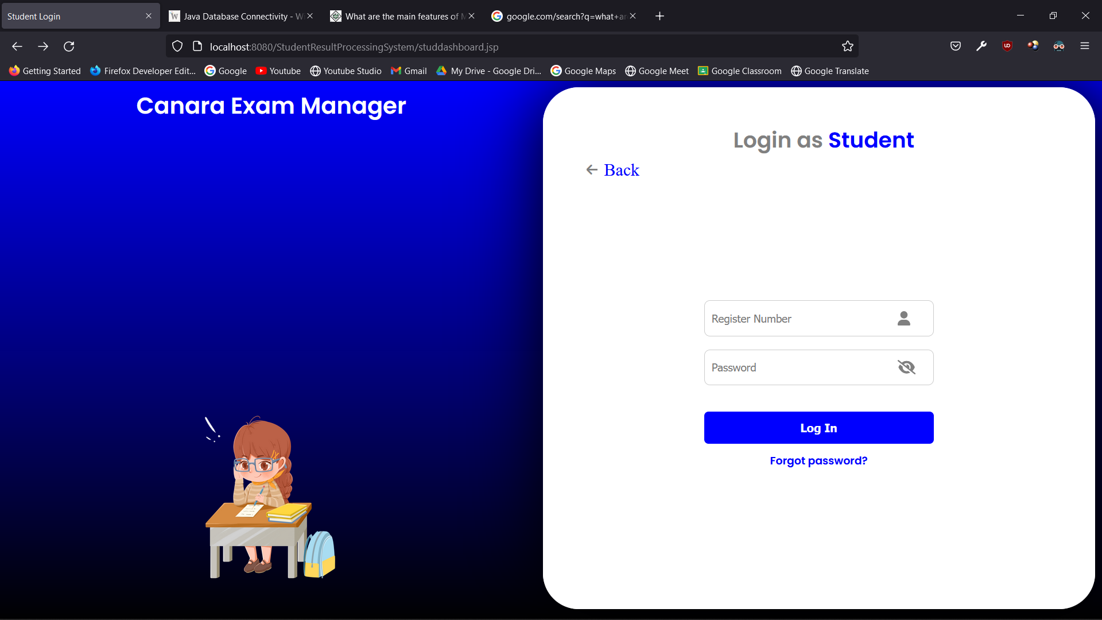

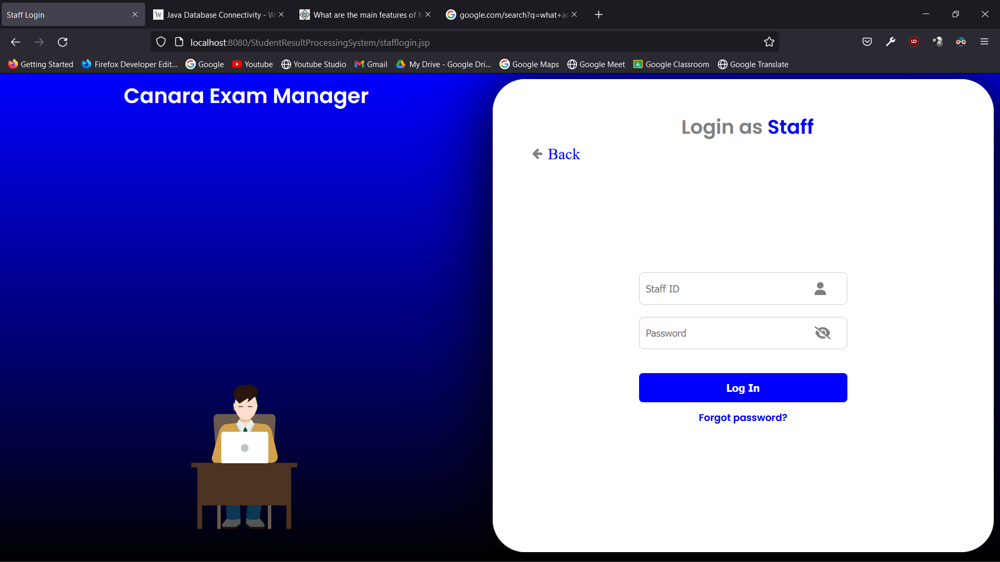

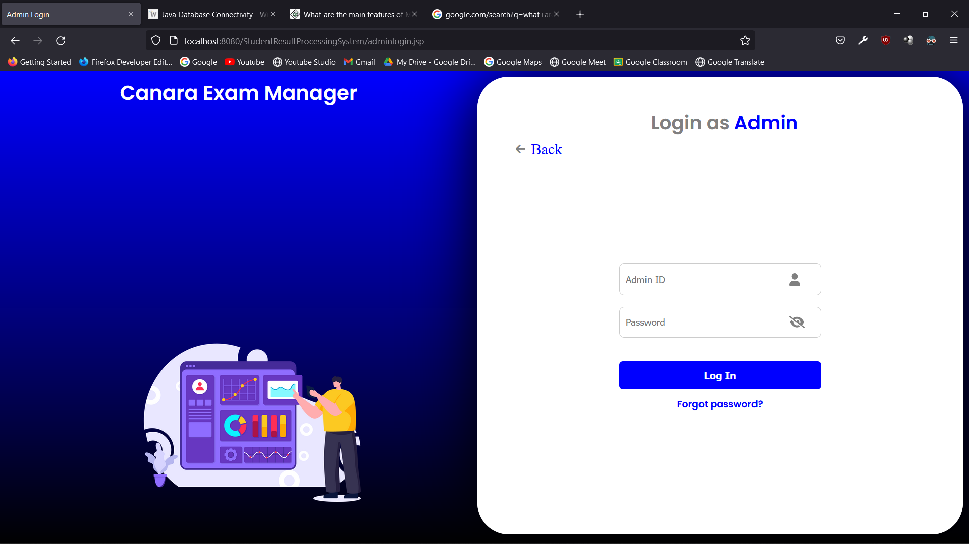

* 1. Main Screen / Home Page

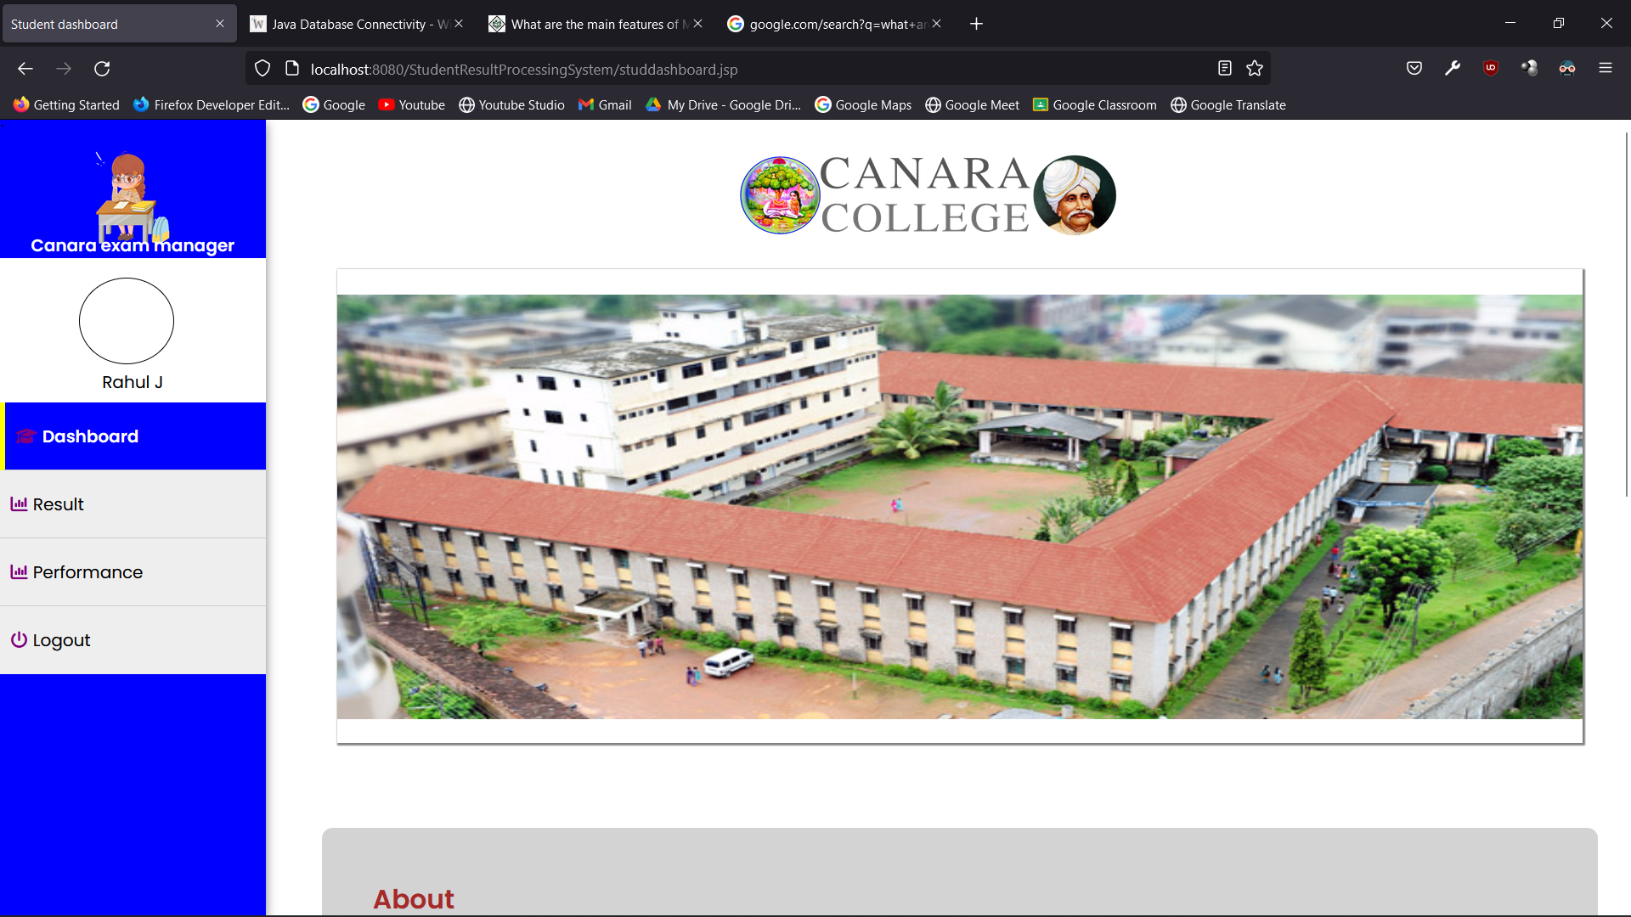

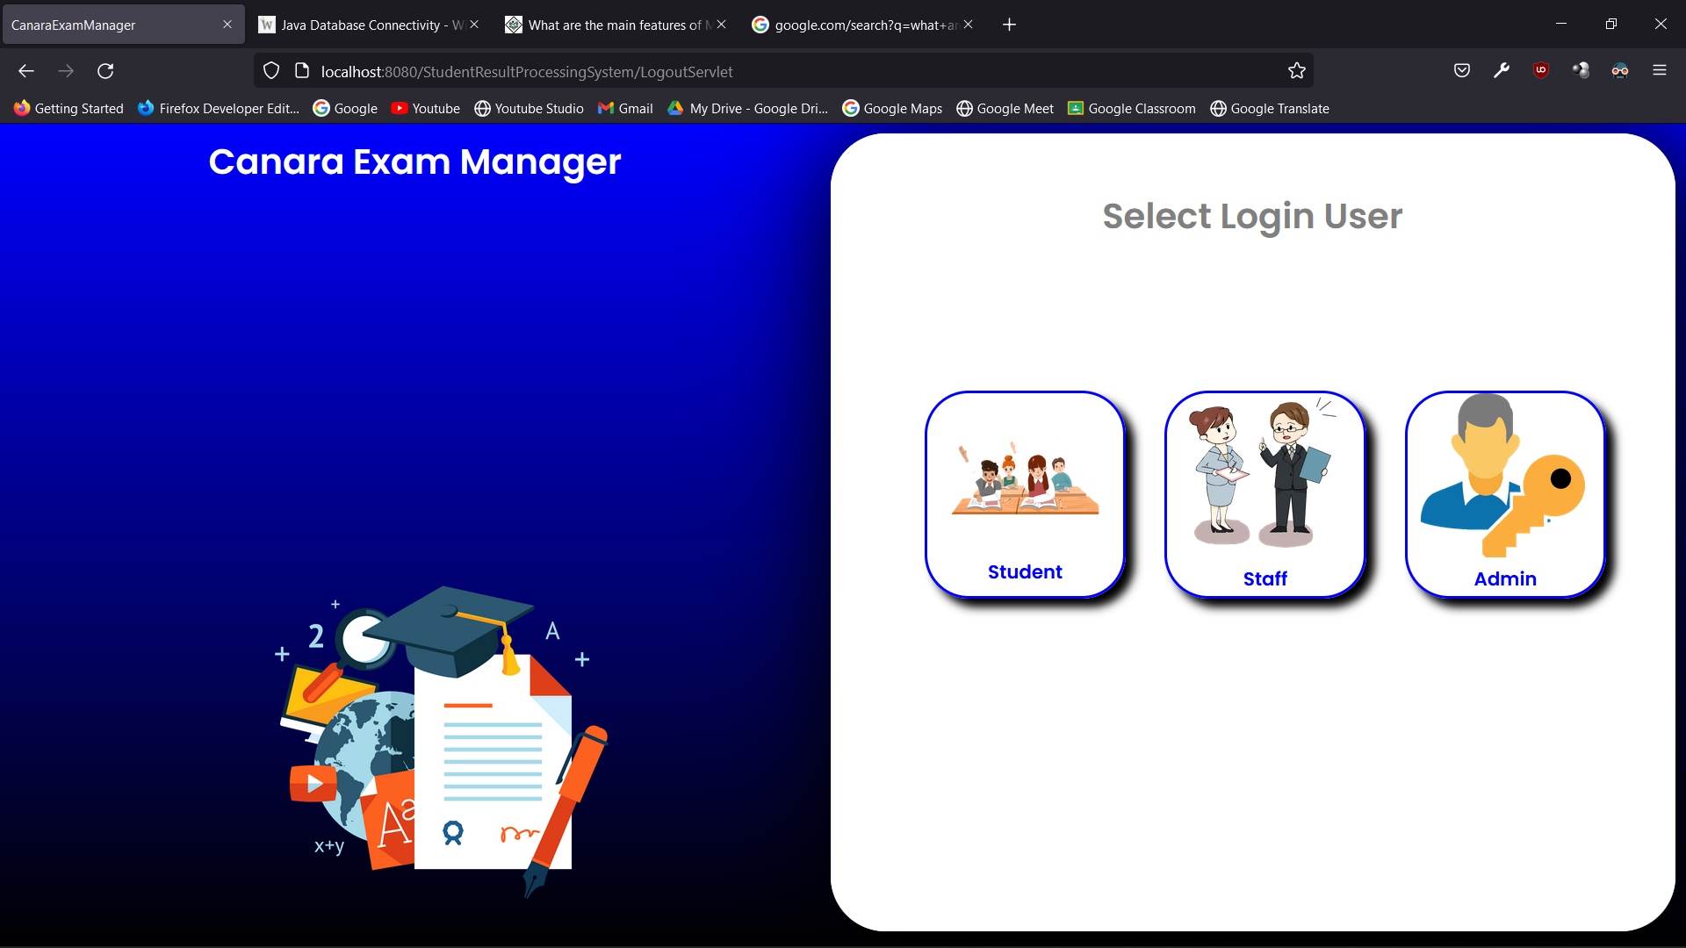

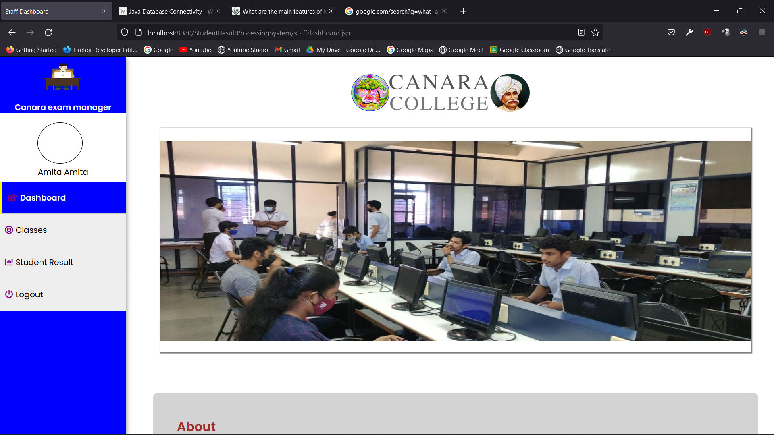

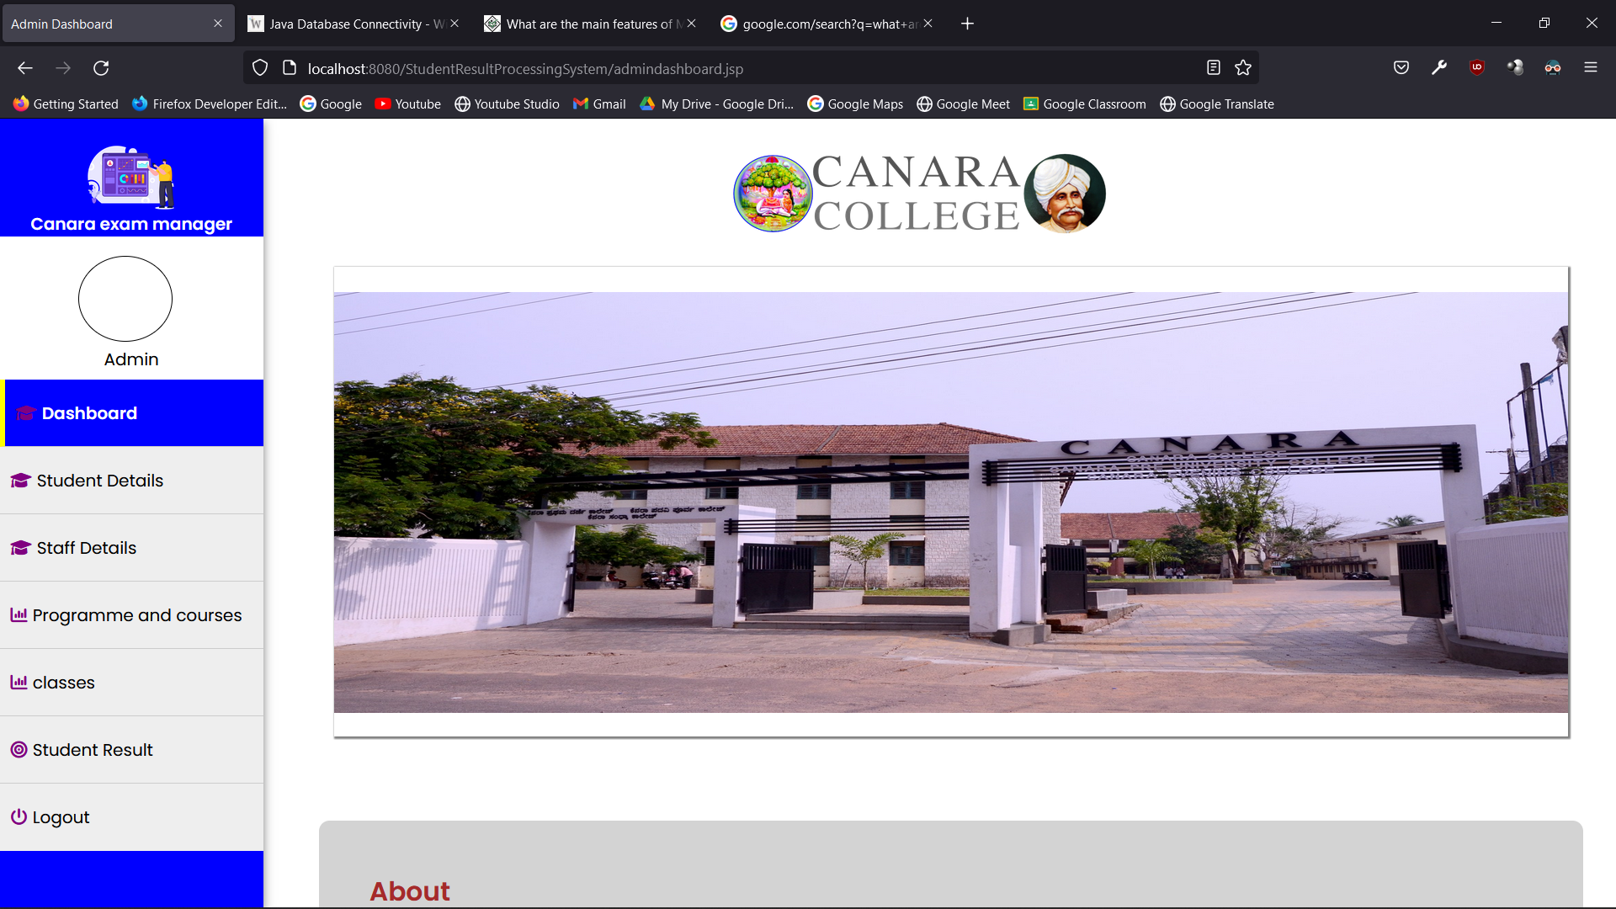

* 1. Menu

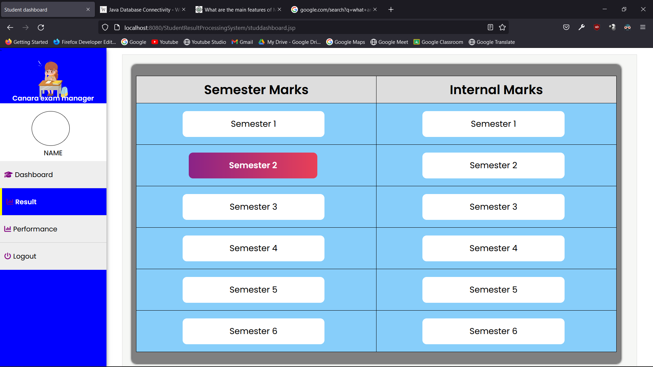

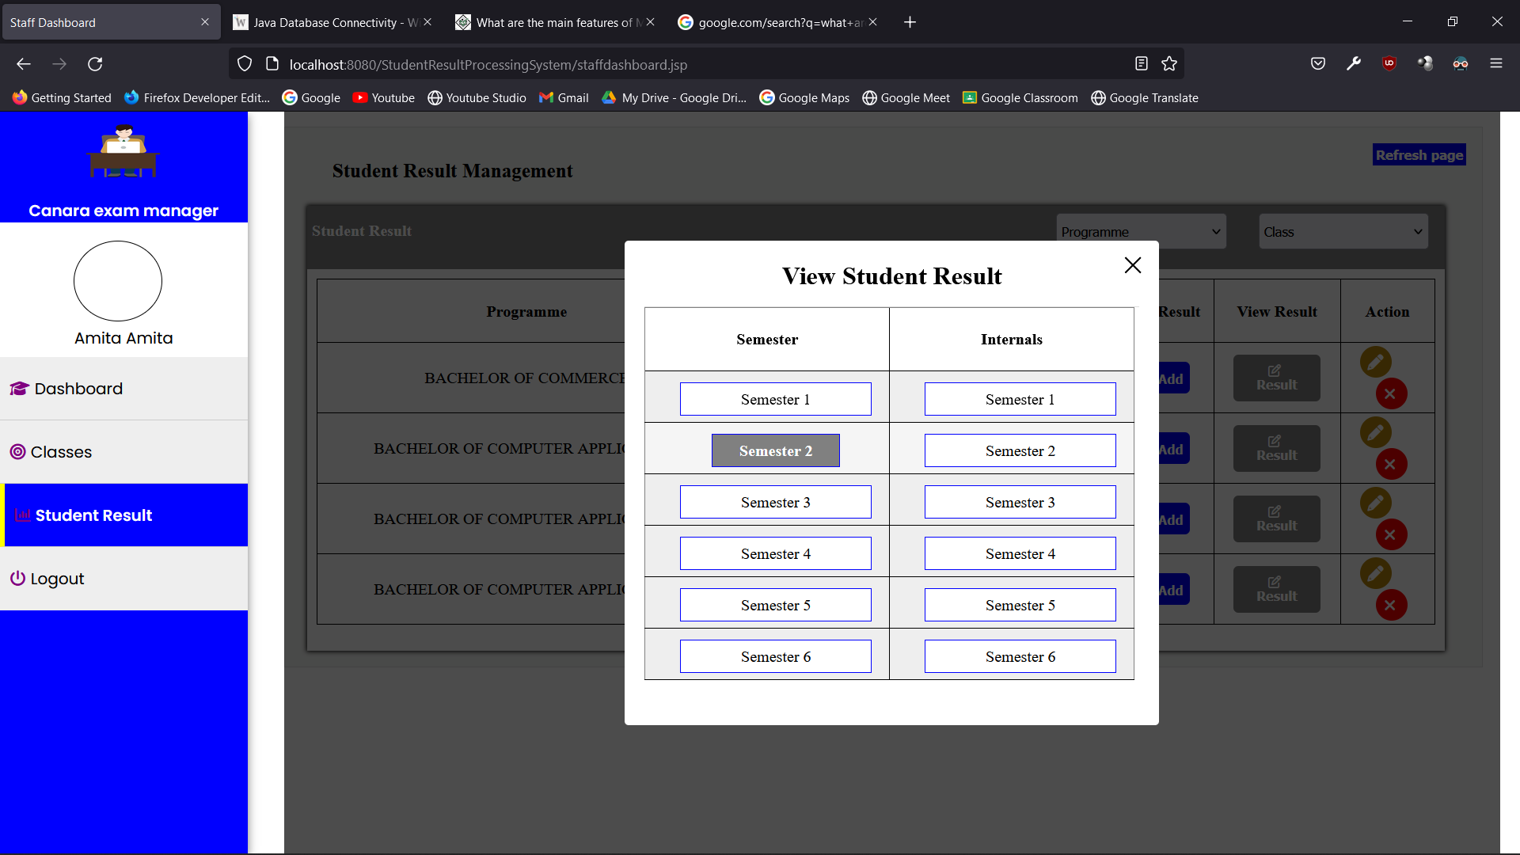

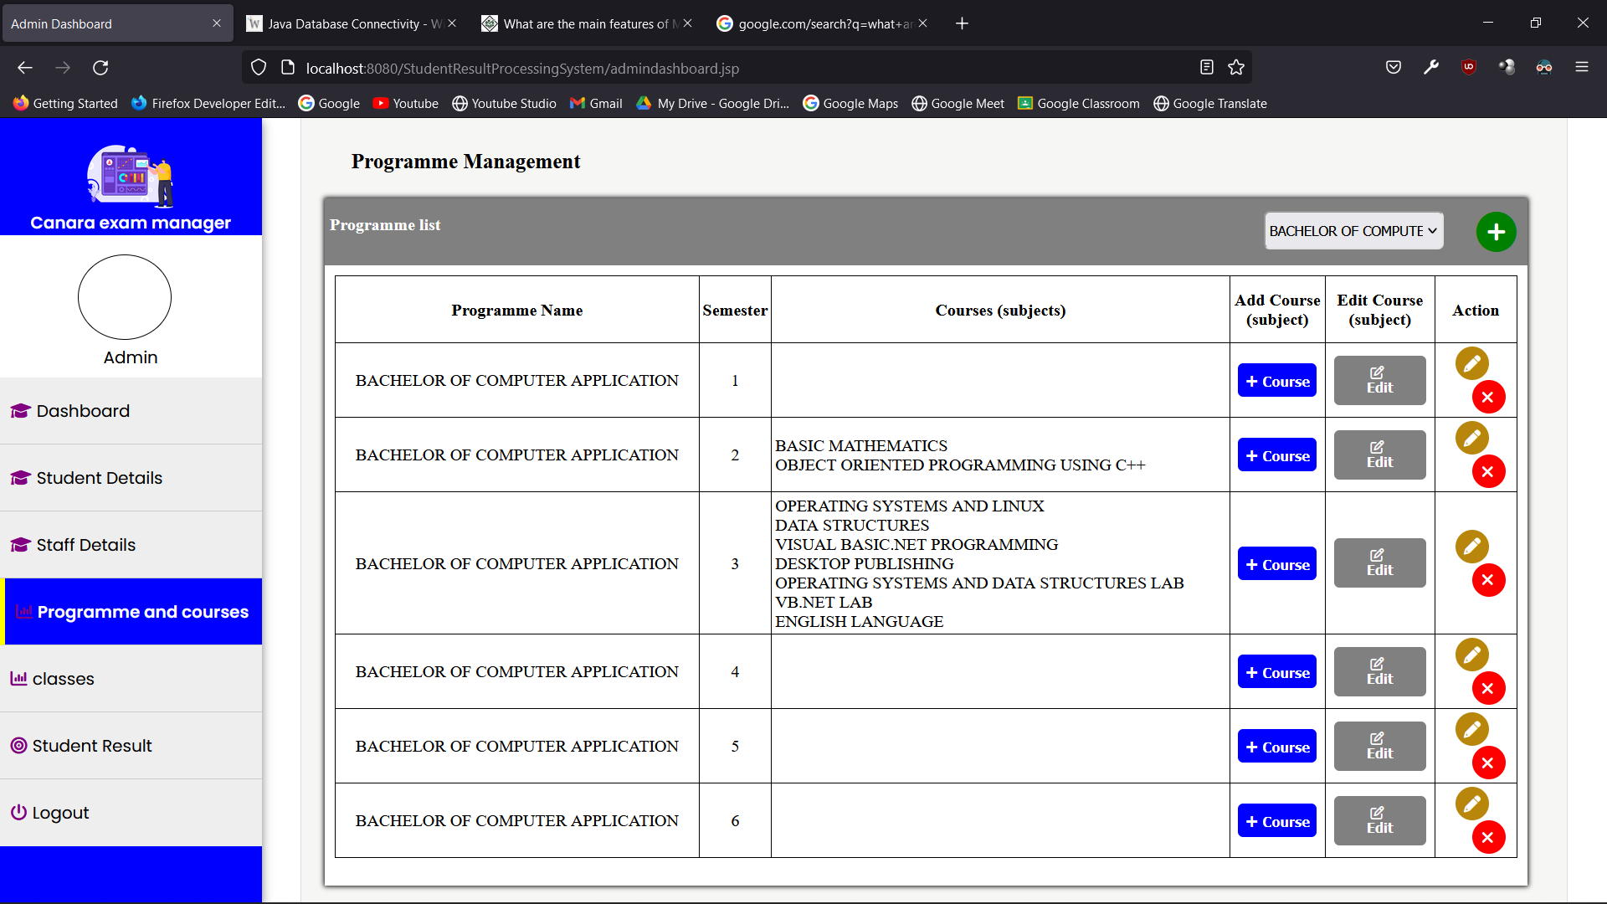

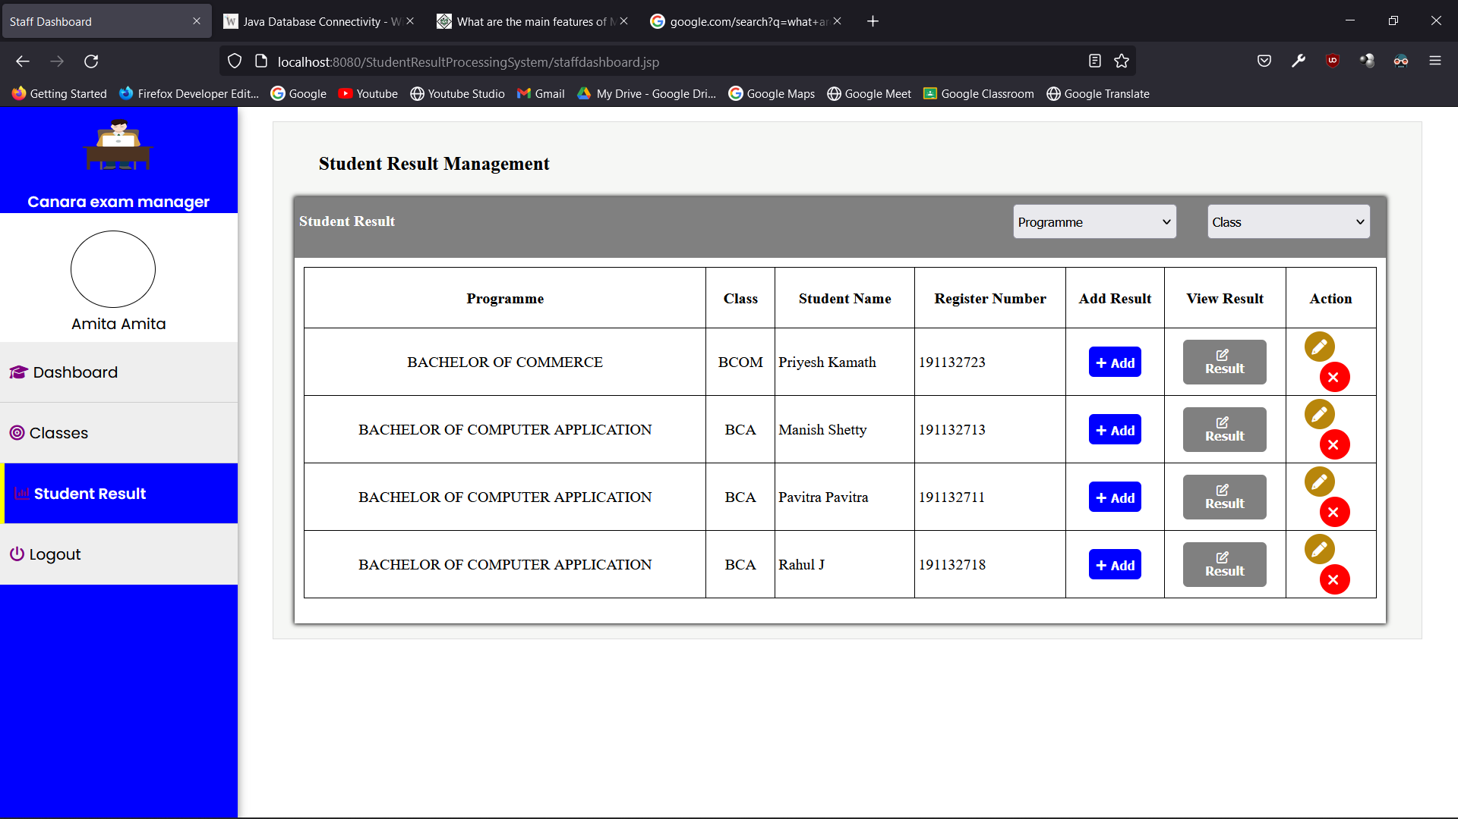

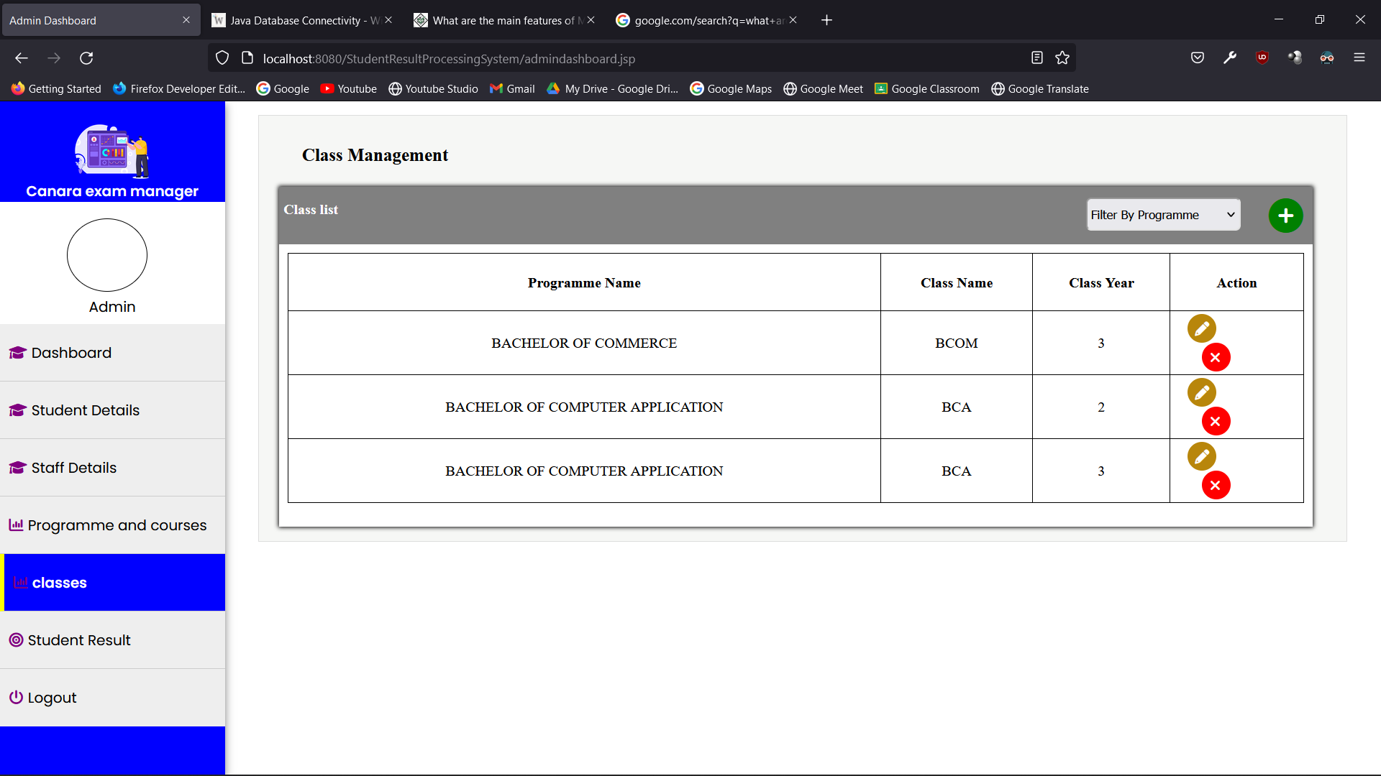

* 1. Data Store / Retrieval / Update

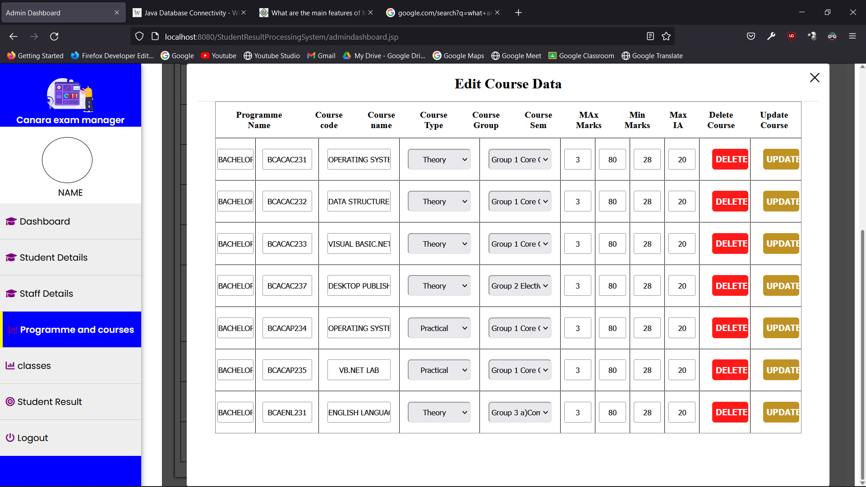

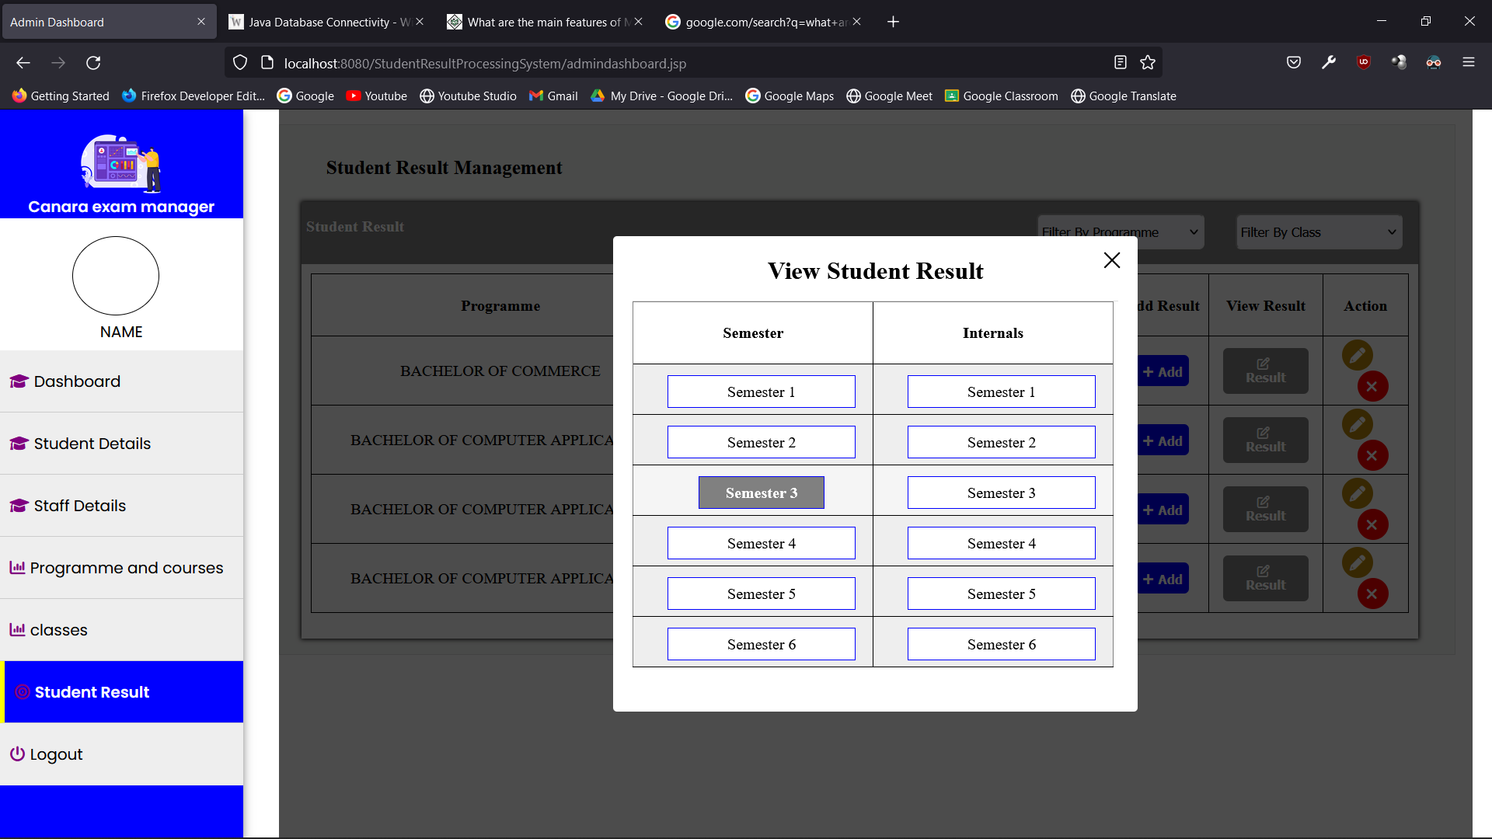

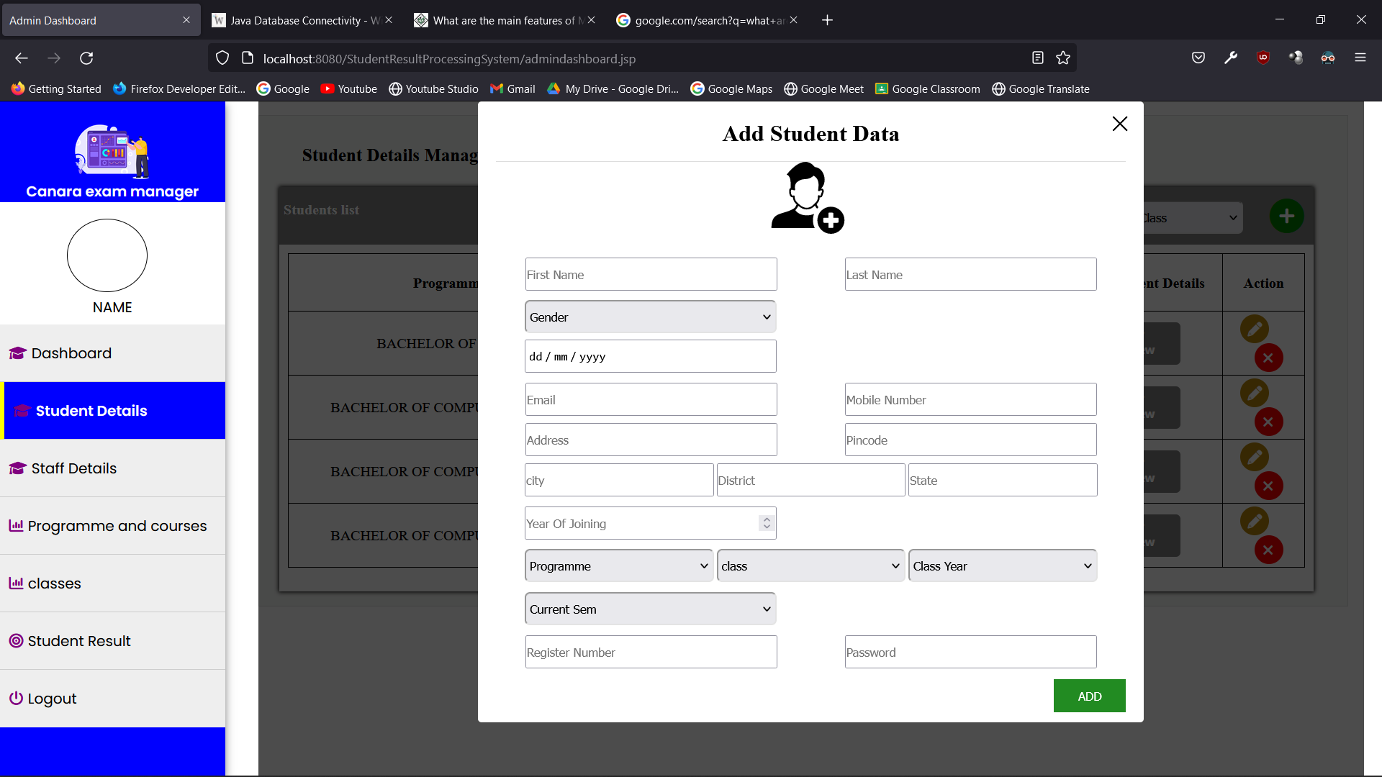

* 1. Validation

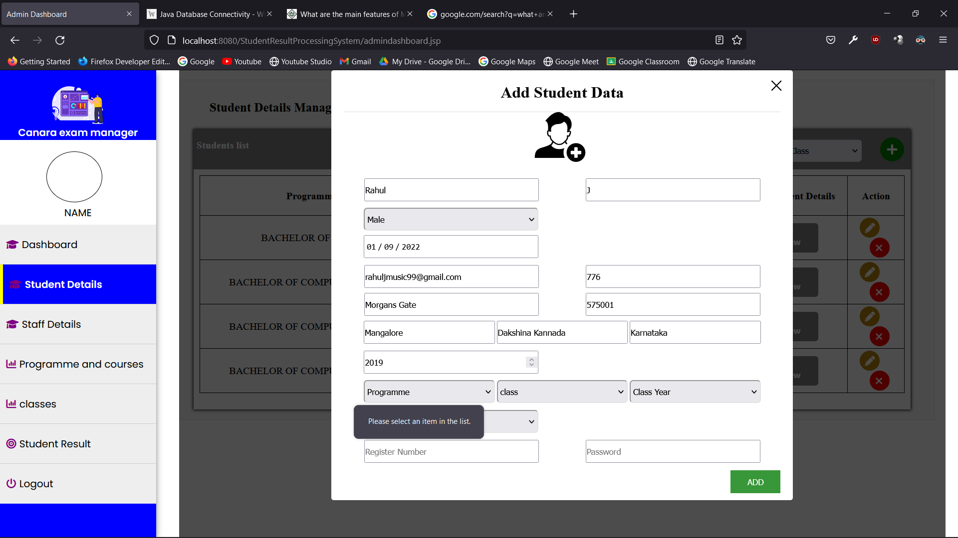

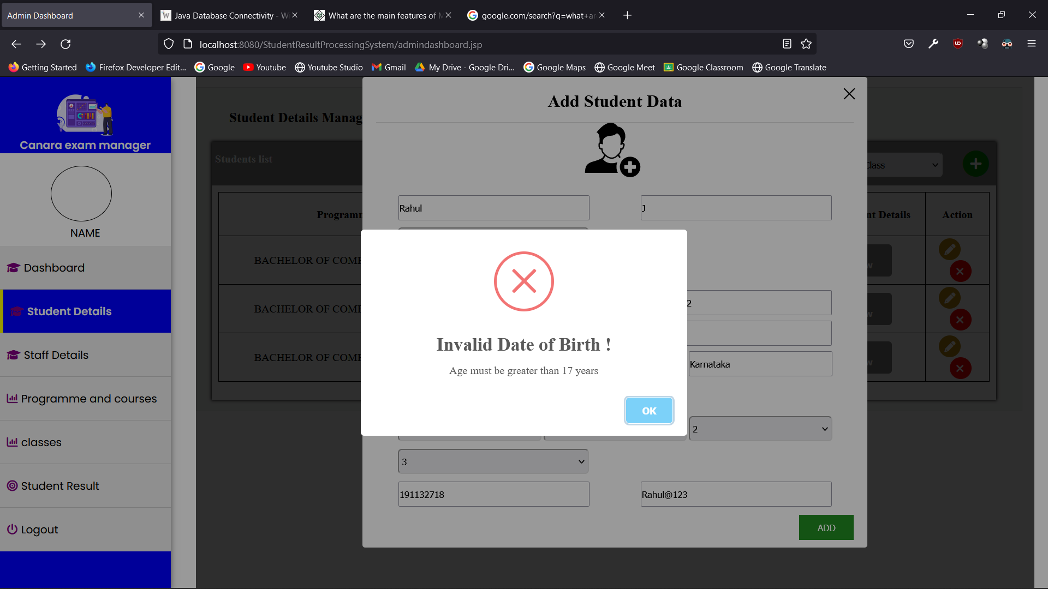

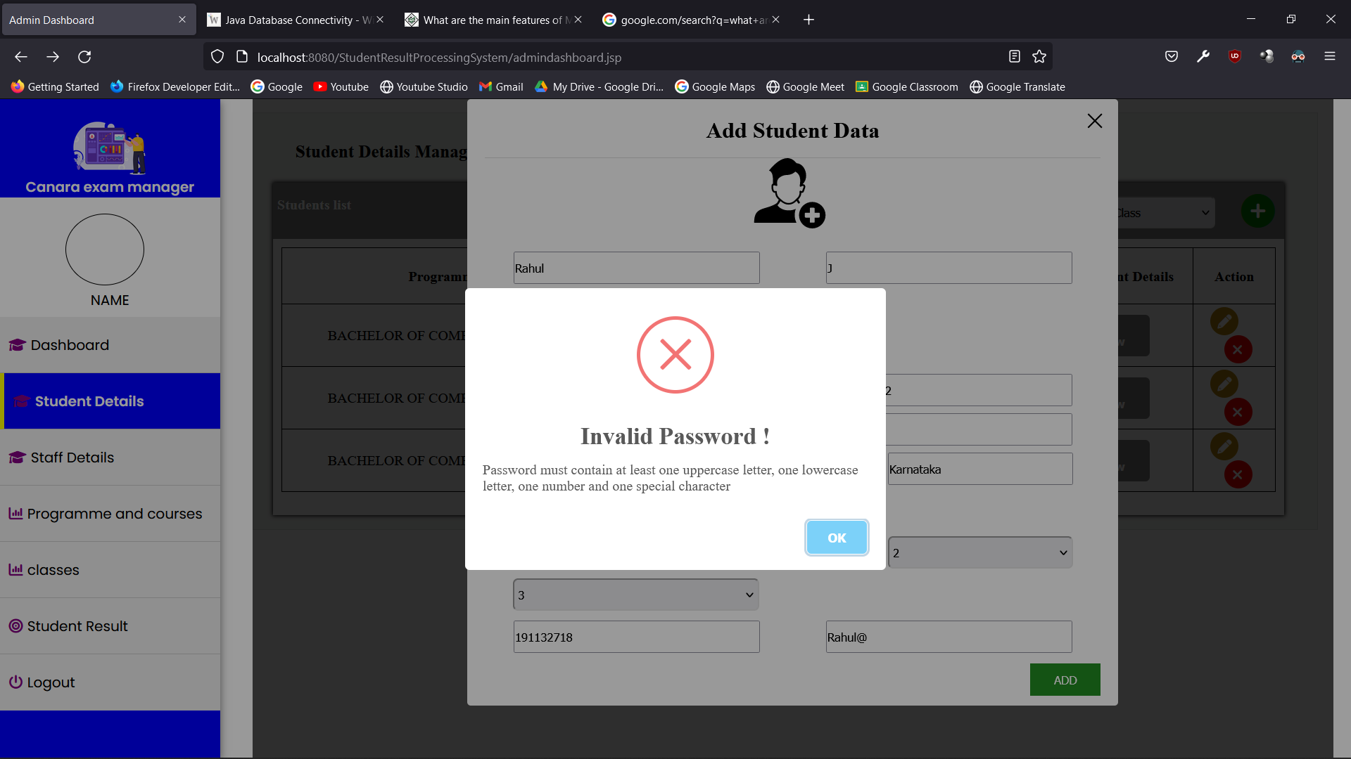

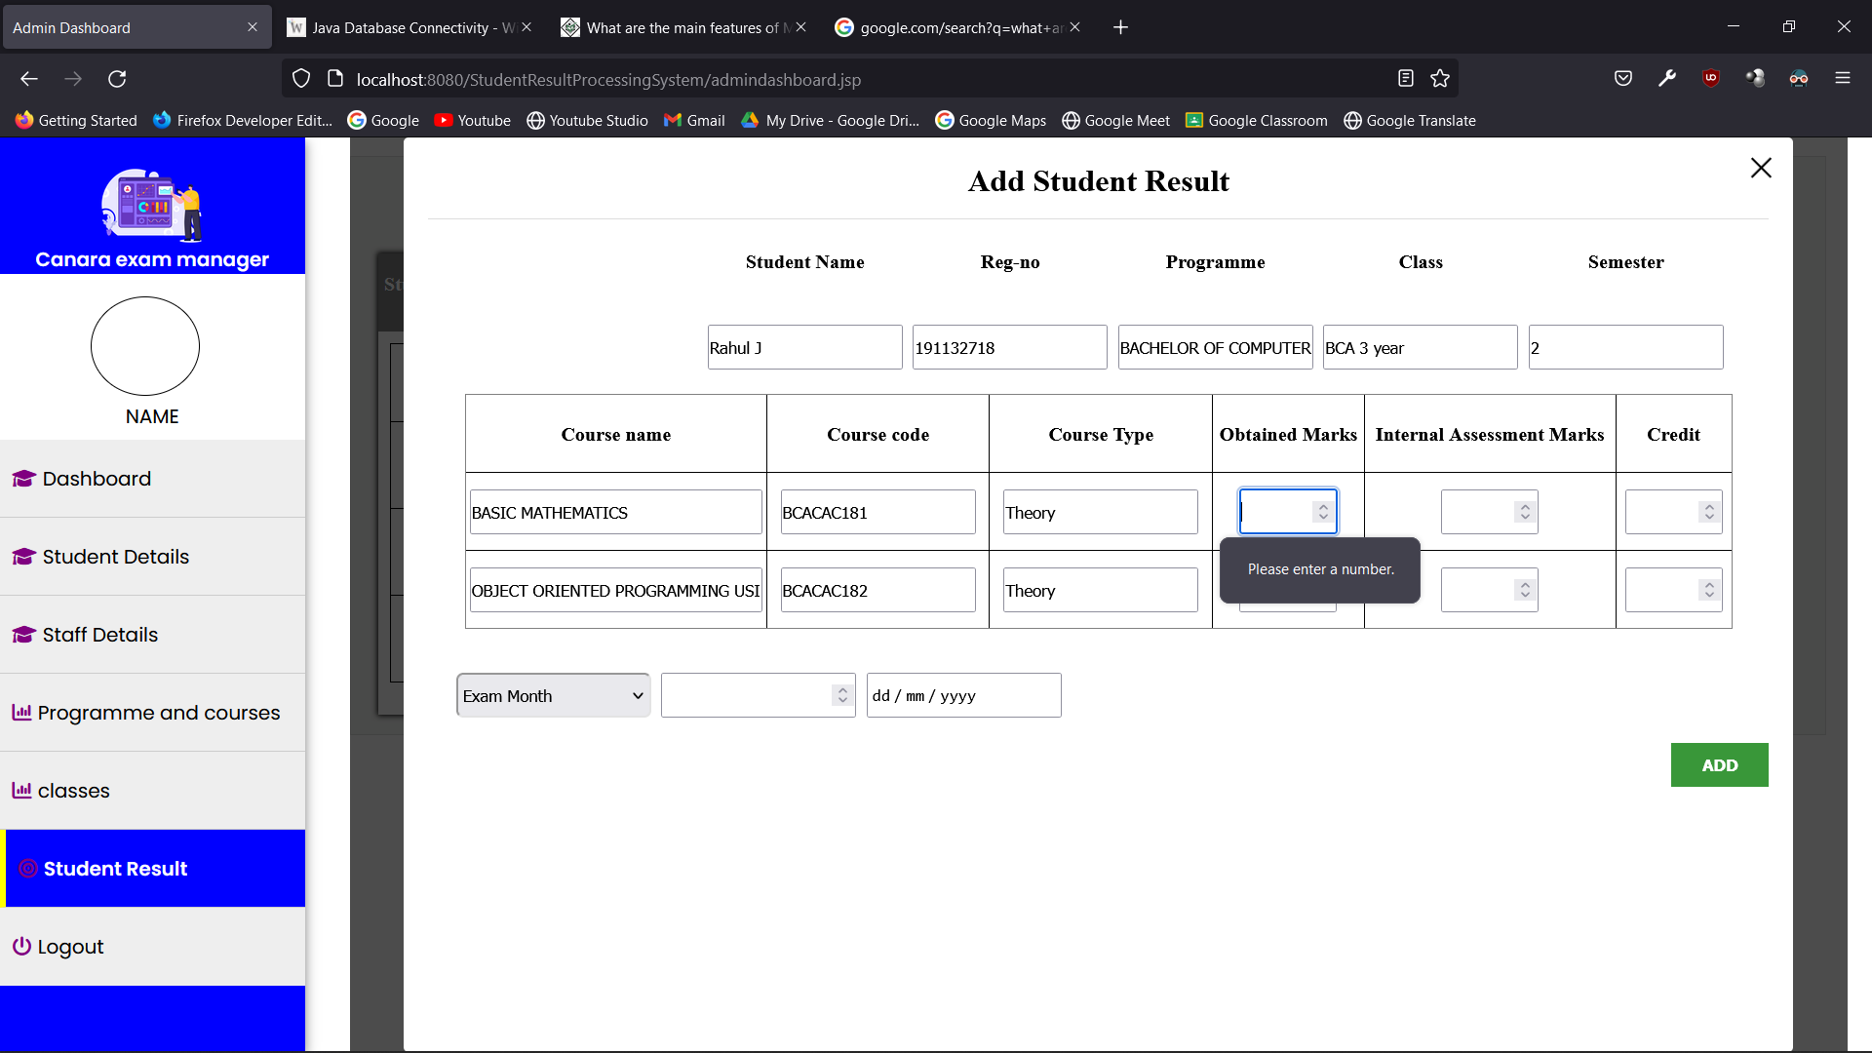

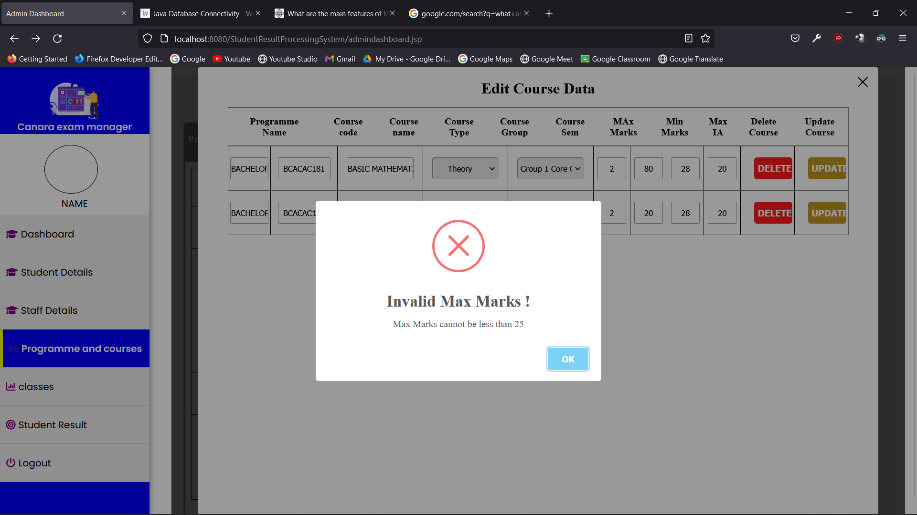

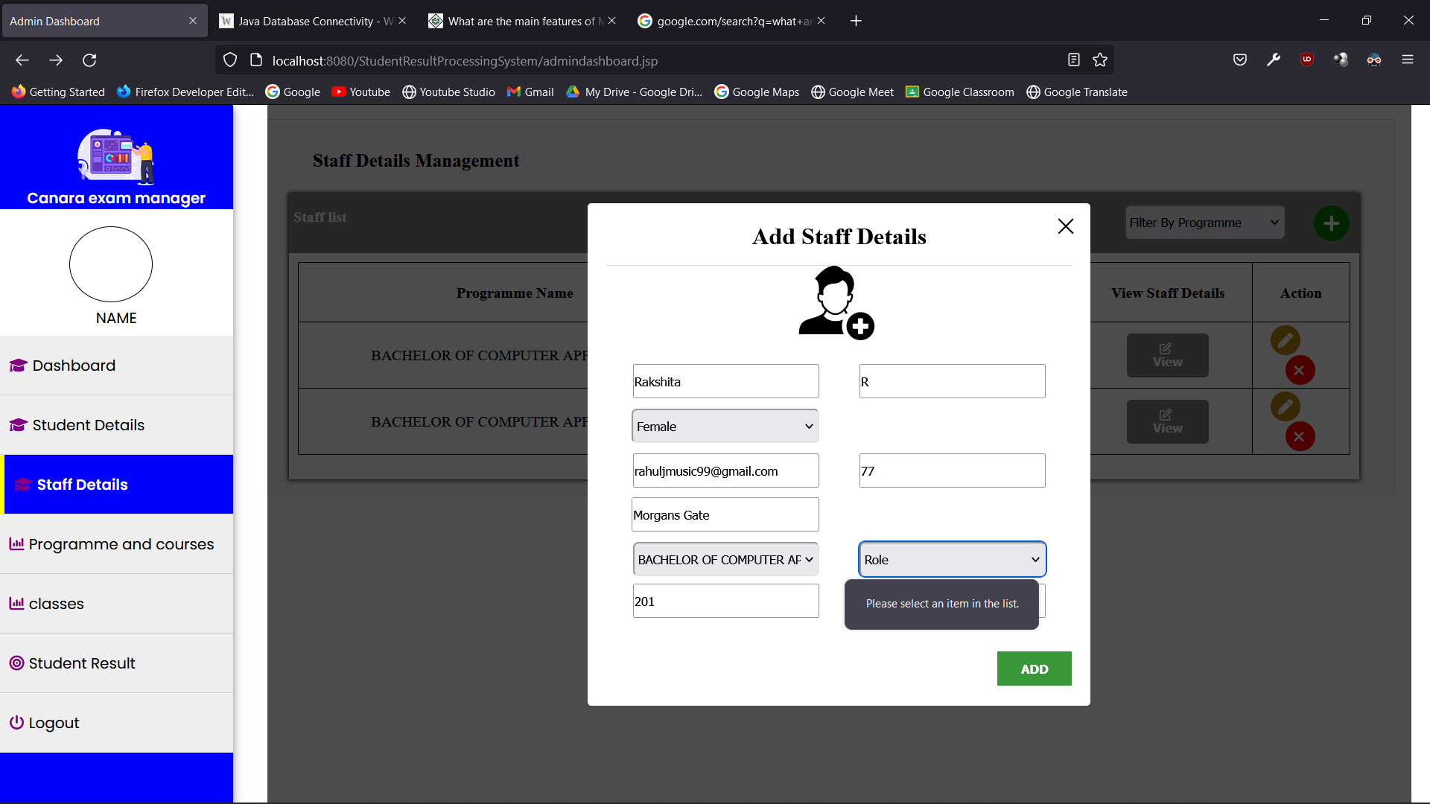

* 1. View

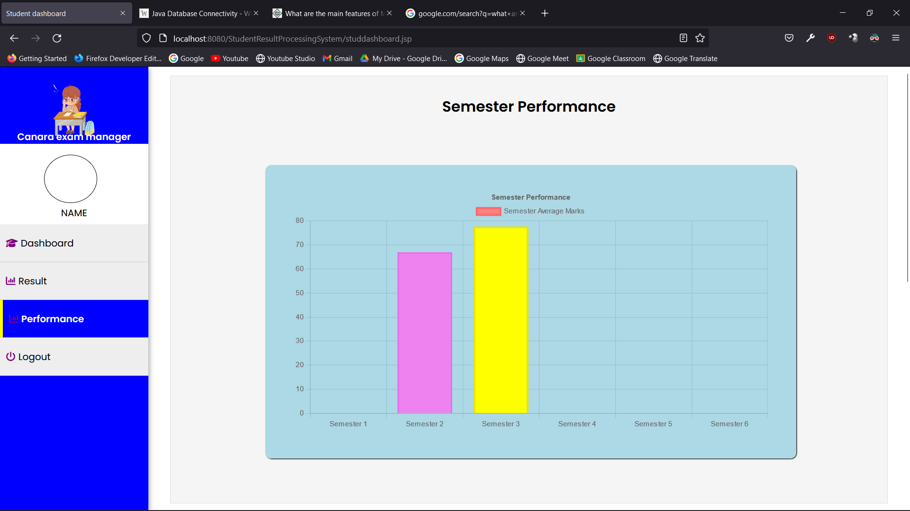

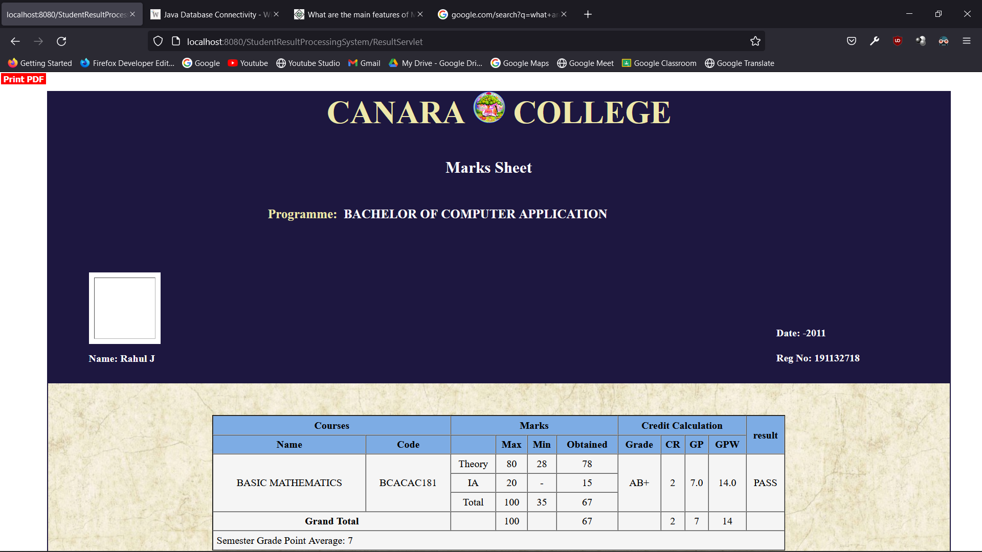

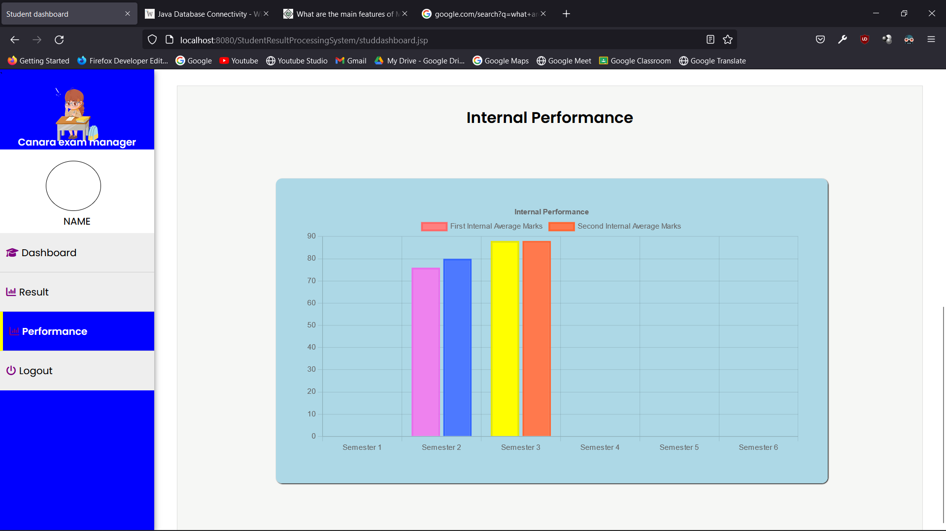

* 1. On Screen Reports

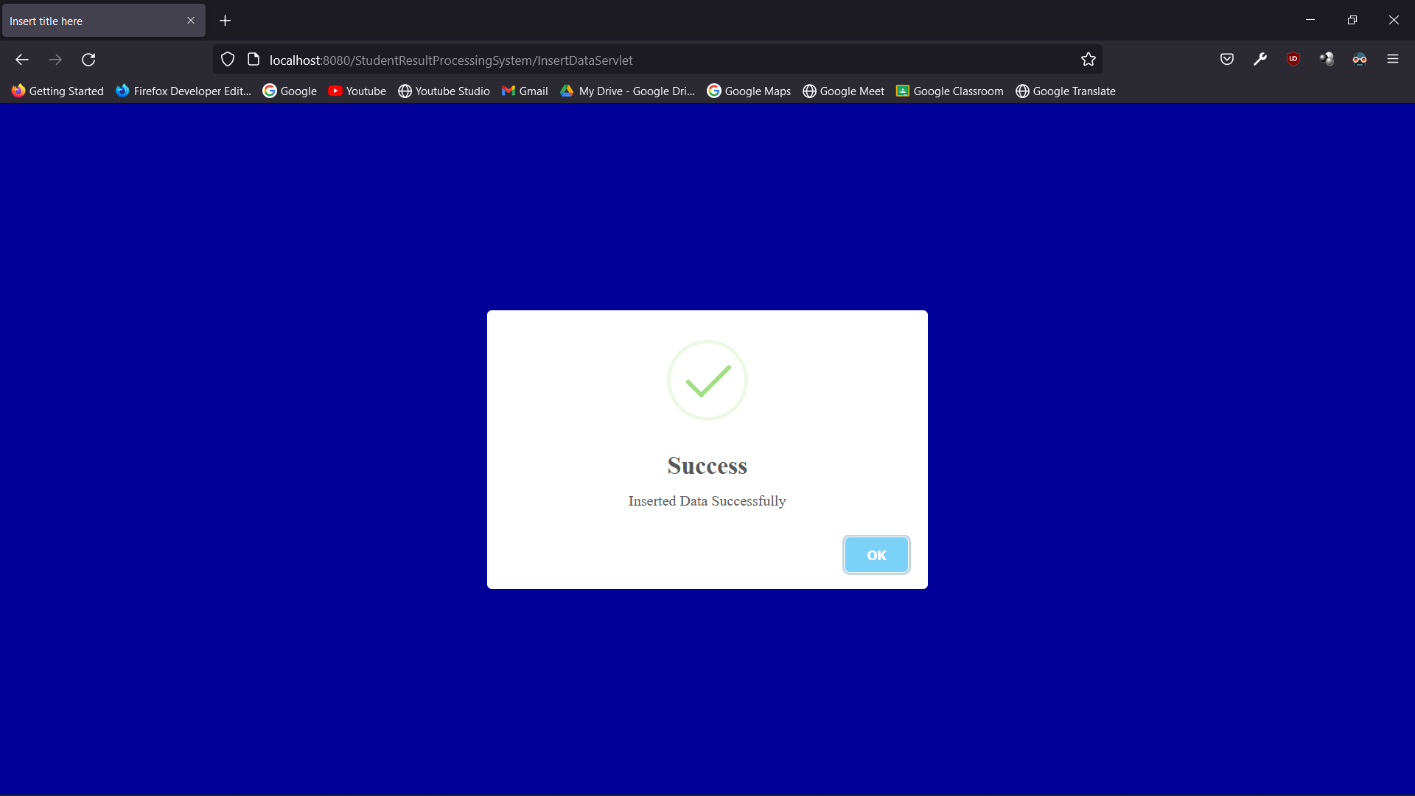

* 1. Alerts

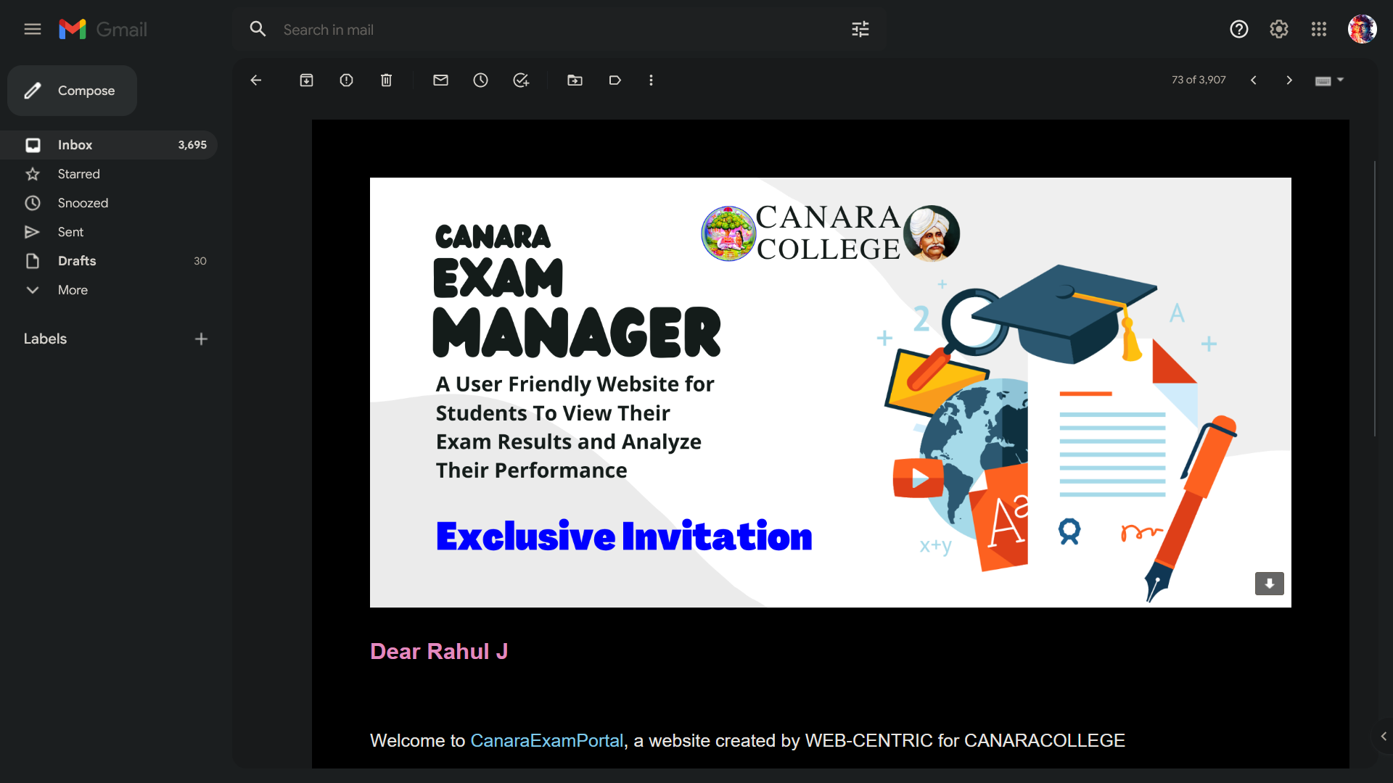

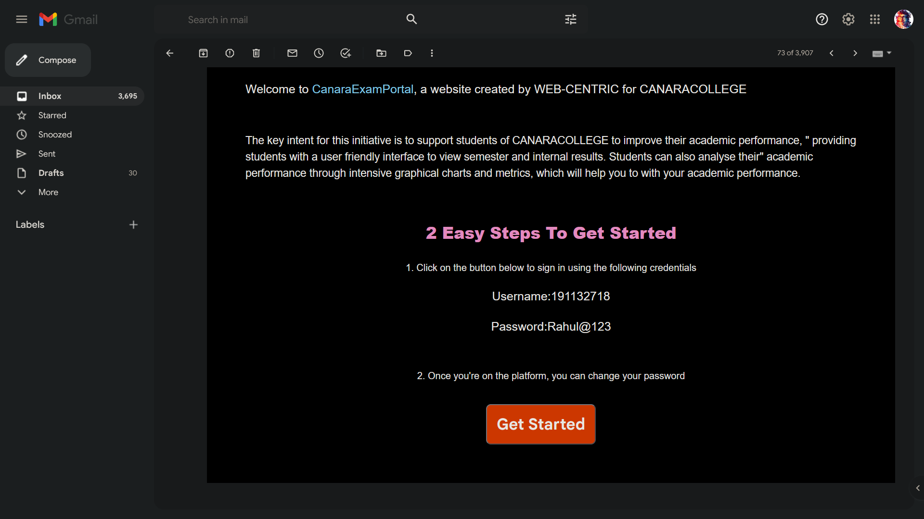

* 1. Error Messages

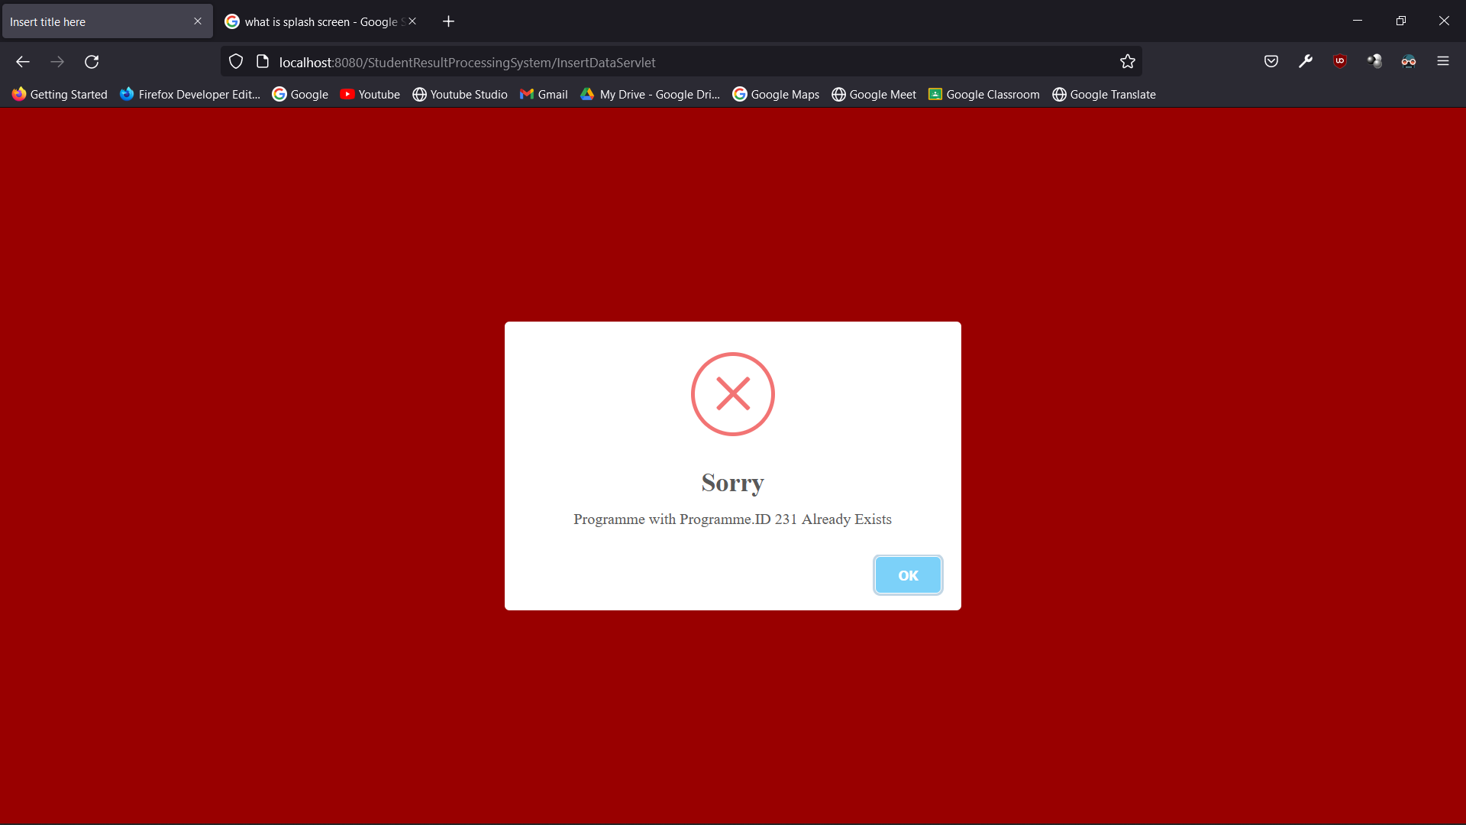

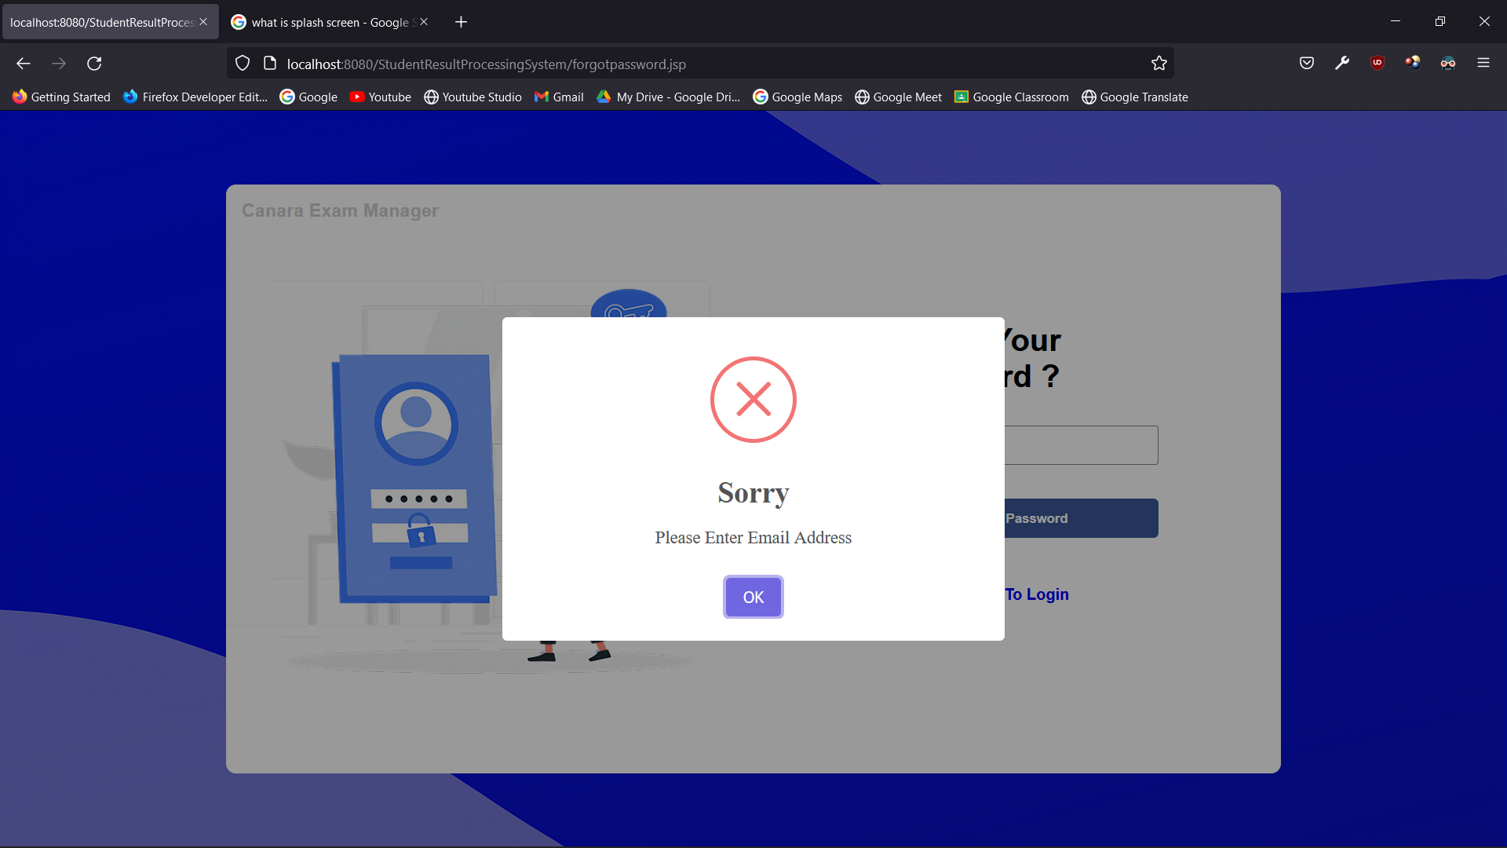

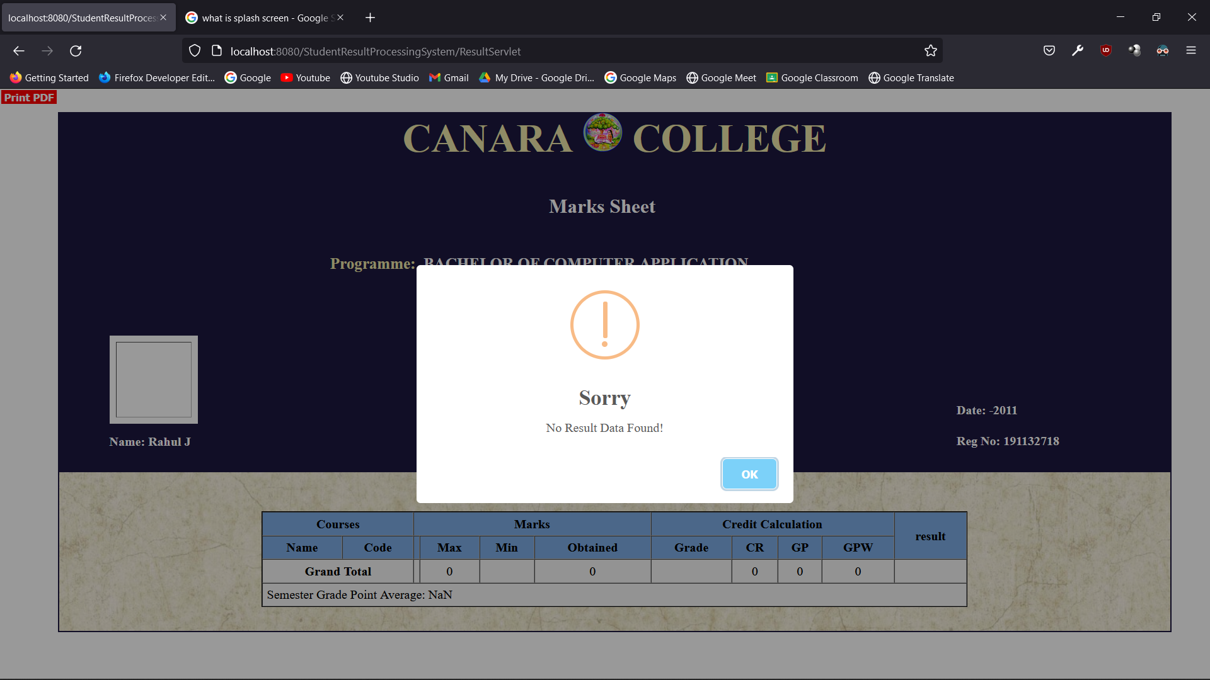

* 1. Other Pages

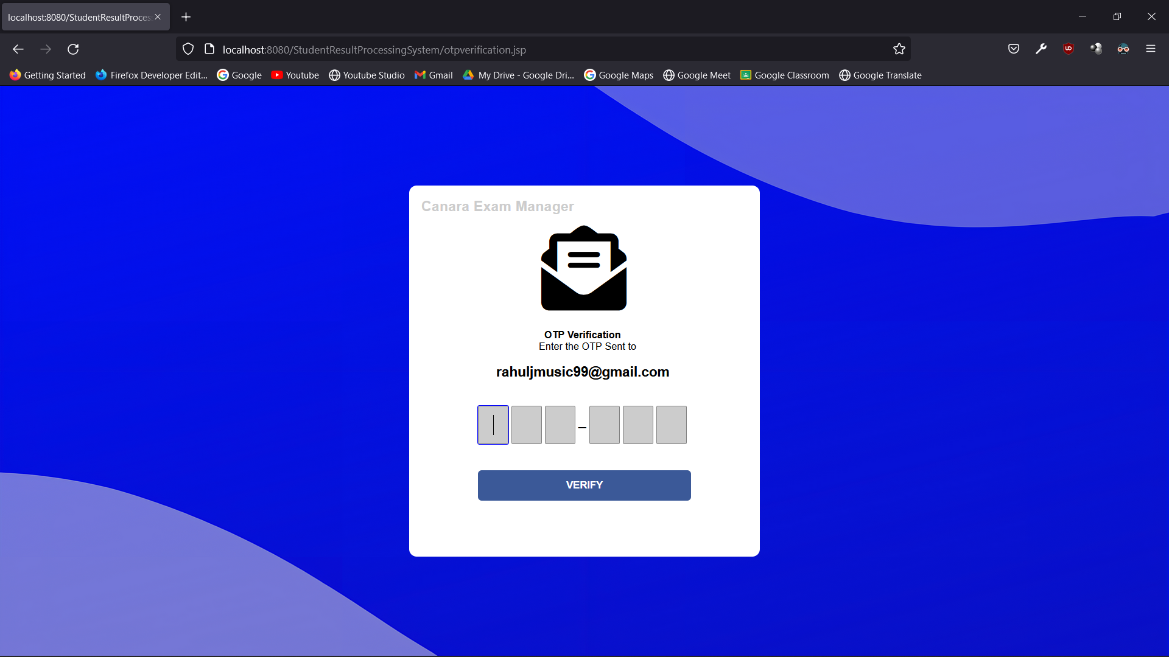

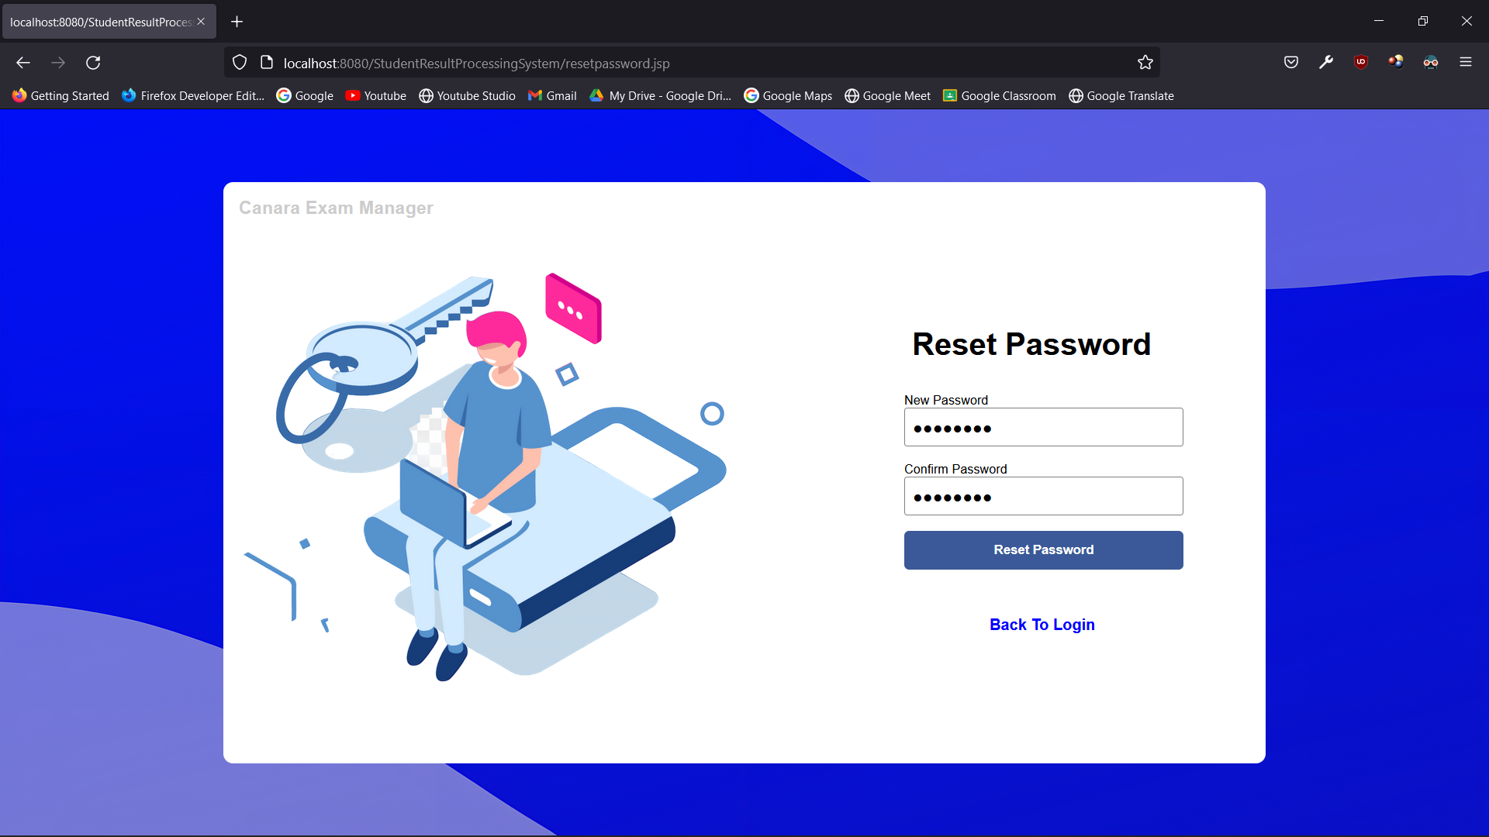

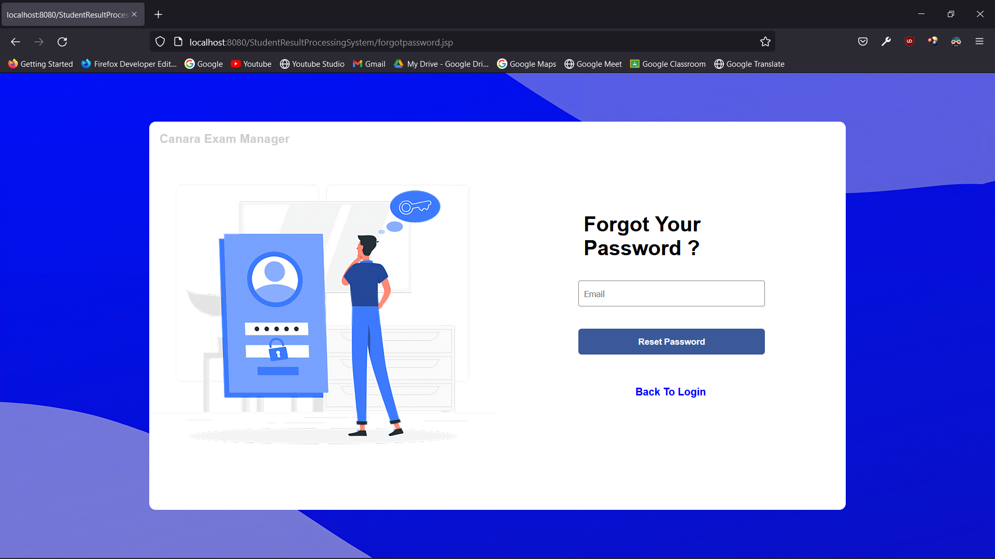

1. **Programme Code Listing**
   1. Introduction

Testing is the process of executing the program with the explicit intention of finding errors. If any, this makes the program fail. This phase is an important part of software development. It performs a very critical role in quality assurance and in ensuring the reliability of software. It is the process of finding errors and missing operations and also a complete verification to determine whether the objectives meet the user requirements.

The goal of testing is to uncover requirements, design, or coding errors in the programs. Consequently, different level of testing is employed in software systems. The testing results are used during maintenance. This section deals with the details of the classes of tests that must be conducted to validate the function, performance, and constraints. This is achieved basically by the means of testing which plays a vital role in the development of the software.

The program to be tested is executed with a set of test cases and the output of the program for the test cases is evaluated to determine if the program is performing as expected. The success of testing in revealing errors in programs depends critically on the test cases. There are two basic approaches to testing Black Box or Fictional Testing and White Box or Structural Testing.

In Functional Testing, the structure of the program is not considered. Test cases are decided solely based on the requirement or specification of the program or module and the internals of the module or the program is not considered for a section of test cases, due to its nature, functional testing often called “Black Box Testing”. It consists of two types of testing:

• Unit Testing

• Integration Testing

* 1. Introduction
* Unit Testing

Unit testing focuses efforts on the smallest unit of software design. This is known as module testing. The modules are tested separately. The test is carried out during the programming stage itself. In this step, each module is found to be working satisfactorily as regards the expected output from the module.

* Integration Testing

Data can be lost across an interface. One module can hurt another, and sub- functions, when combined, may not be linked in the desired manner in major functions. Integration testing is a systematic approach for constructing the program structure, while at the same time conducting tests to uncover errors associated with the interface. The objective is to take unit-tested modules and builds a program structure. All the modules are combined and tested for a while.

* 1. Validation

At the culmination of the integration testing, Software is completely assembled as a package. Interfacing errors have been uncovered and corrected and a final series of software test begin in validation testing. Validation testing can be defined in many ways, but a simple definition is that the validation succeeds when the software functions in a manner that is expected by the customer. After validation test has been conducted, one of the three possible conditions exist.

* The function or performance characteristics confirm to specification and are accepted.
* A deviation from specification is uncovered and a deficiency list is created.
* Proposed system under consideration has been tested by using validation test and found
* to be working satisfactory.
  1. Output Testing

After performing the validation testing, the next step is output testing of the proposed system, since no system could be useful if it does not produce the required output in a specific format. The output format on the screen is found to be correct. The format was designed in the system design time according to the user needs. For the hard copy also; the output comes as per the specified requirements by the user. Hence output testing did not result in any correction for

the system.

* 1. Test Cases
     1. Login Page

|  |  |  |  |
| --- | --- | --- | --- |
| **SL No** | **Test Condition** | **Expected Result** | **Result** |
| 1. | If user clicks on logins without entering ID and Password | Please fill out all the field | Successful |
| 2. | If username is blank but password is entered | Please enter user-name | Successful |
| 3. | If username is entered and password is blank | Please enter password | Successful |
| 4. | If email or password in incorrect | Invalid user credentials | Successful |

* + 1. Admin Module

|  |  |  |  |
| --- | --- | --- | --- |
| **SL No** | **Test Condition** | **Expected Result** | **Result** |
| 1. | When admin clicks the “Profile” Tab | Display’s admin profile | Successful |
| 2. | When admin clicks the “Dashboard” Tab | Display’s admin dashboard | Successful |
| 3. | When admin clicks “Student Details” Tab | Display’s student details | Successful |
| 4. | When admin clicks “Staff Details” Tab | Display’s staff details | Successful |
| 5. | When admin clicks “Programme and Courses” Tab | Display’s programme and courses details | Successful |
| 6. | When admin clicks “Classes” Tab | Display’s classes details | Successful |
| 7. | When admin clicks “Student Result” Tab | Display’s student result details | Successful |

* + - 1. Add Data

|  |  |  |  |
| --- | --- | --- | --- |
| **SL No** | **Test Condition** | **Expected Result** | **Result** |
| 1. | When any fields are empty | Please fill out this field | Successful |
| 2. | When any data is incorrect | Invalid Data | Successful |
| 3. | When particular data already exists | Data Already Exists | Successful |
| 4. | When data is added | Data Inserted Successfully | Successful |

* + - 1. Update Data

|  |  |  |  |
| --- | --- | --- | --- |
| **SL No** | **Test Condition** | **Expected Result** | **Result** |
| 1. | When any fields are empty | Please fill out this field | Successful |
| 2. | When any data is incorrect | Invalid Data | Successful |
| 3. | When particular data does not exist | Data Does not Exists | Successful |
| 4. | When data is updated | Data Updated Successfully | Successful |

* + - 1. Delete Data

|  |  |  |  |
| --- | --- | --- | --- |
| **SL No** | **Test Condition** | **Expected Result** | **Result** |
| 3. | When particular data does not exist | Data Does not Exists | Successful |
| 4. | When data is deleted | Data Deleted Successfully | Successful |

* + 1. Staff Module

|  |  |  |  |
| --- | --- | --- | --- |
| **SL No** | **Test Condition** | **Expected Result** | **Result** |
| 1. | When staff clicks the “Profile” Tab | Display’s staff profile | Successful |
| 2. | When staff clicks the “Dashboard” Tab | Display’s staff dashboard | Successful |
| 3. | When staff clicks the “Classes” Tab | Display’s classes details | Successful |
| 4. | When staff clicks the “Student Result” Tab | Display’s student result details | Successful |

* + - 1. Add Internal Result Data

|  |  |  |  |
| --- | --- | --- | --- |
| **SL No** | **Test Condition** | **Expected Result** | **Result** |
| 1. | When any fields are empty | Please fill out this field | Successful |
| 2. | When any data is incorrect | Invalid Data | Successful |
| 3. | When particular data already exists | Data Already Exists | Successful |
| 4. | When data is added | Data Inserted Successfully | Successful |

* + - 1. Update Internal Result Data

|  |  |  |  |
| --- | --- | --- | --- |
| **SL No** | **Test Condition** | **Expected Result** | **Result** |
| 1. | When any fields are empty | Please fill out this field | Successful |
| 2. | When any data is incorrect | Invalid Data | Successful |
| 3. | When particular data does not exist | Data Does not Exists | Successful |
| 4. | When data is updated | Data Updated Successfully | Successful |

* + - 1. Delete Internal Result Data

|  |  |  |  |
| --- | --- | --- | --- |
| **SL No** | **Test Condition** | **Expected Result** | **Result** |
| 3. | When particular data does not exist | Data Does not Exists | Successful |
| 4. | When data is deleted | Data Deleted Successfully | Successful |

* + 1. Student Module

|  |  |  |  |
| --- | --- | --- | --- |
| **SL No** | **Test Condition** | **Expected Result** | **Result** |
| 1. | When student clicks the “Profile” Tab | Display’s staff profile | Successful |
| 2. | When student clicks the “Dashboard” Tab | Display’s staff dashboard | Successful |
| 3. | When student clicks the “Result” Tab | Display’s classes details | Successful |
| 4. | When student clicks the “Performance” Tab | Display’s student result details | Successful |
| 5. | When student clicks the “Semester” Menu Options | Display’s particular semester results | Successful |

* Conclusion

The Project **“Canara Exam Manager”** ***Student Result Processing System*** Software is a complete multi-user Web-Application. The admin accepts and then processes the scores of students and subsequently produces their report cards. The staff adds or updates student’s internal marks. The students can view and analyze their performances in the examination through graphical charts.

This project aimed at providing colleges to add, view and update student results and generate report cards and performance analysis charts, which can be viewed by the students through user friendly GUI based web pages.

* Limitations

The only limitations are system storage capacity, internet connections, system processing capabilities and browser processing capabilities. A good Internet connection is crucial for this application

* Scope for enhancement (future scope)

In “Student Result Processing System” there are various controls to provide user friendliness. Details can be accessed over the internet, and huge amount of data, records and information can be stored. It provides high level of security and there is no risk of data mismanagement. The overall result processing system is easier to use, flexible and with more features.

* Abbreviations and Acronyms (list)

|  |  |
| --- | --- |
| SRS | Software Requirements Specification |
| SRPS | Student Result Processing System |
| CEM | Canara Exam Manager |
| DFD | Data Flow Diagram |
| ERD | Entity Relationship Diagram |
| CFD | Context Flow Diagram |
| DBMS | Database Management System |
| RDBMS | Relational Database Management System |
| GUI | Graphical User Interface |
| ADMIN | The Administrator |
| JSP | Java Server Page |
| SQL | Structured Query Language |
| HTML | Hyper Text Markup Language |
| CSS | Cascading Style Sheets |
| JS | Java Script |

* Bibliography / References

Books

* Black Book of Java Servlet, JSP AND JDBC.
* Black Book of HTML, CSS, JavaScript, jQuery, AJAX.

Websites

* [www.github.com](http://www.github.com)
* www.stackoverflows.com
* www.geeksforgeeks.org